Number 141, March 12, 2020
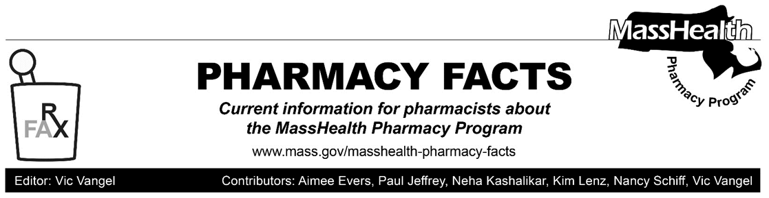

Updates Related to Coronavirus Disease 2019 (COVID-19)

Effective March 14, 2020

In response to the coronavirus disease (COVID-19) outbreak, MassHealth is allowing additional exceptions to the 30-day supply limitation for prescriptions. (See description at 130 CMR 406.411(D): Quantities). Additionally, MassHealth will allow early refills of most existing prescriptions. These policy changes are intended to allow greater flexibility in providing care to MassHealth members who may be affected by the outbreak. For further information about MassHealth coverage and reimbursement policy for services related to COVID-19, please review MassHealth All Provider Bulletin 288 (ALL-288). As with All-288, the policies described in this Pharmacy Facts will remain effective for the duration of the state of emergency declared via Executive Order No. 591: Declaration of a State of Emergency to Respond to COVID-19.

The procedures described in the bulletin apply to all pharmacy claims processed through the Pharmacy Online Processing System (POPS), including claims for the Health Safety Net (HSN) program.

Days’ Supply Limitations: Effective for Dates of Service beginning March 14, 2020

Despite the requirements of 130 CMR 406.411(D)(1): Days’ Supply Limitation, pharmacies may dispense up to a 90-day supply of a prescription drug if requested by a MassHealth member or that member’s prescriber as long as sufficient quantity remains on the prescription to support the quantity being filled. This policy does not apply to drugs that require Prescription Monitoring Program (PMP) reporting, behavioral health medications, antibiotics, IV medications and certain other drugs designated by MassHealth (e.g., drugs for which quantity limits have been individually established for clinical reasons). If a pharmacist believes that dispensing up to a 90-day supply of any drug not covered by the policy would be in the best interest of a MassHealth member, they may call the MassHealth Drug Utilization Review (DUR) program at (800) 745-7318 to request an override.

MassHealth notes that this policy is consistent with the amendments to 130 CMR 406.000: Pharmacy Services proposed on November 29, 2019 and currently pending final promulgation. MassHealth also notes that the Massachusetts Department of Public Health, through the Massachusetts Board of Registration in Pharmacy and the Drug Control Program, allows pharmacists to change the quantity being dispensed on a prescription in the circumstances described in Joint Policy 2018-01: Permitted Prescription Changes and Additions, the relevant portion of which is copied below:

If deemed appropriate in the pharmacist’s professional judgement, the days’ supply dispensed (e.g. 30-day supply with 11 refills vs. 90-day supply with 3 refills) may be changed without consultation only for drugs that do not require PMP reporting.

In the case of drug classes where a change in days’ supply may cause clinical concern, the Board [of Registration in Pharmacy] recommends that prescribers be consulted upon initiation of new therapy and for any changes. Examples of such drug classes include behavioral health drugs and narrow therapeutic index drugs.

Early Refills

Effective for dates of service beginning March 14, 2020, MassHealth will allow early refills of existing prescriptions for drugs as long as at least one refill remains on the prescription. If a pharmacy receives a denial for an early refill, the pharmacy should place a “13” in the Submission Clarification field (NCPDP field 420-DK) to override the denial.

