Number 143, March 25, 2020
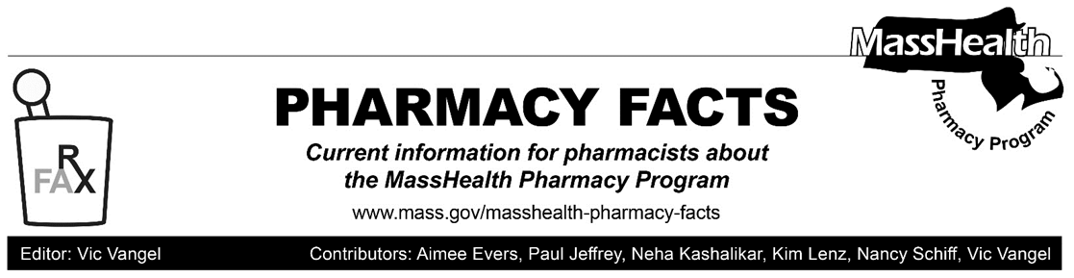
Coronavirus Disease 2019 (COVID-19) and New Policies on Chloroquine and Hydroxychloroquine—Effective for Dates of Service on or after March 26, 2020

In response to the coronavirus disease (COVID-19) outbreak, MassHealth is adopting new policies for the prescribing and dispensing of chloroquine and hydroxychloroquine. Pharmacy claims for chloroquine and hydroxychloroquine should process without a new prior authorization (PA) for individuals with existing prescriptions for lupus, malaria, or rheumatic conditions. If a rejection is encountered, please contact the Drug Utilization Review (DUR) program at (800) 745-7318 for further information. Consistent with All Provider Bulletin 289, in such circumstances pharmacies may dispense up to a 90-day supply if requested by a MassHealth member, Health Safety Net (HSN) patient, or prescriber as long as sufficient quantity remains on the prescription to support the quantity being filled.

Individuals who have or are suspected to have COVID-19, or who have new prescriptions for lupus, malaria, or rheumatic conditions, must go through a PA process before chloroquine and hydroxychloroquine can be dispensed. If a MassHealth member or HSN patient is approved for COVID-19, pharmacies must dispense up to a 14-day supply. If a MassHealth member or HSN patient is approved for other diagnoses, pharmacies may dispense up to a 90-day supply if requested by the MassHealth member, HSN patient, or prescriber as long as sufficient quantity remains on the prescription to support the quantity being filled.

Prescribers may request PA for chloroquine and hydroxychloroquine using the General Drug Prior Authorization Request form.

For further information about MassHealth coverage and reimbursement policy for services related to COVID-19, please review All Provider Bulletin 289, Pharmacy Facts #141, Pharmacy Facts #142, and LTSS Provider Information: Updates Related to the Coronavirus Disease 2019 (COVID-19) (Durable Medical Equipment Providers). Please also visit the MassHealth COVID-19 provider website as MassHealth continues to issue new guidance.

The policies described in this Pharmacy Facts are effective for dates of service or after March 26, 2020, and will remain effective for the duration of the state of emergency declared via Executive Order No. 591. These policies apply to all pharmacy claims processed through the Pharmacy Online Processing System (POPS), including claims for the HSN program.

