Number 144, April 1, 2020
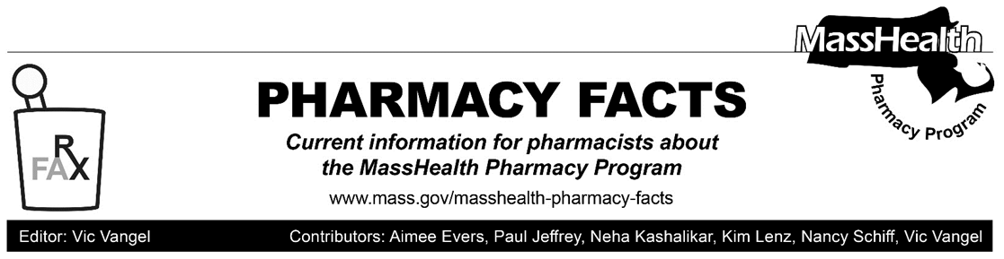
MHDL Update

Below are certain updates to the MassHealth Drug List (MHDL). See the MHDL for a complete listing of updates.

Additions
Effective April 6, 2020, the following newly marketed drugs have been added to the MassHealth Drug List.
- Amzeeq (minocycline foam) – PA
- Baqsimi (glucagon nasal powder) ^{PD}
- Brukinsa (zanubrutinib) – PA
- Drizalma (duloxetine sprinkle capsule) – PA
- Esperoct (factor VIII recombinant, glycopegylated-exei)
- Nourianz (istradefylline) – PA
- Oxbryta (voxelotor) – PA
- Padcev (enfortumab vedotin-ejfv) – PA
- Proair Digihaler (albuterol inhalation powder) – PA
- Relafen DS (nabumetone 1000 mg) – PA
- Secuado (asenapine transdermal) – PA
- Wakix (pitolisant) – PA
- Xenleta (lefamulin tablet) – PA
- Xenleta (lefamulin injection) – PA
Change in Prior-Authorization Status
- Effective March 26, 2020, the following antimalarials will require prior authorization.
- chloroquine phosphate – PA
- hydroxychloroquine – PA
- Effective April 6, 2020, the following antidepressants will no longer require prior authorization when used within newly established quantity limits. Pediatric Behavioral Health Medication Initiative criteria will still apply. For additional information, please see the Pediatric Behavioral Health Medication Initiative documents found at www.mass.gov/druglist.
- Aplenzin (bupropion hydrobromide extended-release) – PA < 6 years and PA > 30 units/month
- Pristiq # (desvenlafaxine succinate extended-release) – PA < 6 years and PA > 30 units/month
- Effective April 6, 2020, the following antidepressant will no longer require prior authorization when used within established quantity limits. Pediatric Behavioral Health Medication Initiative criteria will still apply. For additional information, please see the Pediatric Behavioral Health Medication Initiative documents found at www.mass.gov/druglist.
- Fetzima (levomilnacipran) – PA < 6 years and PA > 30 units/month
- Effective April 6, 2020, the following antidepressant will no longer require prior authorization. Pediatric Behavioral Health Medication Initiative criteria will still apply. For additional information, please see the Pediatric Behavioral Health Medication Initiative documents found at www.mass.gov/druglist.
- Sarafem # (fluoxetine 20 mg tablet for premenstrual dysphoric disorder) – PA < 6 years
- Effective April 6, 2020, the following intranasal corticosteroids will no longer require prior authorization when used within established quantity limits.
- Beconase AQ (beclomethasone nasal spray) – PA > 1 inhaler/month
- Zetonna (ciclesonide nasal aerosol, 37 mcg) – PA > 1 inhaler/month
- Effective April 6, 2020, the following immunosuppressant will require prior authorization.
- Envarsus XR (tacrolimus extended-release tablet) – PA
- Effective April 6, 2020, the following ulcerative colitis agents will no longer require prior authorization.
- Dipentum (olsalazine)
- Pentasa (mesalamine controlled-release)
- Effective April 6, 2020, the following antidiabetic agent will no longer require prior authorization.
- Trulicity (dulaglutide) ^{PD}
Updated MassHealth Brand Name Preferred Over Generic Drug List
The MassHealth Brand Name Preferred Over Generic Drug List has been updated to reflect recent changes to the MassHealth Drug List.
- Effective April 6, 2020, the following agent will be added to the MassHealth Brand Name Preferred Over Generic Drug List.
- Advair (fluticasone/salmeterol inhalation powder) ^{BP} – PA
- Daraprim (pyrimethamine) ^{BP} – PA
- Dymista (azelastine/fluticasone propionate) ^{BP}
b. Effective April 6, 2020, the following agents will be removed from the
MassHealth Brand Name Preferred
Over Generic Drug List.
- Solodyn # (minocycline extended-release 80 mg, 105 mg tablet)
- Treximet (sumatriptan/naproxen) – PA
- Uceris (budesonide extended-release
tablet) – PA
Legend

PA Prior authorization is required. The prescriber must obtain prior authorization for the drug in order for the pharmacy to receive payment. Note: PA applies to both the brand-name and the FDA “A”-rated generic equivalent of listed product.

# Designates a brand-name drug with FDA “A”-rated generic equivalents. Prior authorization is required for the brand, unless a particular form of that drug (for example, tablet, capsule, or liquid) does not have an FDA “A”-rated generic equivalent.

^{BP} Brand preferred over generic equivalents. In general, MassHealth requires a trial of the preferred drug or clinical rationale for prescribing the nonpreferred drug generic equivalent.

^{CO} This agent is listed on the Acute Hospital Carve-Out Drugs List and is subject to additional monitoring and billing requirements

^{PD} In general, MassHealth requires a trial of the preferred drug (PD) or a clinical rationale for prescribing a non-preferred drug within a therapeutic class.

