Number 145, April 28, 2020
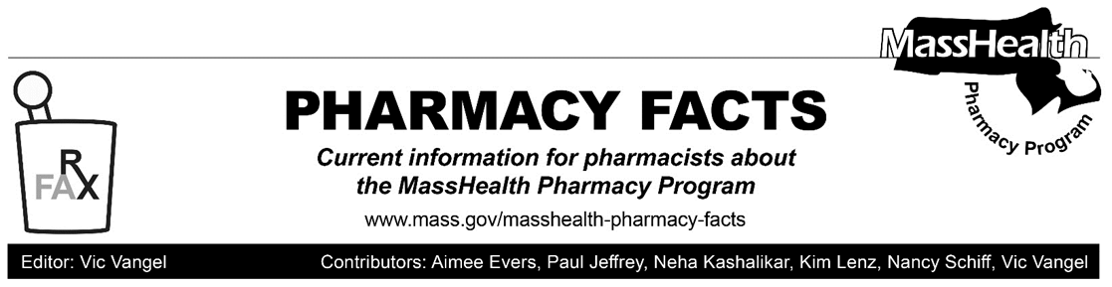
Additional Updates Related to Coronavirus Disease 2019 (COVID-19)—Effective Immediately

Prescription Delivery

To promote social distancing and to allow greater flexibility in providing patient care to MassHealth members who may be affected by COVID-19, MassHealth will make a payment adjustment to the professional dispensing fee when medications are delivered to a member’s personal residence (including homeless shelters). The payment adjustment will be the lower of the provider’s usual and customary charge for prescription delivery or $8.00, and will be made only when MassHealth is the primary payer.

Pharmacies may bill for home delivery through the Pharmacy Online Processing System
(POPS) using the following instructions if the requirements set forth in this Pharmacy Facts are met.
- Enter “01” in Other Amount Claimed Submitted Qualifier (NCPDP Field # 479-H8)
- Enter up to $8.00 in Other Amount Claimed Submitted (NCPDP Field 480-H9). Pharmacies should make sure that the delivery fee (NCPDP Field 480-H9) is reflected in provider billed amount (i.e., usual and customary and/or gross amount due). If the provider does not typically charge for home delivery, it would not be entitled to this delivery fee.
- If the claim receives payment associated with a delivery, the payment will be added to the Dispensing Fee Paid (NCPDP Field 507-F7).

MassHealth will pay the delivery fee to a provider only once per member per day regardless of the number of prescriptions being delivered. The fee is payable only for deliveries to members living in personal residences and is not payable for claims for members living in any type of institution or residential facility (except for homeless shelters).

For Pharmacies That Provide Durable Medical Equipment (DME)

Updated information for DME providers can be found at the following URL.

https://www.mass.gov/doc/ltss-provider-updates-for-covid-19/download

Streamlined PA Requirements for DME and Supplies and Oxygen/Respiratory Equipment and Supplies

MassHealth is lifting the requirement that providers obtain PA before delivering DME, oxygen/respiratory equipment, and supplies. While PA is not required before delivery, providers must continue to submit required documentation for PA requests and obtain PA for all services identified as subject to PA under MassHealth provider regulations at 130 CMR 409.000, 130 CMR 427.000, and 130 CMR 450.000; and as specified in the MassHealth DME and Oxygen Payment and Coverage Guideline Tool at https://www.mass.gov/info-details/masshealth-paymentand-coverage-guideline-tools. MassHealth will conduct a streamlined review for documentation required for processing PAs (e.g., manufacturer invoices) and issue PA approval notices based on provided documentation.

Instructions for Billing
Providers must submit for and obtain PA for all items subject to PA before submitting a claim for payment; otherwise, the claim will be denied. The requested start date on the PA should be on or before the date of delivery. This change is effective for dates of delivery on or after March 31, 2020.

The streamlined PA requirements DO NOT apply to the following.
- Mobility devices (including, but not limited to, manual wheelchairs, power wheelchairs, and accessories)
- Chest-wall oscillation/vest
- Alternative Augmentative Communication devices

