Number 146, May 11, 2020
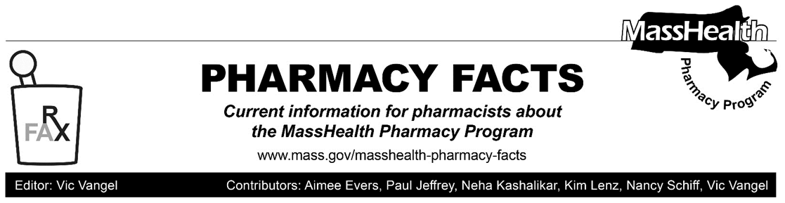
Claims for Additional Non-Drug Items Payable through POPS
As described below, pharmacies will be able to bill the Pharmacy Online Processing System for additional non-drug products effective May 18, 2020. These additional items are:
- Automatic blood pressure monitors
- Disposable syringe and needle units (in addition to insulin syringes already available for POPS claims)
- Peak flow meters
- Vaporizers
Please be aware that not all manufacturers of these products may provide information and identifying NDCs to First Data Bank, which in turn makes that information available to POPS. If a pharmacy submits a claim and receives a denial message that states, “54 - Non-Matched Product/Service ID Number,” it is because the NDC is not found in the system. If a pharmacy encounters this type of rejection, the pharmacy should dispense the same product from a different manufacturer and submit a new claim.
MHDL Update
Below are certain updates to the MassHealth Drug List (MHDL). See the MHDL for a complete listing of updates.
Additions
Effective May 18, 2020, the following newly marketed drugs have been added to the MHDL.

- Absorica LD (isotretinoin micronized) – PA
- Aklief (trifarotene) – PA
- Tramadol 100 mg – PA
Change in Prior-Authorization Status
- Effective May 18, 2020, the following inhaled corticosteroid will require prior authorization (PA).
- Alvesco (ciclesonide inhaler) – PA
  - Pulmicort (budesonide inhalation suspension) – PA
b. Effective May 18, 2020, the following anticoagulant will no longer require PA.
- Eliquis ((apixaban) ^{PD}
Updated MassHealth Brand Name Preferred Over Generic Drug List
The MassHealth Brand Name Preferred Over Generic Drug List has been updated to reflect recent changes to the MHDL.

- Effective May 18, 2020, the following agents will be added to the MassHealth Brand Name Preferred Over Generic Drug List.
- Proglycem (diazoxide) ^{BP}
- Zomig (zolmitriptan tablet) ^{BP} – PA
- Zovirax (acyclovir ointment) ^{BP} – PA

- Effective May 18, 2020, the following agent will be removed from the MassHealth Brand Name Preferred Over Generic Drug List.
- Uloric (febuxostat) – PA

Updated MassHealth Non-Drug Product List
Effective May 18, 2020, the following medical supplies will be added to the MassHealth Non-Drug Product List.
- Automatic blood pressure monitors
- Disposable syringe and needle units
- Peak flow meters
- Vaporizers
____________________________________
Legend

PA Prior authorization is required. The prescriber must obtain prior authorization for the drug in order for the pharmacy to receive payment. Note: PA applies to both the brand-name and the FDA “A”-rated generic equivalent of listed product.

^{BP} Brand preferred over generic equivalents. In general, MassHealth requires a trial of the preferred drug or clinical rationale for prescribing the nonpreferred drug generic equivalent.

^{PD} In general, MassHealth requires a trial of the preferred drug (PD) or a clinical rationale for prescribing a nonpreferred drug within a therapeutic class.

