Number 147, May 13, 2020
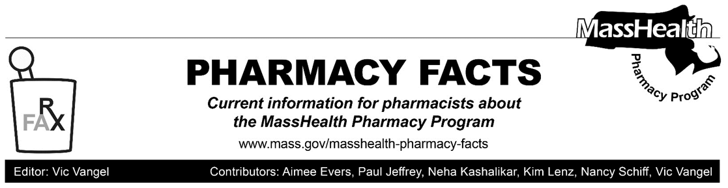

Additional Updates Related to Coronavirus Disease 2019 (COVID-19) for Pharmacies Serving Health Safety Net Patients – Effective Immediately

New Flexibility

Effective for dates of service beginning April 13, 2020, through May 18, 2020, Health Safety Net (HSN) patients who are unable to receive their medications from their regular HSN provider can temporarily have prescriptions filled by any pharmacy in the MassHealth provider network. Pharmacies are instructed to submit these claims through the Pharmacy Online Processing System (POPS), in accordance with the instructions below.

Billing

When a claim for an HSN patient is submitted by a pharmacy that is not already associated with an HSN provider with a Group ID of MASSHEALTH, the pharmacy will receive a claim denial 06 – M/I Group ID, with a message text ‘RESUBMIT CLAIM WITH HSN AS THE GROUP ID’. The pharmacy should then resubmit the claim after entering HSN in the Group ID field (NCPDP field #301-C1).

The HSN will also temporarily ease certain limits on HSN providers that directly operate both a 340B pharmacy and a retail pharmacy.
Specifically, for dates of service beginning April 13, 2020, and for the duration of the state of emergency declared by the Governor via Executive Order No. 591, and notwithstanding 101 CMR 613.03(2)(c), the HSN will temporarily remove the limit on the number of times an HSN provider may fill prescriptions for an HSN patient out of its retail (i.e., non-340B) stock, regardless of whether such patient is a regular patient of the HSN provider filling the prescription. Providers should note that this temporary flexibility will continue in effect after the option for HSN patients to use pharmacies that are not already associated with an HSN provider, as described above, expires on May 18, 2020. Please see EOHHS Administrative Bulletin 20-49 for additional information.

Notwithstanding these flexibilities, HSN providers are encouraged to continue serving their regular HSN patients when appropriate and safe to do so.

