Number 148, June 18, 2020
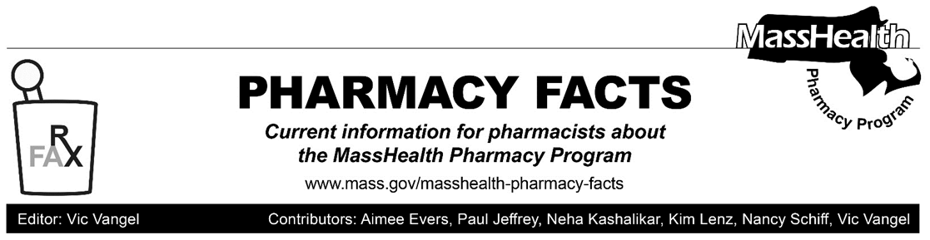

Pharmacy Copay Changes
MassHealth is revising its copay policies for certain services and members. Starting July 1, 2020, MassHealth members with an income at or below 50% of the federal poverty level (FPL) and MassHealth members categorically eligible for MassHealth because they are receiving other public assistance (“referred eligibles”) such as Supplemental Security Income (SSI), Transitional Aid to Families with Dependent Children (TAFDC), or services through the Emergency Aid to the Elderly, Disabled and Children (EAEDC) Program, will no longer be required to pay copays on drugs covered by MassHealth. Additionally, starting July 1, 2020, MassHealth members will not have to pay copays on:
- FDA-approved medications for detoxification and maintenance treatment of substance use disorders (SUD);
- preventive services rated Grade A and B by the US Preventive Services Task Force (USPSTF) or broader exclusions specified by MassHealth (e.g., low-dose aspirin; colonoscopy preparation); and
- vaccines and their administration recommended by the Advisory Committee on Immunization Practices (ACIP)².
MassHealth is updating regulation 130 CMR 450.000 accordingly. In addition, no copays apply to COVID-19 testing and treatment services for the duration of the national emergency.

Pharmacy providers will be able to see the new service and population exclusions as part of the claim response in the Pharmacy Online Processing System (POPS). The Eligibility Verification System (EVS) will not be updated to display any new or additional copay information as part of the
July 1, 2020, implementation.

Member Notifications of These Changes
MassHealth notified members impacted by the population exclusions (those with incomes at or under 50% FPL and “referred eligibles") in May 2020. Please note that while copays for SUD treatment, preventive services, and ACIP recommended vaccines will be eliminated for all members, this member notice was only sent to the members impacted by the population exclusions.

Pharmacy Copayment Poster Changes
The pharmacy copayment poster has been updated to reflect the new policy changes effective July 1, 2020, and can be found on the MassHealth Pharmacy Publications and Notices for Pharmacy Providers page, under the heading, Sample Copayment Poster.

Pharmacies are required by MassHealth regulations at 130 CMR 450.130(F) to post a notice about MassHealth copays in areas where copays are collected. The notice must
- be visible to the public and easily readable;
- specify the exclusions from the copay requirement listed in 130 CMR 450.130(D) and (E); and
- instruct members to inform providers if they believe they are excluded from the copay requirement.

For More Information
Please contact the MassHealth Pharmacy Technical Help Desk (available 24/7) at
(866) 246-8503 to understand the on-file demographics (e.g., date of birth) for the MassHealth, Children’s Medical Security Plan, or Health Safety Net member. However, please note that call center staff cannot change a member’s demographic information. Instead, the MassHealth member must contact the MassHealth Customer Service Team (CST) at (800) 841-2900 for assistance (Hours: Monday – Friday, excluding holidays, 8:00 a.m. – 5:00 p.m.).

As these ratings may be updated by the USPSTF. 2 As these recommendations may be updated by the ACIP.

