Number 149, June 26, 2020
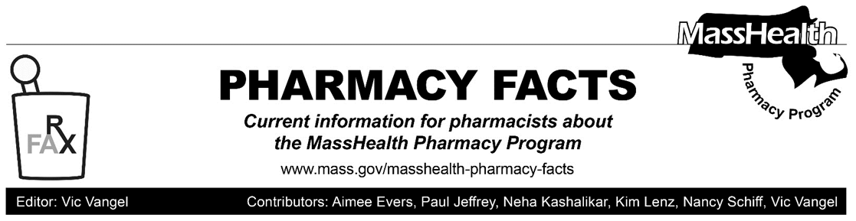

MHDL Update

Below are certain updates to the MassHealth Drug List (MHDL). See the MHDL for a complete listing of updates.

Additions
Effective June 29, 2020, the following newly marketed drugs have been added to the MassHealth Drug List.
- Ayvakit (avapritinib) – PA
- Caplyta (lumateperone) – PA
- Gvoke (glucagon auto-injection, prefilled syringe) – PA
- Jatenzo (testosterone undecanoate capsule) – PA
- Nexletol (bempedoic acid) – PA
- Palforzia (peanut allergen powder-dnfp) – PA
- Procysbi (cysteamine delayed-release granule) – PA
- Quzyttir (cetirizine injection) ^ – PA
- Recarbrio (imipenem/cilastatin/relebactam) – PA
- Reyvow (lasmiditan) – PA
- romidepsin - PA
- Ruxience (rituximab-pvvr) – PA
- Talicia (omeprazole/amoxicillin/rifabutin) – PA
- Tazverik (tazemetostat) – PA
- Truxima (rituximab-abbs) – PA
- Ubrelvy (ubrogepant) – PA
- Valtoco (diazepam nasal spray) – PA > 10 units/month

Change in Prior-Authorization Status
- Effective June 29, the following topical antiviral agents will no longer require prior authorization.
- Xerese (acyclovir/hydrocortisone)
- Zovirax (acyclovir cream, ointment) ^{BP}
- Effective June 29, the following triptan will no longer require prior authorization when used within established quantity limits.
- Zomig (zolmitriptan tablet) ^{BP} – PA > 18 units/month
- Effective June 29, the following ophthalmic anti-inflammatory agents will no longer require prior authorization.
- Acuvail (ketorolac 0.45% ophthalmic solution)
- Maxidex (dexamethasone ophthalmic suspension)
- Nevanac (nepafenac 0.1% ophthalmic suspension)
- Effective June 29, 2020, the following combination H. Pylori medication will no longer require prior authorization.
  - Pylera (bismuth subcitrate/metronidazole/tetracycline)
- Effective June 29, 2020, the following antiretroviral agent will no longer require prior authorization.
- Symtuza (darunavir/cobicistat/
emtricitabine/tenofovir alafenamide) ^{PD}
(continued)

Updated MassHealth Brand Name Preferred Over Generic Drug List

The MassHealth Brand Name Preferred Over Generic Drug List has been updated to reflect recent changes to the MassHealth Drug List.
- Effective June 29, 2020, the following agent will be added to the MassHealth Brand Name Preferred Over Generic Drug List.
- Kitabis Pak (tobramycin inhalation solution) ^{BP}
- Effective June 29, 2020, the following agent will be removed from the MassHealth Brand Name Preferred Over Generic Drug List.
- Coly-Mycin S (colistin/neomycin/
thonzonium/hydrocortisone)

Legend
^{PA} Prior authorization is required. The prescriber must obtain prior authorization for the drug in order for the pharmacy to receive payment. Note: PA applies to both the brand- name and the FDA “A”-rated generic equivalent of listed product.
# Designates a brand-name drug with FDA “A”-rated generic equivalents. Prior authorization is required for the brand, unless a particular form of that drug (for example, tablet, capsule, or liquid) does not have an FDA “A”-rated generic equivalent.
^{BP} Brand preferred over generic equivalents. In general, MassHealth requires a trial of the preferred drug or clinical rationale for prescribing the nonpreferred drug generic equivalent.
^{PD} In general, MassHealth requires a trial of the preferred drug (PD) or a clinical rationale for prescribing a nonpreferred drug within a therapeutic class.
^{CO} Carve-Out. This agent is listed on the Acute Hospital Carve-Out Drugs List and is subject to additional monitoring and billing requirements

Food Assistance Resources for MassHealth Members

As a result of the COVID-19 pandemic, a growing number of individuals and families across Massachusetts are facing food insecurity, many for the first time. MassHealth, in partnership with other state agencies and food non-profit organizations, has developed a simple guide that you can use to help identify MassHealth patients who need food assistance and connect them to resources in the community. Those food assistance resources can provide your patients with immediate access to food, as well as recurring financial support for the purchase of food.
- Patient-facing food assistance handout, which provides information about available resources. The handout can be printed and given to patients, or if you are connecting with patients via phone, text, or email, you can provide patients a link for this handout:
  - English version: https://www.mass.gov/doc/food-assistance-during-the-covid-19-emergency/download
  - Spanish version: https://www.mass.gov/doc/asistencia-alimentaria-durante-la-emergencia-por-covid-19/download
  - You can find accessible versions for this handout here (English) and here (Spanish)
- Provider-facing guide to help you better understand how to identify patients who need food assistance and the resources available to help them.
  - English version: https://www.mass.gov/doc/connecting-your-patients-with-food-resources/download
  - Spanish version: https://www.mass.gov/doc/como-conectar-a-sus-pacientes-con-recursos-de-alimentos/download
  - You can find accessible versions for this guide here (English) and here (Spanish)
We hope that this information will be helpful to your MassHealth patients who need food assistance. If you have any questions about these resources, please call the Project Bread FoodSource Hotline at 1-800-645-8333.

