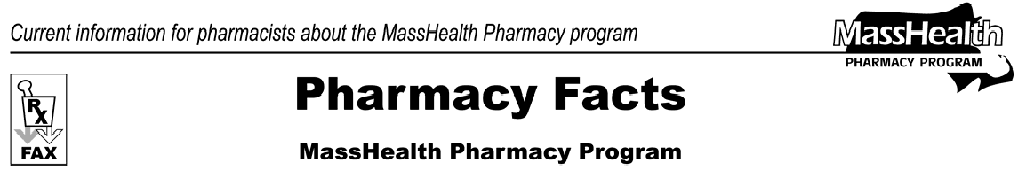
Number 15
December 30, 2005
- Editor: Vic Vangel • Contributors: Chris Burke, Gary Gilmore, Paul Jeffrey, James Monahan •

Medicare Part D Prescription Drug Coverage Update
In our last fax we told you that legislation was pending to provide additional coverage to dually eligible MassHealth members. The legislation, “An act providing emergency prescription drug coverage for seniors and the disabled” (S2310), has been signed and will be put into effect on January 1. This bill provides “wrap-around” benefits for copay and nonformulary drugs for MassHealth and Prescription Advantage members under certain conditions. These wrap-around benefits will continue from January 1 until June 30, 2006. This issue of Pharmacy Facts deals only with the MassHealth portions of the bill.
Copay: Approximately 30,000 dually eligible MassHealth members will be responsible for copay charges of $2.00 for generic drugs and $5.00 for brand-name drugs under their Part D plans (as opposed to the majority of members who will be assessed $1.00 and $3.00 copays.) Part of the legislation is designed to ensure that these members are not responsible for a higher copay under Medicare Part D than they were under MassHealth. To achieve this, pharmacies will need to submit claims to MassHealth as a secondary payer when a dually eligible member is assessed a copay greater than the
$1.00 for generics and $3.00 for brands that they presently are responsible for. For example, if a pharmacist processes a claim for a brand-name drug and receives a response to collect a $5.00 copay from the member from the Medicare D plan, the pharmacist would then submit a claim to MassHealth as a secondary payer. The pharmacy would submit the claim using Other Coverage Code “08” (billing for copay) and show gross amount due as $5.00.
MassHealth will pay the pharmacy $2.00 and the member will still be responsible for $3.00. On a

Medicare Part D Prescription Drug Coverage Update (cont.)
claim submitted for copay only, the MassHealth wrap- around copay is limited to $1.00 for generics if the submitted amount is not over $2.00, and up to $3.00 for brands if the submitted amount is over $2.00.
Formulary: The other change required by this legislation ensures that a dually eligible member has the ability to receive a prescription that may not be part of their Medicare Part D plan’s formulary during a six-month transition period ending on 6/30/2006.
Please remember that all of the Medicare Part D prescription drug plans have their own transition policies in place. If a pharmacy is not able to fill a prescription for a dually eligible member because a drug is not included on the Part D plan’s formulary, the pharmacy may bill MassHealth as a secondary payer after exhausting the Part D transition plan. In this case the pharmacist would bill MassHealth as a secondary payer using an appropriate Other Coverage Code and corresponding Other Payer Reject Code. This procedure can be used once for up to a 30-day supply of the drug. If after the 30-day supply is given and the Part D plan still denies a claim for the same medication, a pharmacist may bill MassHealth once for a 72-hour supply of medication by using Level-of- Service Code “03” (emergency fill). We expect the transition plans put in place by the Medicare Part D plans to accommodate most of these situations; however, MassHealth will be available as a secondary payer if needed.
Medicare Part B: There is no change in how MassHealth pays for products covered under Medicare Part B. MassHealth will continue to act as a secondary payer for these services.

Please direct any questions or comments (or to be taken off of this fax distribution) to
Victor Moquin of ACS at 617-423-9830.

