Number 150, July 13, 2020
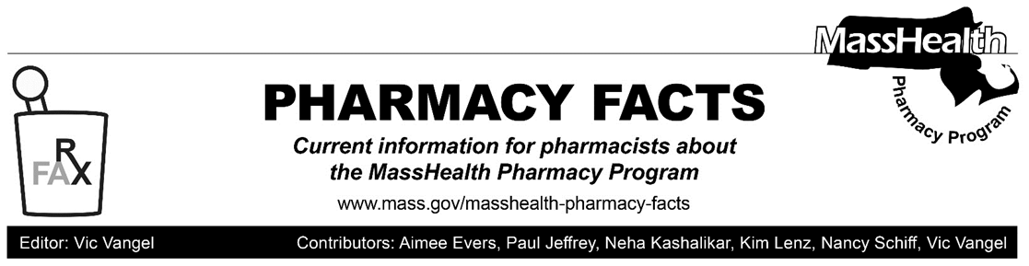
Additional Updates Related to Coronavirus Disease 2019 (COVID-19)

In response to the coronavirus disease (COVID-19) outbreak, MassHealth had announced certain temporary policy changes to provide greater flexibility in providing patient care to MassHealth members. In light of changing conditions, with this Pharmacy Facts, MassHealth is ending the policy changes listed below.

Notwithstanding these changes, and consistent with 130 CMR 406.411(B), MassHealth reminds pharmacists that emergency overrides are available in certain circumstances. When the pharmacist determines that an emergency exists, the MassHealth agency will pay the pharmacy for at least a 72-hour, nonrefillable supply of the drug in compliance with state and federal regulations. To obtain an emergency override, pharmacists should contact the Drug Utilization Review Program at (800) 745-7318 during normal business hours. If outside business hours, pharmacies may submit an emergency override claim with a value of “03” for Level of Service (field 418). After the prescription is adjudicated, the pharmacy should remove the “03” from the level of service field before the next fill.

Early Refills
In Pharmacy Facts #141, MassHealth implemented the following policy change.

“Effective for dates of service beginning March 14, 2020, MassHealth will allow early refills of existing prescriptions for drugs as long as at least one refill remains on the prescription. If a pharmacy receives a denial for an early refill, the pharmacy should place a “13” in the Submission Clarification field (NCPDP field 420-DK) to override the denial.”

Effective July 15, 2020, MassHealth will no longer allow early refills of existing prescriptions for drugs.
Prior Authorization (PA) Requirements for Certain Drugs
In Pharmacy Facts #142, MassHealth implemented the following policy change.
“MassHealth is temporarily removing PA requirements for the following drugs and drug classes.
- Aminoglycoside Agents—Inhaled
- Antibiotics—Oral and Injectable
- Antifungals—Oral and Injectable
- Respiratory Agents—Oral and Inhaled
- Sublocade
Accordingly, and notwithstanding any contrary requirements in the MassHealth Drug List, prescribers do not have to obtain PA for those drugs; and pharmacies should fill and dispense these prescriptions without any PA requirement.”
Effective July 15, 2020, PA requirements for these classes of drugs will be reinstated, except that PA requirements will not be reinstated for Sublocade. PA removal for Sublocade will remain in effect consistent with Pharmacy Facts #142.
Extension of Existing PAs
In Pharmacy Facts #142, MassHealth implemented the following policy change.

“MassHealth is working to identify and extend PAs that are due to expire in the coming weeks. MassHealth anticipates that, where appropriate, these existing PAs will be extended for up to another 60 days from the date of expiration.

Notwithstanding this initiative, pharmacies should continue to outreach to prescribers in the event a new PA is required.”

This initiative is no longer in effect and MassHealth is not extending PAs that are due to expire.

Pharmacies should expect to receive additional updates in the future regarding other temporary policy changes that have been put in place to address the COVID-19 outbreak.

