Number 151, August 4, 2020
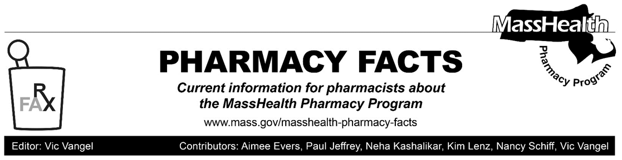

MHDL Update

Below are certain updates to the MassHealth Drug List (MHDL). See the MHDL for a complete listing of updates.

Additions

Effective August 10, 2020, the following newly marketed drugs have been added to the MassHealth Drug List.
- Arazlo (tazarotene lotion) – PA
- Avsola (infliximab-axxq) – PA
- Darzalex Faspro (daratumumab-hyaluronidase-fihj) – PA
- Dayvigo (lemborexant) – PA
- Enhertu (fam-trastuzumab deruxtecan-nxki) – PA
- Etopophos (etoposide phosphate) – PA
- Fetroja (cefiderocol) – PA
- Nexlizet (bempedoic acid/ezetimibe) – PA
- Nurtec (rimegepant) – PA
- Sarclisa (isatuximab-irfc) – PA
- Trijardy XR (empagliflozin/linagliptin/metformin extended-release) – PA
- Trodelvy (sacituzumab govitecan-hziy) – PA
- Tukysa (tucatinib) – PA
- Xcopri (cenobamate) – PA

Updated MassHealth Brand Name Preferred Over Generic Drug List

The MassHealth Brand Name Preferred Over Generic Drug List has been updated to reflect recent changes to the MassHealth Drug List.

Effective August 10, 2020, the following agent will be removed from the MassHealth Brand Name Preferred Over Generic Drug List.
- Zomig # (zolmitriptan tablet) – PA > 18 units/month

Abbreviations, Acronyms, and Symbols

# This designates a brand-name drug with FDA “A”-rated generic equivalents. Prior authorization is required for the brand, unless a particular form of that drug (for example, tablet, capsule, or liquid) does not have an FDA “A”-rated generic equivalent.
PA Prior authorization is required. The prescriber must obtain prior authorization for the drug in order for the pharmacy to receive payment. Note: Prior authorization applies to both the brand-name and the FDA “A”-rated generic equivalent of listed product.

Thank You to MassHealth Providers

COVID-19 has touched every corner of our Commonwealth, and while we have seen the devastating impact of the virus on many of our communities, we have also seen health care providers rise to the occasion to provide care and comfort to patients and support critical public health efforts to keep Massachusetts residents safe.
On behalf of everyone at MassHealth, we want to extend our gratitude to you, our provider community, during this unprecedented and challenging time.

Many providers have been on the frontlines of the COVID-19 public health emergency, providing preventive care and educating patients about staying safe during the pandemic, providing direct care to individuals sick with COVID-19, continuing to ensure access to essential emergency and institutional care, and comforting patients, families, and staff who are mourning every tragic loss of life. Others have seen their practice dramatically shift in response to COVID-19, whether that involved transitioning much of their care to telehealth services, finding unique ways to reach members, and temporarily deferring and delaying non-essential treatment as a necessary public health measure. We recognize that for many providers these have been an especially challenging three months, and we appreciate your continued dedication to serving MassHealth members.
As we move forward in reopening the Commonwealth, the participation and support of our provider community will be critical. We are working with our colleagues across Health and Human Services, and in coordination with you and the rest of the provider community, to establish thoughtful guidelines for this work.
Again, we appreciate your support and dedication to our members and look forward to our continued partnership through the COVID-19 pandemic and beyond.

Sincerely,

Amanda Cassel Kraft
Acting Medicaid Director

