Number 152, September 4, 2020
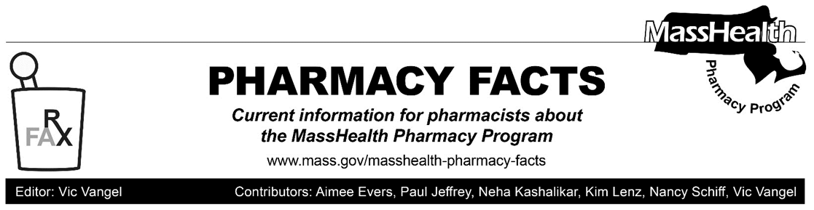
Off-Cycle Update to MassHealth Brand Name Over Generic Drug List
Effective September 8, 2020, the following agent will be added to the MassHealth Brand Name Preferred Over Generic Drug List.
- Tecfidera (dimethyl fumarate)^{BP} − PA

This update will be reflected in the next regular update to the MassHealth Drug List, expected September 21, 2020.

Notice of Eli Lilly’s Limited Distribution to 340B Covered Entities and their Contract Pharmacies
Effective September 1, 2020, Eli Lilly has indicated that they will no longer allow 340B covered entities to purchase their products at 340B prices to distribute to their contract pharmacies. To minimize impact on patients due to this action, pharmacy providers with affected MassHealth members or Health Safety Net patients should reach out to the member’s or patient’s provider to obtain a new prescription for an alternative product. Providers should contact Eli Lilly at 340B@Lilly.com with questions, concerns, or to inquire about their Special Exception for Insulins. Pharmacy providers should call MassHealth DUR at (800) 745-7318 if they encounter any billing issues for an alternative product.
Legend

PA Prior authorization is required. The prescriber must obtain prior authorization for the drug in order for the pharmacy to receive payment. Note: PA applies to both the brand-name and the FDA “A”-rated generic equivalent of listed product.

^{BP} Brand preferred over generic equivalents. In general, MassHealth requires a trial of the preferred drug or clinical rationale for prescribing the non-preferred drug generic equivalent.

