Number 154, October 8, 2020
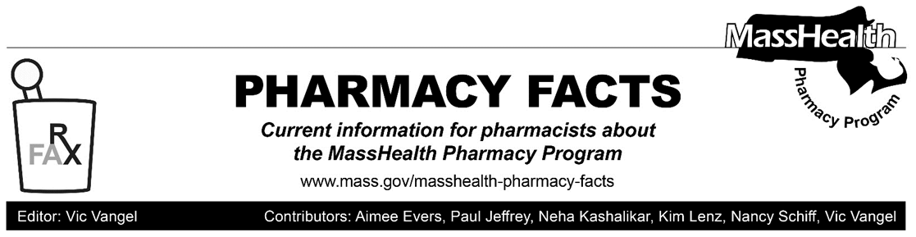
Additional Update Related to Coronavirus Disease 2019 (COVID-19)

In response to the coronavirus disease (COVID-19) outbreak, MassHealth had announced certain temporary policy changes to provide greater flexibility in providing patient care to MassHealth members. In light of changing conditions, with this Pharmacy Facts, MassHealth is ending the policy change listed below.

Notwithstanding this change, and consistent with 130 CMR 406.411(B), MassHealth reminds pharmacists that emergency overrides are available in certain circumstances. When the pharmacist determines that an emergency exists, the MassHealth agency will pay the pharmacy for at least a 72-hour, nonrefillable supply of the drug in compliance with state and federal regulations. To obtain an emergency override, pharmacists should contact the Drug Utilization Review Program at (800) 745-7318 during normal business hours. If outside business hours, pharmacies may submit an emergency override claim with a value of “03” for Level of Service (field 418). After the prescription is adjudicated,
the pharmacy should remove the “03” from the level of service field before the next fill.
Albuterol Inhalers
In Pharmacy Facts #142, MassHealth implemented the following policy change.
“MassHealth is temporarily removing the requirement to use brand name ProAir when dispensing an albuterol inhaler. Claims for both branded ProAir inhalers and generic equivalents will be accepted. When dispensing either drug, the pharmacy should enter a DAW code of ‘0’.”

Effective October 12, 2020, the requirement to dispense brand name ProAir will be reinstated.
Pharmacies should expect to receive additional updates in the future regarding other temporary policy changes that have been put in place to address the COVID-19 outbreak.

