Number 156, October 27, 2020
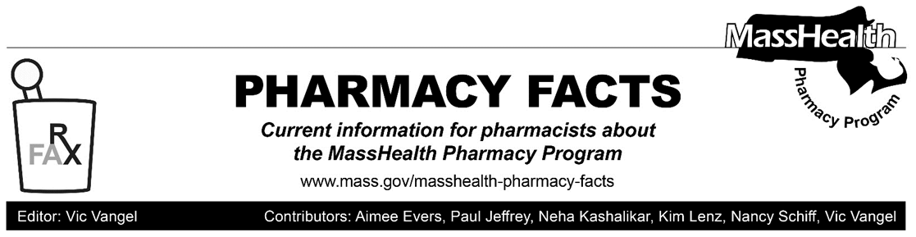
MHDL Update

Below are certain updates to the MassHealth Drug List (MHDL). See the MHDL for a complete listing of updates.

Additions

Effective November 2, 2020, the following newly marketed drugs have been added to the MassHealth Drug List.

- Fintepla (fenfluramine) – PA
- Isturisa (osilodrostat) – PA
- Koselugo (selumetinib) – PA
- Menquadfi (quadrivalent meningococcal conjugate vaccine) ¹
- Qinlock (ripretinib) – PA
- Semglee (insulin glargine) – PA
- teriparatide 620 mcg/2.48 mL – PA
- Zerviate (cetirizine ophthalmic solution) – PA
Change in Prior-Authorization Status
- Effective November 2, 2020 the following ophthalmic anti-allergy agents will no longer require prior authorization (PA).
- Alocril (nedocromil)
- Alomide (lodoxamide)
- Bepreve (bepotastine)
- Lastacaft (alcaftadine)
- Effective November 2, 2020, the following osteoporosis and bone metabolism agents will no longer require PA.
- alendronate solution
- Boniva # (ibandronate tablet)
- Effective November 2, 2020, the following oncology agent will require PA.
- Aczone (dapsone 7.5% gel) – PA
Updated MassHealth Brand Name Preferred Over Generic Drug List
- Effective November 2, 2020, the following agents will be added to the MassHealth Brand Name Preferred Over Generic Drug List.
- Bethkis (tobramycin inhalation solution) ^{BP} – PA
- Kuvan ^{BP} – PA
- Lialda (mesalamine delayed-release) ^{BP}
- Monurol (fosfomycin) ^{BP}
- Strattera (atomoxetine) ^{BP} – PA < 6 years (sapropterin)
- Tykerb (lapatinib) ^{BP}
- Effective November 2, 2020, the following agent will be removed from the MassHealth Brand Name Preferred Over Generic Drug List.
- Aczone (dapsone 7.5% gel) – PA
____________________________________
Legend

PA Prior authorization is required. The prescriber must obtain PA for the drug in order for the pharmacy to receive payment. Note: PA applies to both the brand-name and the FDA “A”-rated generic equivalent of listed product.

# Designates a brand-name drug with FDA “A”-rated generic equivalents. PA is required for the brand, unless a particular form of that drug (for example, tablet, capsule, or liquid) does not have an FDA “A”-rated generic equivalent.

^{BP} Brand preferred over generic equivalents. In general, MassHealth requires a trial of the preferred drug or clinical rationale for prescribing the nonpreferred drug generic equivalent.

¹ Product may be available through the Massachusetts Department of Public Health (DPH). Please check with DPH for availability. MassHealth does not pay for immunizing biologicals (i.e., vaccines) and tubercular (TB) drugs that are available free of charge through local boards of public health or through the Massachusetts DPH without PA (130 CMR 406.413(C)). In cases where free vaccines are available to providers for specific populations (e.g., children, high risk, etc.), MassHealth will reimburse the provider only for individuals not eligible for the free vaccines. Notwithstanding the above, MassHealth will pay pharmacies for seasonal flu vaccine serum without PA, if the vaccine is administered in the pharmacy.

