Number 157, December 1, 2020
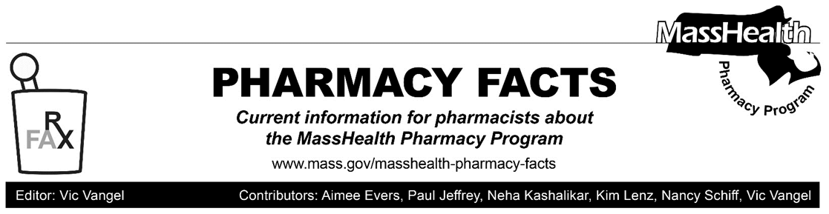

Additional Updates Related to Coronavirus Disease 2019 (COVID-19) – Effective Immediately

Days’ Supply Limitations for Drugs Used for Family Planning

Despite the requirements of 130 CMR 406.411(D)(1): Days’ Supply Limitation, pharmacies may dispense up to a 365-day supply of drugs used for family planning if requested by a MassHealth member or that member’s prescriber as long as sufficient quantity remains on the prescription to support the quantity being filled.

MassHealth anticipates extending this requirement permanently consistent with the amendments to 130 CMR 406.000: Pharmacy Services proposed on November 29, 2019, and currently pending final promulgation.

Claims Processing Reminder for Pharmacies Servicing Health Safety Net Patients

Many Health Safety Net (HSN) patients also have MassHealth Limited coverage. MassHealth Limited provides emergency health services to people who have an immigration status that prevents them from obtaining other coverage. MassHealth Limited provides coverage for antibiotics for MassHealth Limited members.

HSN is always a payer of last resort. If an individual has other insurance, coverage, or other available payer options, providers must bill the individual’s primary insurance or other available payer before billing HSN. Such coverage includes but is not limited to
- commercial insurance;
- MassHealth (including Limited);
- Medicare;
- coverage through the Health Connector; or
- Children's Medical Security Plan,

For pharmacies, this means that claims should be submitted to MassHealth before being submitted to HSN. This is especially relevant for MassHealth Limited members receiving a prescription for an antibiotic, because, as noted above, antibiotics are covered for members with MassHealth Limited coverage.

As a reminder, the value entered in the Group ID field in the Pharmacy Online Processing System (POPS) directs the claim to the proper program. Claims must contain a Group ID (field #301-C1) of either “MassHealth” for individuals eligible for Massachusetts Medicaid; “CMSP” for individuals eligible for Children’s Medical Security Plan; or “HSN” for Pharmacies enrolled in the HSN program.

