Number 158, December 18, 2020
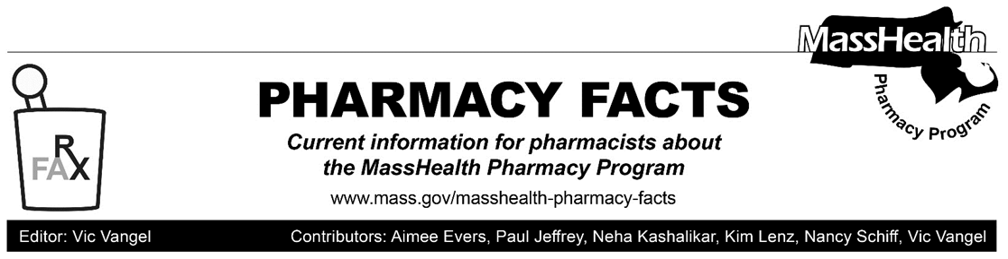
MHDL Update

Below are certain updates to the MassHealth Drug List (MHDL). See the MHDL for a complete listing of updates.

Additions

- Effective December 21, 2020, the following newly marketed drugs have been added to the MassHealth Drug List.
- Airduo Digihaler (fluticasone/salmeterol inhalation powder) – PA
- Armonair Digihaler (fluticasone propionate inhalation powder) – PA
- Breztri (budesonide/glycopyrrolate/formoterol) – PA
- Dojolvi (triheptanoin) – PA
- Durysta (bimatoprost implant) – PA
- Kynmobi (apomorphine film) – PA
- Luxturna (voretigene neparvovec) ^{CO} ^ – PA
- Lyumjev (insulin lispro) – PA
- Monjuvi (tafasitamab-cxix) – PA
- Ortikos (budesonide extended-release capsule) – PA
- Rukobia (fostemsavir) ^{PD} – PA
- Tecartus (brexucabtagene autoleucel) ^{CO} ^ – PA
- Vyondys 53 (golodirsen) – PA
- Effective January 1, 2021, the following newly marketed drugs have been added to the MassHealth Drug List.
- Givlaari (givosiran) ^{PD} – PA
- Effective for the dates listed below, the following COVID-19 treatment and preventive therapies have been added to the MassHealth Drug List as of December 13, 2020.
- bamlanivimab (COVID EUA – November 10, 2020)
- casirivimab (COVID EUA – November 21, 2020)
- imdevimab (COVID EUA – November 21, 2020)
- Olumiant (baricitinib COVID EUA – November 19, 2020) ^{H}
- Pfizer COVID19 Vaccine (COVID EUA – December 11, 2020)
- Veklury (remdesivir – October 22, 2020) ^{H}

Change in Prior Authorization Status

- Effective December 21, 2020, the following antiemetic will no longer require prior authorization (PA).
- Transderm-Scop (scopolamine transdermal patch) ^{BP}
- Effective December 21, 2020, the following antiemetic will no longer require PA within newly established quantity limits.
- granisetron tablet – PA > 2 tablets/28 days
- Effective December 21, 2020, the following antiemetic will require PA when exceeding newly established quantity limits.
- Emend (fosaprepitant injection) – PA > 2 vials/28 days ^{BP}
- Effective December 21, 2020, the following antiemetic will require PA.
  - Cinvanti (aprepitant injectable emulsion) – PA
- Effective December 21, 2020, the following glaucoma agent will no longer require PA.
- Lumigan (bimatoprost 0.01% ophthalmic solution)
- Effective December 21, 2020, the following Alzheimer’s agents will no longer require PA within quantity limits. Pediatric Behavioral Health Medication Initiative criteria will still apply. For additional information, please see the Pediatric Behavioral Health Medication Initiative documents found at www.mass.gov/druglist.
- Aricept # (donepezil 23 mg tablet) – PA < 6 years and PA > 1 unit/day
- Namzaric (memantine/donepezil extended-release) – PA < 6 years and PA > 1 unit/day
- Namenda XR # (memantine extended-release) ^{BP} – PA < 6 years and PA > 1 unit/day
- Effective December 21, 2020, the following Alzheimer’s agent will no longer require PA within quantity limit.
  - Exelon # (rivastigmine patch) – PA > 1 unit/day
- Effective December 21, 2020, the following Alzheimer’s agents will no longer require PA below age limits.
  - Razadyne ER # (galantamine extended-release capsule) – PA > 1 unit/day
  - rivastigmine capsule – PA > 2 units/day

Updated MassHealth Non-Drug Product List

Effective January 1, 2021, the following medical supplies will be added to the MassHealth Non-Drug Product List.
- Dexcom G6 and Freestyle Libre continuous glucose monitors used for the management of diabetes – PA

Updated MassHealth Brand Name Preferred Over Generic Drug List

The MassHealth Brand Name Preferred Over Generic Drug List has been updated to reflect recent changes to the MassHealth Drug List.

- Effective December 21, 2020, the following agents will be added to the MassHealth Brand Name Preferred Over Generic Drug List.
- Banzel (rufinamide) ^{BP} – PA
- Emend (fosaprepitant injection) ^{BP} – PA > 2 vials/28 days
- Tirosint (levothyroxine) ^{BP}
- Vascepa (icosapent ethyl) ^{BP} – PA
- Effective December 21, 2020, the following agent will be removed from the MassHealth Brand Name Preferred Over Generic Drug List.
- Tarceva (erlotinib) – PA
____________________________________
Legend

PA Prior authorization is required. The prescriber must obtain prior authorization for the drug in order for the pharmacy to receive payment. Note: PA applies to both the brand-name and the FDA “A”-rated generic equivalent of listed product.

# Designates a brand-name drug with FDA “A”-rated generic equivalents. Prior authorization is required for the brand, unless a particular form of that drug (for example, tablet, capsule, or liquid) does not have an FDA “A”-rated generic equivalent.

^{BP} Brand preferred over generic equivalents. In general, MassHealth requires a trial of the preferred drug or clinical rationale for prescribing the nonpreferred drug generic equivalent.

^{H} Available only in an inpatient hospital setting. MassHealth does not pay for this drug to be dispensed through the retail pharmacy or physician's office.

^{PD} In general, MassHealth requires a trial of the preferred drug (PD) or a clinical rationale for prescribing a nonpreferred drug within a therapeutic class.

^{CO} Carve-Out. This agent is listed on the Acute Hospital Carve-Out Drugs List and is subject to additional monitoring and billing requirements.
^ Available through the health care professional who administers the drug. MassHealth does not pay for this drug to be dispensed through a retail pharmacy.

