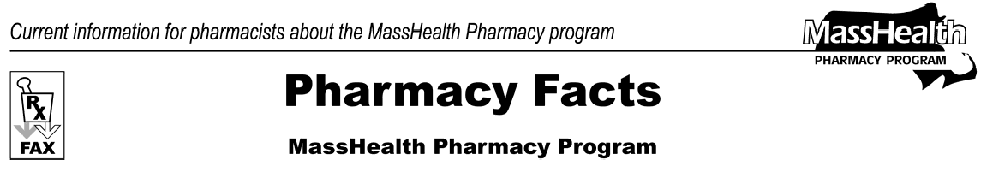
Number 16
January 9, 2006
- Editor: Vic Vangel • Contributors: Chris Burke, Gary Gilmore, Paul Jeffrey, James Monahan •

Medicare Part D Prescription Drug Update
URGENT - - Due to widespread and systemic problems across the Commonwealth with the implementation of Medicare Part D drug coverage for MassHealth members, as of January 7, 2006, MassHealth will allow pharmacies to bill MassHealth for outpatient prescription drugs for individuals with both Medicare and MassHealth. You must try to bill an individual’s Medicare Part D plan as the primary
payer. However, when all else fails, pharmacies may bill MassHealth directly.
This is a temporary, short-term solution in response to an emergency situation that threatens the health and well-being of MassHealth's members. This step ensures that individuals with both Medicare and MassHealth receive their needed medications until the Medicare Part D program and associated systems are operational. MassHealth will closely track the progress of improvements to Medicare Part D processes, and over the coming days and weeks will regularly re-assess the need for this temporary solution.
This fax clarifies the process that pharmacies will follow to ensure coverage of medications for individuals with MassHealth and Medicare. No dually eligible person should leave a pharmacy without his or her medications, if she/he has an otherwise valid prescription that MassHealth would otherwise pay for. MassHealth policies and regulations governing prescriptions (e.g., the MassHealth Drug List, prior authorization, etc.) will remain in force.
Follow these steps:
- Confirm MassHealth eligibility (MassHealth card, MassHealth letter, or history of billing to MassHealth).
Medicare Part D Prescription Drug Update
(cont.)
- Check for Medicare eligibility and Part D enrollment through the E1 query process. For E1 query problems call 1-866-835-7595. Note: MassHealth does not have the current Part D enrollment information for dual beneficiaries immediately accessible for pharmacies.
- If the E1query shows enrollment in a Part D plan, bill that plan or contact the plan for billing information. Note: Dually eligible persons should never be assessed a copayment higher than $5. If you see a higher copayment, the Part D plan must assist you with overriding the higher copayment.
- If the E1 query shows that the individual is not enrolled in a drug plan or if the E1 query fails, bill the Wellpoint/Anthem contingency plan. For information on billing Wellpoint call 1-800-662-0210.
- If the claim cannot be billed to the primary Medicare Part D plan or to WellPoint/Anthem, the claim can be billed to MassHealth.

Please direct any questions or comments (or to be taken off of this fax distribution) to
Victor Moquin of ACS at 617-423-9830.

