Number 161, February 4, 2021
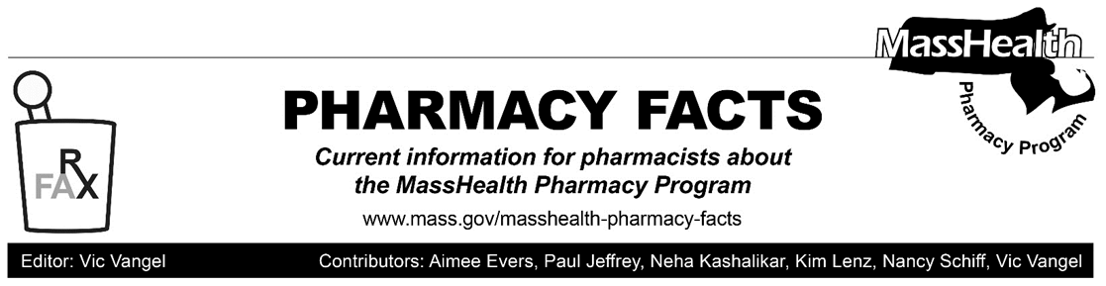
MHDL Update

Below are certain updates to the MassHealth Drug List (MHDL). See the MHDL for a complete listing of updates.

Additions
- Effective February 8, 2021, the following newly marketed drugs have been added to the MassHealth Drug List.
- Enspryng (satralizumab-mwge) – PA
- Evrysdi (risdiplam) – PA
- Kesimpta (ofatumumab prefilled syringe) – PA
- Ongentys (opicapone) – PA
- Onureg (azacitidine tablet) – PA
- pretomanid – PA
- Twirla (levonorgestrel/ethinyl estradiol patch)
- Uplizna (inebilizumab-cdon) – PA
- Vaxelis (diphtheria/tetanus/acellular pertussis/poliovirus inactivated/haemophilus B conjugate/hepatitis B vaccine)¹
- Vumerity (diroximel fumarate) – PA
- Effective for the date listed below, the following COVID-19 preventative therapy has been added to the MassHealth Drug List on December 19, 2020.
- Moderna COVID-19 Vaccine (COVID EUA – December 18, 2020)
Change in Prior-Authorization Status
- Effective February 8, 2021, the following inhaled respiratory agents will no longer require prior authorization (PA).
- Advair (fluticasone/salmeterol inhalation aerosol)
- Advair (fluticasone/salmeterol inhalation powder) ^{BP}
- Dulera (mometasone/formoterol)
- Symbicort (budesonide/formoterol) ^{BP}
- Effective February 8, 2021, the following inhaled respiratory agent will no longer require PA within the newly established age limit.
- Pulmicort # (budesonide inhalation suspension) – PA
- Effective February 8, 2021, the following inhaled respiratory agents will no longer require PA for use above quantity limits.
- Incruse (umeclidinium)
- Seebri (glycopyrrolate inhalation powder)
- Spiriva (tiotropium)
- Tudorza (aclidinium)
Updated MassHealth Brand Name Preferred Over Generic Drug List
The MassHealth Brand Name Preferred Over Generic Drug List has been updated to reflect recent changes to the MassHealth Drug List.
- Effective February 8, 2021, the following agents will be added to the MassHealth Brand Name Preferred Over Generic Drug List.
- Afinitor Disperz (everolimus tablets for oral suspension) ^{BP} – PA
- Amitiza (lubiprostone) ^{BP} – PA
- Androgel (testosterone 1.62% gel pump) ^{BP} – PA
- Antara (fenofibrate 30 mg, 90 mg capsule) ^{BP}
- Brovana (arformoterol) ^{BP} – PA
- Bystolic (nebivolol) ^{BP}
- Cayston (aztreonam) ^{BP}
- Chantix (varenicline) ^{BP}
- Daliresp (roflumilast) ^{BP} – PA
- Durezol (difluprednate) ^{BP} – PA
- Forteo (teriparatide 600 mcg/2.4 mL) ^{BP} – PA
- Fycompa (perampanel tablet) ^{BP} – PA
- Intelence (etravirine) ^{BP}
- Jevtana (cabazitaxel) ^{BP} – PA
- Jublia (efinaconazole) ^{BP} – PA
- Lyrica CR (pregabalin extended-release) ^{BP} – PA
- Narcan (naloxone nasal spray) ^{BP}
- Neupro (rotigotine transdermal system) ^{BP} – PA
- Osmoprep (sodium phosphate) ^{BP}
- Perforomist (formoterol inhalation solution) ^{BP} – PA
- Pradaxa (dabigatran etexilate mesylate 110 mg) ^{BP} – PA > 70 capsules/365 days
- Pradaxa (dabigatran etexilate mesylate 75 mg, 150 mg) ^{BP} – PA
- Purixan (mercaptopurine oral suspension) ^{BP}– PA
- Sandostatin LAR (octreotide injectable suspension) ^{BP}
- Selzentry (maraviroc tablet) ^{BP} – PA
- Suprep (sodium sulfate/potassium sulfate/magnesium sulfate) ^{BP} – PA
- Sutent (sunitinib) ^{BP} – PA
- Thalomid (thalidomide) ^{BP}
- Velphoro (sucroferric oxyhydroxide) ^{BP}
- Zomig (zolmitriptan nasal spray) ^{BP} – PA
- Zytiga (abiraterone 250 mg, 500 mg) ^{BP} – PA
- Effective February 8, 2021, the following agent will be removed from the MassHealth Brand Name Preferred Over Generic Drug List.
- Flector (diclofenac topical patch) – PA
- Sustiva # (efavirenz)
____________________________________
Legend

PA Prior authorization is required. The prescriber must obtain PA for the drug in order for the pharmacy to receive payment. Note: PA applies to both the brand-name and the FDA “A”-rated generic equivalent of listed product.

# Designates a brand-name drug with FDA “A”-rated generic equivalents. PA is required for the brand, unless a particular form of that drug (for example, tablet, capsule, or liquid) does not have an FDA “A”-rated generic equivalent.

^{BP} Brand preferred over generic equivalents. In general, MassHealth requires a trial of the preferred drug or clinical rationale for prescribing the nonpreferred drug generic equivalent.

¹ Product may be available through the Massachusetts Department of Public Health (DPH). Please check with DPH for availability. MassHealth does not pay for immunizing biologicals (i.e., vaccines) and tubercular (TB) drugs that are available free of charge through local boards of public health or through the Massachusetts DPH without prior authorization (130 CMR 406.413(C)). In cases where free vaccines are available to providers for specific populations (e.g., children, high risk, etc.), MassHealth will reimburse the provider only for individuals not eligible for the free vaccines. Notwithstanding the above, MassHealth will pay pharmacies for seasonal flu vaccine serum without PA, if the vaccine is administered in the pharmacy.

