Pharmacy Facts
Number 163, May 7, 2021
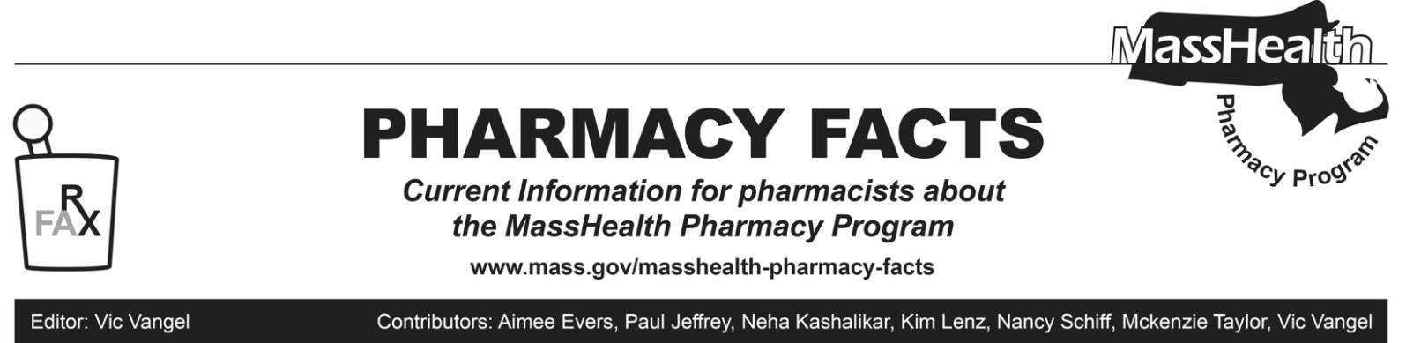

Removal of Prior Authorization (PA) Requirements for Chloroquine and Hydroxychloroquine, Effective May 10, 2021

In response to the coronavirus disease (COVID-19) outbreak, MassHealth announced certain temporary policy changes to provide greater flexibility in providing patient care to MassHealth members and Health Safety Net (HSN) patients, including the following policy change described in Pharmacy Facts #143:
“Individuals who have or are suspected to have COVID-19, or who have new prescriptions for lupus, malaria, or rheumatic conditions, must go through a PA process before chloroquine and hydroxychloroquine can be dispensed. If a MassHealth member or HSN patient is approved for COVID-19, pharmacies must dispense up to a 14-day supply. If a MassHealth member or HSN patient is approved for other diagnoses, pharmacies may dispense up to a 90-day supply if requested by the MassHealth member, HSN patient, or prescriber as long as sufficient quantity remains on the prescription to support the quantity being filled.”
Effective May 10, 2021, the PA requirements for chloroquine and hydroxychloroquine will be removed.
Pharmacies should expect to receive additional updates in the future about other temporary policy changes that have been put in place to address the COVID--19 outbreak.

Vaccine Administration Rates

The allowed vaccine administration rate for vaccines other than COVID-19 submitted through POPS is now $20.45. This administration fee should be entered in NCPDP field “Incentive Amount Submitted” (438-E3)

MHDL Update

Below are certain updates to the MassHealth Drug List (MHDL). See the MHDL for a complete listing of updates.

Additions

Effective May 10, 2021, the following newly marketed drugs have been added to the MassHealth Drug List.

- Bafiertam (monomethyl fumarate) – PA
- Byfavo (remimazolam) ^ – PA
- Cabenuva (cabotegravir/rilpivirine) – PA
- Danyelza (naxitamab-gqgk) – PA
- Imcivree (setmelanotide) – PA
- Orladeyo (berotralstat) – PA
- Phexxi (lactic acid/citric acid/potassium bitartrate vaginal gel)
- Riabni (rituximab-arrx) – PA
- Vocabria (cabotegravir) – PA
- Zokinvy (lonafarnib) – PA

Change in PA Status

- Effective May 10, 2021, the following anticonvulsants will no longer require PA for adult members. Pediatric Behavioral Health Medication Initiative criteria will still apply. For additional information, please see the Pediatric Behavioral Health Medication Initiative documents found at www.mass.gov/druglist.
- Equetro (carbamazepine extended-release) – PA < 6 years
- Qudexy XR # (topiramate extended-release capsule) – PA < 6 years
- Effective May 10, 2021, the following anticonvulsant will no longer require PA. Pediatric Behavioral Health Medication Initiative polypharmacy criteria will still apply. For additional information, please see the Pediatric Behavioral Health Medication Initiative documents found at www.mass.gov/druglist.
- Onfi # (clobazam suspension, tablet)
- Effective May 10, 2021, the following antimalarials will no longer require PA.
- chloroquine phosphate
- hydroxychloroquine
Updated MassHealth Brand Name Preferred Over Generic Drug List

The MassHealth Brand Name Preferred Over Generic Drug List has been updated to reflect recent changes to the MassHealth Drug List.

- Effective May 10, 2021, the following agents will be added to the MassHealth Brand Name Preferred Over Generic Drug List.
- Azopt (brinzolamide) ^{BP} – PA
- Carac (fluorouracil 0.5% cream) ^{BP} – PA
- Diastat (diazepam rectal gel) ^{BP} – PA > 5 kits (10 syringes)/month
- Firvanq (vancomycin oral solution) ^{BP}
- Timoptic Ocudose (timolol ophthalmic unit dose solution) ^{BP} – PA
- Effective May 10, 2021, the following agents will be removed from the MassHealth Brand Name Preferred Over Generic Drug List.
- Emend (fosaprepitant injection) – PA > 2 vials/28 days
- Kuvan (sapropterin) – PA
- Revatio (sildenafil oral suspension) – PA
- Sensipar # (cinacalcet)
- Zovirax # (acyclovir ointment)

____________________________________
Legend

PA Prior authorization is required. The prescriber must obtain prior authorization for the drug in order for the pharmacy to receive payment. Note: PA applies to both the brand-name and the FDA “A”-rated generic equivalent of listed product.

# Designates a brand-name drug with FDA “A”-rated generic equivalents. Prior authorization is required for the brand, unless a particular form of that drug (for example, tablet, capsule, or liquid) does not have an FDA “A”-rated generic equivalent.

^{BP} Brand preferred over generic equivalents. In general, MassHealth requires a trial of the preferred drug or clinical rationale for prescribing the nonpreferred drug generic equivalent

