Number 164, May 14, 2021
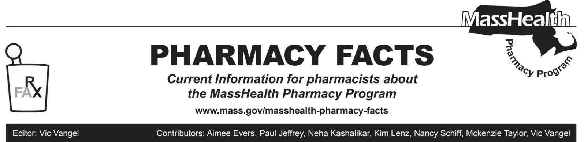
Days’ Supply Limitations for Drugs Used for Family Planning
MassHealth would again like to remind pharmacies about information provided in Pharmacy Facts #157 (December 2020).

Despite the requirements of 130 CMR 406.411(D)(1): Days’ Supply Limitation, pharmacies may dispense up to a 365-day supply of drugs used for family planning if requested by a MassHealth member or that member’s prescriber as long as sufficient quantity remains on the prescription to support the quantity being filled.

This policy is consistent with the requirements of An Act Relative to Advancing Contraceptive Coverage and Economic Security in our State (ACCESS), which applies to most Massachusetts insurance plans, including MassHealth, the Group Insurance Commission (GIC), and private insurers subject to regulation by the Massachusetts Division of Insurance (DOI). Please see the following DOI bulletin relating to contraceptive coverage requirements for regulated insurers: Bulletin 2020-26 (August 2020).

MassHealth anticipates extending this policy permanently, consistent with the amendments to 130 CMR 406.000: Pharmacy Services proposed on November 29, 2019, and currently pending final promulgation.
Please take any steps necessary when a member requests a 365-day supply of a family planning product, including contacting the member’s prescriber if an insufficient quantity remains on the current prescription.

