Number #165, May 24, 2021
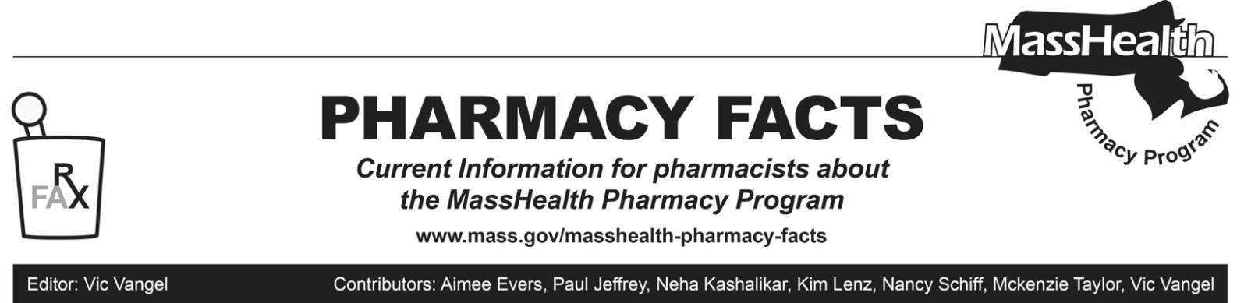
Coronavirus Disease 2019 (COVID-19) Vaccine Billing Information, Including Vaccine Coverage Policy for MassHealth Limited Members
MassHealth is sending this Pharmacy Facts to ensure providers are aware of previously-issued guidance related to billing for COVID-19 vaccination, including an update on coverage for MassHealth Limited Members.

Previous Guidance
MassHealth has issued the following All Provider Bulletins and Pharmacy Facts relating to vaccine administration for COVID-19:
- All-Provider Bulletin 304 (December 2020): Coverage and Payment for COVID-19 Vaccine Administration, Testing, and Monoclonal Antibody Product Infusion.
- All-Provider Bulletin 307 (January 2021):- Updated Payment Rates and Authorized Providers for COVID-19 Vaccine Administration.
- All-Provider Bulletin 312 (March 2021): Additional Authorized Vaccine Product, Antibody Treatment, Update to Authorized Providers and Coverage Policy for MassHealth Limited Members COVID-19 Vaccine Administration.
- All-Provider Bulletin 313 (March 2021): Updated Payment Rates and Authorized Providers for COVID-19 Vaccine Administration.
- All-Provider Bulletin 317 (April 2021):
Update to Authorized Providers for COVID-19 Vaccine Administration.
- Pharmacy Facts #160 (January 22, 2021)
COVID-19 Vaccine Billing Information
- Pharmacy Facts #162 (March 25, 2021)
COVID-19 Vaccine Billing Information
COVID-19 Vaccine Coverage Policy for MassHealth Limited Members
Notwithstanding 130 CMR 450.105(F)(1) or any other regulation to the contrary, and in accordance with the American Rescue Plan Act of 2021 (Public Law No. 117-2), COVID-19 vaccines and vaccine administration services are a covered service for MassHealth Limited members effective for dates of service beginning March 11, 2021. Such services are payable by MassHealth to participating providers qualified to provide such services.
Providers are required to bill MassHealth for such services rendered on or after March 11, 2021, rather than the federal COVID-19 Uninsured Program portal for uninsured patients, administered by the Health Resources and Services Administration (HRSA). Providers should continue to bill the federal COVID-19 Uninsured Program portal for COVID-19 vaccine administration services rendered to MassHealth Limited members for dates of service prior to March 11, 2021, and should continue to bill the federal COVID-19 Uninsured Program portal for vaccine administration services provided to all other uninsured patients, including Health Safety Net patients without other coverage.

Accordingly, pharmacy providers are able to bill claims for COVID-19 vaccine administration for MassHealth Limited members through POPS for dates of service on or after March 11, 2021. If a pharmacy provider previously billed for COVID-19 vaccine administration of MassHealth Limited members through POPS for dates of service on or after March 11, 2021, and was denied, providers can resubmit through POPS.

