Number 166, June 15, 2021
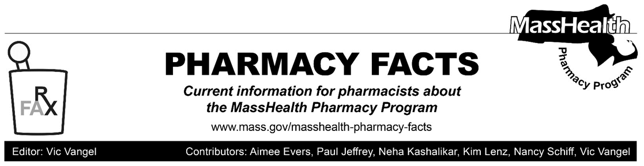

Pharmacy Copay Changes
Effective July 1, 2021, MassHealth is replacing the current $250 annual pharmacy copay cap with a member-specific monthly copay cap not to exceed 2% of the member’s monthly household income.
- A copay cap is the highest dollar amount that a member can be charged in copays in a month.
- MassHealth will calculate a monthly copay cap for each member based on the lowest income in their household and their household size, as applicable. MassHealth will round the member’s monthly copay cap down to the nearest ten-dollar increment up to $60 and determine their final monthly copay cap as shown in the table below.
If a member’s monthly copay cap is calculated to be: | Their final monthly copay cap will be:
$0 to $9.99 | No Copays
$10 to $19.99 | $10
$20 to $29.99 | $20
$30 to $39.99 | $30
$40 to $49.99 | $40
$50 to $59.99 | $50
$60 or Greater | $60
- For example, if a member’s monthly copay cap is $12.50 in July, the member will not be charged more than $10 of copays in July. If the member’s household income or family size changes in August, their monthly copay cap may change for August.
- If members have questions about the copay policy, they can reach the MassHealth Customer Service Center (CSC) at (800) 841-2900, Monday through Friday between 8:00 a.m. and 5:00 p.m. For TTY, members can call (800) 497-4648 during the same hours.

Member Notifications of These Changes
Beginning in May 2021, MassHealth will send a notice to members explaining these changes and notifying members of their initial monthly copay cap. Starting July 1, 2021, MassHealth will send a notice to members whenever their monthly copay cap changes or whenever they meet their current monthly copay cap.

POPS Claim Response
The Pharmacy Online Processing System (POPS) will track members’ monthly copay caps and accumulated copay amounts as part of the claim response. Please note that if in the adjudication of a POPS claim a copay is applicable, the dollar amount is returned in the response field “Amount of Copay”/ 518-FI.
EVS Updates
Message Trigger Scenario | Business Logic | Message Structure
Member has met Pharmacy Copay Cap for the Tracking Period | Accumulated Pharmacy Copays for the current Tracking Period is greater than or equal to the Pharmacy Copay Cap for the Tracking Period. | Member has met the pharmacy copay cap for the month of [MM/CCYY]
Member is exempt from pharmacy Copay | Member is exempt from pharmacy Copays for the current Tracking Period due to a categorical exclusion | Member is exempt from pharmacy copays for the month of [MM/CCYY]
Always show on Copay Panel | The message is shown every time user accesses a screen | Copays apply only to drugs dispensed at pharmacies. All applicable copay amount(s) will be identified on the pharmacy provider’s claim remittance. For a list of copay-exempt members and drugs, refer to 130 CMR 450.130.
The Eligibility Verification System (EVS) on the Provider Online Service Center (POSC) will also be updated to display the new copay information.

Pharmacy Copayment Poster Changes
The pharmacy copayment poster has been updated to reflect the new policy changes effective July 1, 2021 and to add clarifying language, and can be found on the MassHealth Pharmacy Publications and Notices for Pharmacy Providers page, under the heading, Sample Copayment Poster.

Pharmacies are required by MassHealth regulations at 130 CMR 450.130(F) to post a notice about MassHealth copays in areas where copays are collected. The notice must
- be visible to the public and easily readable;
- specify the exclusions from the copay requirement listed in 130 CMR 450.130(D) and (E); and
- instruct members to inform providers if they believe they are excluded from the copay requirement.

For More Information
Please contact the MassHealth Pharmacy Technical Help Desk (available 24/7) at
(866) 246-8503 to understand the on-file demographics (e.g., date of birth) for the MassHealth, Children’s Medical Security Plan, or Health Safety Net member. However, please note that call center staff cannot change a member’s demographic information. Instead, the MassHealth member must contact the MassHealth Customer Service Center (CSC) at (800) 841-2900 for assistance. Hours: Monday – Friday, excluding holidays, 8:00 a.m. – 5:00 p.m.

Please note: Members will be subject to the new copay policy starting July 1, 2021. However, for the duration of the Federal COVID-19 Public Health Emergency, members will not be charged more than $250 in total copays annually.
The updated copay policy will not apply to Children’s Medical Security Plan (CMSP) members, and any drugs that are charged through Health Safety Net (HSN) will continue to be subject to the $250 annual pharmacy copay cap.

