Number 167, June 15, 2021
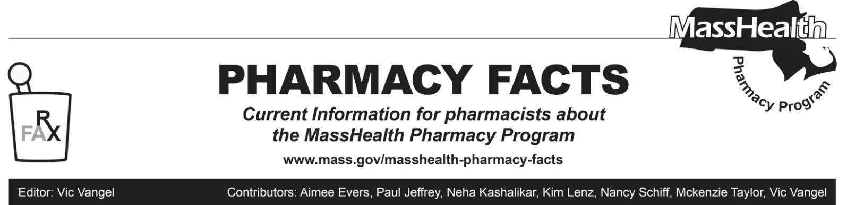

Updates Related to Coronavirus Disease 2019 (COVID-19)

Effective June 15, 2021
Following the March 2020 declaration of a state of emergency in the Commonwealth due to the COVID-19 outbreak, MassHealth introduced a number of flexibilities for coverage and billing necessitated by the COVID-19 outbreak. The state of emergency in the Commonwealth, declared March 2020, is ending at 12:01 a.m. on June 15, 2021. The federal public health emergency relating to COVID-19 initially declared by the federal Secretary of Health and Human Services on January 31, 2020 remains in effect.
As described below, MassHealth will continue to pay for prescription delivery and allow for additional exceptions to 30-day supply limitations.

Prescription Delivery
As described in Pharmacy Facts 145 and in 101 CMR 446.03(05), eligible providers receive a payment adjustment to the professional dispensing fee when medications are delivered to a personal residence (including homeless shelters). The payment adjustment is the lower of the provider's usual and customary charge for prescription delivery or $8.00, and will be made only when the MassHealth agency is the primary payer.
Pharmacies may bill for home delivery through the Pharmacy Online Processing System (POPS) using the following instructions if the requirements set forth in this Pharmacy Facts are met.
• Enter “01” in Other Amount Claimed Submitted Qualifier (NCPDP Field # 479-H8)
• Enter up to $8.00 in Other Amount Claimed Submitted (NCPDP Field 480-H9). Pharmacies should make sure that the delivery fee (NCPDP Field 480-H9) is reflected in provider billed amount (i.e., usual and customary or gross amount due, or both). If the provider does not typically charge for home delivery, they would not be entitled to this delivery fee.
• If the claim receives payment associated with a delivery, the payment will be added to the Dispensing Fee Paid (NCPDP Field 507-F7).
MassHealth will pay the delivery fee to a provider only once per member per day regardless of the number of prescriptions being delivered. The fee is payable only for deliveries to members living in personal residences and is not payable for claims for members living in any type of institution or residential facility, except for homeless shelters. This payment adjustment is not changed by the end of the state of emergency in Massachusetts and will continue to be in effect.

Days’ Supply Limitations
As described in Pharmacy Facts 141, Pharmacy Facts 142, All Provider Bulletin 289, and All Provider Bulletin 291, MassHealth allowed additional exceptions to the 30-day supply limitation described at 130 CMR 406.411(D). These flexibilities will continue in place through the end of the federal COVID-19 public health emergency.
Specifically, and notwithstanding the requirements of 130 CMR 406.411(D)(1), pharmacies may dispense up to a 90-day supply of a prescription drug, including behavioral health medications and schedule IV benzodiazepines and hypnotics, if requested by a MassHealth member or that member’s prescriber as long as sufficient quantity remains on the prescription to support the quantity being filled. Except as described above, this policy does not apply to drugs that require Prescription Monitoring Program (PMP) reporting, antibiotics, IV medications and certain other drugs designated by MassHealth (e.g., drugs for which quantity limits have been individually established for clinical reasons). If, based on a pharmacist’s professional judgment, a pharmacy believes that dispensing up to a 90-day supply of any drug not generally subject to this policy would be in the best interest of a MassHealth member, it may call the MassHealth Drug Utilization Review (DUR) program at (800) 745-7318 to request an override.

MassHealth notes that this policy is consistent with the amendments to 130 CMR 406.000: Pharmacy Services proposed on November 29, 2019 and currently pending final promulgation. MassHealth also notes that the Massachusetts Department of Public Health, through the Massachusetts Board of Registration in Pharmacy and the Drug Control Program, allows pharmacists to change the quantity being dispensed on a prescription in the circumstances described in Joint Policy 2018-01: Permitted Prescription Changes and Additions, the relevant portion of which is copied below:

If deemed appropriate in the pharmacist’s professional judgement, the days’ supply dispensed (e.g. 30-day supply with 11 refills vs. 90-day supply with 3 refills) may be changed without consultation only for drugs that do not require PMP reporting.
In the case of drug classes where a change in days’ supply may cause clinical concern, the Board [of Registration in Pharmacy] recommends that prescribers be consulted upon initiation of new therapy and for any changes. Examples of such drug classes include behavioral health drugs and narrow therapeutic index drugs.

