Number 168 June 23, 2021
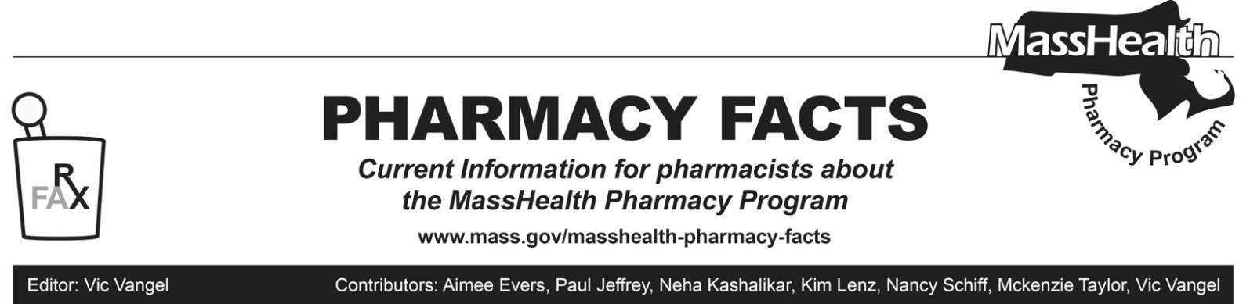
MHDL Update

Below are certain updates to the MassHealth Drug List (MHDL). See the MHDL for a complete listing of updates.

Additions
- Effective June 28, 2021, the following newly marketed drugs have been added to the MassHealth Drug List.
- Breyanzi (lisocabtagene maraleucel) ^{CO} ^ – PA
- Eysuvis (loteprednol 0.25% suspension) – PA
- fluorescein/benoxinate
- Gemtesa (vibegron) – PA
- Herceptin Hylecta (trastuzumab/hyaluronidase-oysk) – PA
- Herzuma (trastuzumab-pkrb) – PA
- Kanjinti (trastuzumab-anns) – PA
- Lupkynis (voclosporin) – PA
- Margenza (margetuximab-cmkb) – PA
- Mvasi (bevacizumab-awwb) – PA
- Mycapssa (octreotide capsule) – PA
- Ogivri (trastuzumab-dkst) – PA
- Olinvyk (oliceridine) ^ – PA
- Ontruzant (trastuzumab-dttb) – PA
- Orgovyx (relugolix) – PA
- Oxlumo (lumasiran) – PA
- Ponvory (ponesimod) – PA
- Qelbree (viloxazine) – PA
- Tepmetko (tepotinib) – PA
- Thyquidity (levothyroxine)
- Trazimera (trastuzumab-qyyp) – PA
- Verquvo (vericiguat) – PA
- Zirabev (bevacizumab-bvzr) – PA
- Effective for the date listed below, the following COVID-19 preventative therapy has been added to the MassHealth Drug List on June 09, 2021.
- sotrovimab (COVID EUA – May 26, 2021)

Change in Prior-Authorization Status
- Effective June 28, 2021, the following dermatologic agents will no longer require prior authorization (PA).
- Aldara # (imiquimod 5% cream)
- Condylox Gel (podofilox gel)
- Efudex (fluorouracil 5% cream) ^{BP}
- Effective June 28, 2021, the following antipsychotic agents will no longer require PA within updated quantity limits. Pediatric Behavioral Health Medication Initiative criteria will still apply. For additional information, please see the Pediatric Behavioral Health Medication Initiative documents found at www.mass.gov/druglist.
- Abilify # (aripiprazole tablet) – PA < 6 years and PA > 2 units/day
- Seroquel XR # (quetiapine extended- release 150 mg, 200 mg) – PA < 6 years and PA > 2 units/day
- Zyprexa # (olanzapine 2.5 mg, 5 mg, 7.5 mg, 10 mg, 20 mg tablets) – PA < 6 years and PA > 2 units/day
- Effective June 28, 2021, the following antipsychotic agent will no longer require PA when used within quantity limits. Pediatric Behavioral Health Medication Initiative criteria will still apply. For additional information, please see the Pediatric Behavioral Health Medication Initiative documents found at www.mass.gov/druglist.
- Risperdal M-Tab # (risperidone 0.25 mg orally disintegrating tablet) – PA < 6 years and PA > 2 units/day
- Effective June 28, 2021, the following antipsychotic agent will require PA when exceeding newly established quantity limits. Pediatric Behavioral Health Medication Initiative criteria will still apply. For additional information, please see the Pediatric Behavioral Health Medication Initiative documents found at www.mass.gov/druglist.
- Risperdal M-Tab # (risperidone 2 mg orally disintegrating tablet) – PA < 6 years and PA > 2 units/day
- Effective June 28, 2021, the following antipsychotic agent will require PA for all ages.
- Risperdal M-Tab (risperidone 3 mg orally disintegrating tablet) – PA
- Effective June 28, 2021, the following anticonvulsant agent will require PA when exceeding newly established dosing limits. Pediatric Behavioral Health Medication Initiative criteria will still apply. For additional information, please see the Pediatric Behavioral Health Medication Initiative documents found at www.mass.gov/druglist.
- Neurontin # (gabapentin capsule, solution, tablet) – PA < 6 years and PA > 3600 mg/day
- Effective June 28, 2021, the following injectable antibiotic agents will no longer require PA.
  - Cubicin # (daptomycin)
  - daptomycin
- Effective June 28, 2021, the following glaucoma agent will no longer require PA.
  - Azopt (brinzolamide) ^{BP}
- Effective June 28, 2021, the following hereditary angioedema agent will require PA.
  - Kalbitor (ecallantide) ^ – PA
- Effective June 28, 2021, the following oncology agent will require PA.
  - Herceptin (trastuzumab) – PA
- Effective July 1, 2021, the following antiretroviral/HIV agent will no longer require PA.
  - Cabenuva (cabotegravir/rilpivirine) ^{PD}

Updated MassHealth Brand Name Preferred Over Generic Drug List

The MassHealth Brand Name Preferred Over Generic Drug List has been updated to reflect recent changes to the MassHealth Drug List.
- Effective June 28, 2021, the following agents will be added to the MassHealth Brand Name Preferred Over Generic Drug List.
- Bepreve (bepotastine) ^{BP}
- Combigan (brimonidine/timolol, ophthalmic) ^{BP}
- Prezista (darunavir) ^{BP PD}
- Revlimid (lenalidomide) ^{BP} – PA
- Teflaro (ceftaroline) ^{BP} – PA
- Thiola (tiopronin) ^{BP}
- Zoladex (goserelin) ^{BP} – PA
- Effective June 28, 2021, the following agents will be removed from the MassHealth Brand Name Preferred Over Generic Drug List.
- Atripla # (efavirenz/emtricitabine/tenofovir)
- Kaletra # (lopinavir/ritonavir)
- Purixan (mercaptopurine oral suspension) – PA
- Rapaflo (silodosin) – PA
- Silenor (doxepin tablet) – PA
- Truvada # (emtricitabine/tenofovir disoproxil fumarate)

Legend

PA Prior authorization is required. The prescriber must obtain prior authorization for the drug in order for the pharmacy to receive payment. Note: PA applies to both the brand-name and the FDA “A”-rated generic equivalent of listed product.

# Designates a brand-name drug with FDA “A”-rated generic equivalents. Prior authorization is required for the brand, unless a particular form of that drug (for example, tablet, capsule, or liquid) does not have an FDA “A”-rated generic equivalent.

^{BP} Brand preferred over generic equivalents. In general, MassHealth requires a trial of the preferred drug or clinical rationale for prescribing the nonpreferred drug generic equivalent.

^{PD} In general, MassHealth requires a trial of the preferred drug (PD) or a clinical rationale for prescribing a nonpreferred drug within a therapeutic class.

^ This drug is available through the health care professional who administers the drug. MassHealth does not pay for this drug to be dispensed through a retail pharmacy.

^{CO} Carve-Out. This agent is listed on the Acute Hospital Carve-Out Drugs List and is subject to additional monitoring and billing requirements.

