Number 169, August 5, 2021
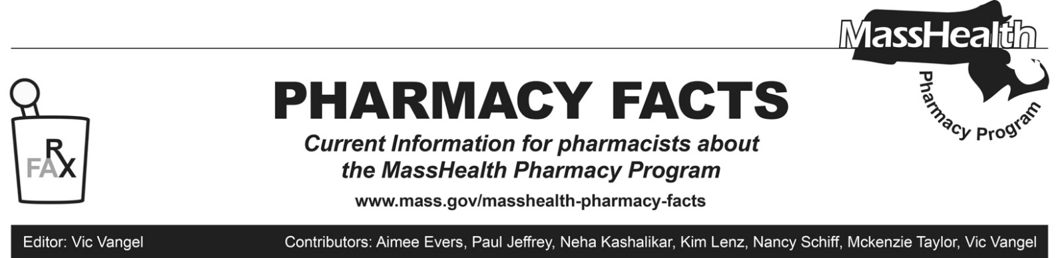

MHDL Update

What follows are certain updates to the MassHealth Drug List (MHDL). See the MHDL for a complete listing of updates.

Additions

Effective August 9, 2021, the following newly marketed drugs have been added to the MassHealth Drug List.
- Abecma (idecabtagene vicleucel) – CO ^ PA
- Amondys 45 (casimersen) – PA
- Bronchitol (mannitol inhalation powder) – PA
- Evkeeza (evinacumab-dgnb) – PA
- Exservan (riluzole film) – PA
- Fotivda (tivozanib) – PA
- Nulibry (fosdenopterin) – PA
- Pepaxto (melphalan flufenamide) – PA
- Reditrex (methotrexate subcutaneous injection) – PA
- ursodiol 200 mg, 400 mg capsule – PA
- Vesicare LS (solifenacin suspension) – PA
- Zegalogue (dasiglucagon) – PA

Change in Prior-Authorization (PA) Status

Effective August 9, 2021, the following antifungal topical agents will no longer require PA.

- Mentax (butenafine)

Effective August 9, 2021, the following antifungal topical agent will no longer require PA outside of age limits.

  - nystatin/triamcinolone cream, ointment

Effective August 9, 2021, the following topical corticosteroid agents will no longer require PA.

- Capex (fluocinolone shampoo)
- Clobex # (clobetasol propionate lotion, spray)
- Halog (halcinonide ointment)
- Olux # (clobetasol propionate foam)
- Vanos # (fluocinonide 0.1% cream)

Effective August 9, 2021, the following topical corticosteroid agent will require PA.

- amcinonide lotion – PA

Effective August 9, 2021, the following inhaled respiratory agent will require PA.

- Proventil (albuterol) – PA

Effective August 9, 2021, the following gabapentinoid agents will require PA for concurrent therapy (overlapping pharmacy claims for both agents for at least 60 days within a 90-day period).

  - Lyrica (pregabalin) – PA
  - Neurontin # (gabapentin capsule, solution, tablet) – PA < 6 years and PA > 3600 mg/day

Updated MassHealth Brand Name Preferred Over Generic Drug List

The MassHealth Brand Name Preferred Over Generic Drug List has been updated to reflect recent changes to the MassHealth Drug List.

- Effective August 9, 2021, the following agents will be added to the MassHealth Brand Name Preferred Over Generic Drug List.
- Buphenyl (sodium phenylbutyrate powder) ^{BP}
- Colcrys (colchicine tablet) ^{BP} – PA
- Depakote (divalproex sprinkle capsule) ^{BP} – PA < 6 years
- Soolantra (ivermectin cream) ^{BP} – PA
- Taclonex (betamethasone / calcipotriene scalp suspension) ^{BP} – PA
- Targretin (bexarotene) ^{BP}
- Effective August 9, 2021, the following agents will be removed from the MassHealth Brand Name Preferred Over Generic Drug List.
- Differin (adapalene 0.3% gel tube) – PA
- Riomet # (metformin solution) – PA ≥ 13 years

____________________________________
Legend

PA Prior authorization is required. The prescriber must obtain prior authorization for the drug in order for the pharmacy to receive payment. Note: PA applies to both the brand-name and the FDA “A”-rated generic equivalent of listed product.

# Designates a brand-name drug with FDA “A”-rated generic equivalents. Prior authorization is required for the brand, unless a particular form of that drug (for example, tablet, capsule, or liquid) does not have an FDA “A”-rated generic equivalent.

^{BP} Brand preferred over generic equivalents. In general, MassHealth requires a trial of the preferred drug or clinical rationale for prescribing the nonpreferred drug generic equivalent.

^{CO} Carve-Out. This agent is listed on the Acute Hospital Carve-Out Drugs List and is subject to additional monitoring and billing requirements.

^{PD} In general, MassHealth requires a trial of the preferred drug (PD) or a clinical rationale for prescribing a nonpreferred drug within a therapeutic class.

^ Available through the health care professional who administers the drug. MassHealth does not pay for this drug to be dispensed through a retail pharmacy.

