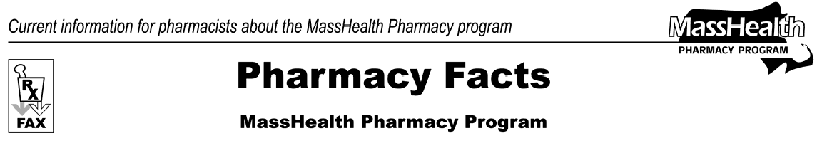
Number 17
January 25, 2006
- Editor: Vic Vangel • Contributors: Chris Burke, Gary Gilmore, Paul Jeffrey, James Monahan •

Medicare Part-D Prescription Drug

Coverage Update

We would like to thank all pharmacies in the Commonwealth for providing a valuable service to our dually eligible members in processing their prescriptions. The transition to the Medicare Part-D plans has not been easy for anyone involved, and we applaud your efforts.

As you know, MassHealth has been accepting and paying for claims for all dually-eligible members without requiring evidence of Part-D coverage since emergency procedures were enacted on 1/7/2006. Now we are making another change in claims adjudication for our dually eligible members, effective Thursday 1/26/2006 at 1:00 A.M.

If MassHealth receives a claim as the primary payer for a dually eligible member for a Part D covered drug, MassHealth will deny the claim. (The Part-D excluded drugs, such as benzodiazepines, will pay if otherwise valid and available to MassHealth members). The POPS system will display the message “AE – QMB Bill Medicare” to indicate that the member is dually eligible, and that the pharmacist must attempt to bill a Part-D plan. We still expect that the pharmacy will use the E1 query to determine what Part D program a MassHealth member is enrolled in. If the pharmacy cannot ascertain Part-D eligibility information for the member, the denial can be overridden by placing a “2” in the Eligibility Clarification Code field (NCPDP field 309-C) and demonstrating that the claim was sent to a Part-D plan. Though the claim will not deny because of Medicare-D coverage, it will still be subject to all of MassHealth’s other billing procedures and requirements. The use of this Eligibility Clarification Code is a temporary emergency measure. In the future, the use of this code will no longer override a denied claim.
In Pharmacy Facts #15, MassHealth described procedures for sending a claim to reduce a dually eligible member’s co-pay from the $2.00 and $5.00 level (as determined by the Part-D plan) to the standard MassHealth co-pay levels of $1.00 and $3.00.
Pharmacies should use Other Coverage Code 8 when billing MassHealth for this co-pay. As of Thursday 1/26/2006 pharmacies may also submit “co-pay wrap” claims to MassHealth using Other Coverage Codes 2 or 4. The pharmacy must insert the amount of the co- pay required by the Part-D plan in the Patient Paid Amount field (NCPDP field 433-DX). The maximum amount allowed in the field is $5.00, which is the highest co-pay a dually eligible member would be responsible for under Part-D. Contact the Part-D plan if you are prompted to request a copayment greater than $5.00.

If a Part-D plan denies a claim because the drug is not on its formulary, the pharmacy may submit the claim to MassHealth using Other Coverage Code 3, along with the appropriate reject code. The claim will still be subject to all of MassHealth’s other billing procedures and requirements.

Under the emergency procedures enacted on January 7, 2006, MassHealth will continue to be the payer of last resort for the dually eligible member who experiences difficulty having a claim paid by a Medicare Part D prescription drug plan. The procedures outlined above provide pharmacists with the information needed to allow these members to have an appropriately written prescription filled at the point of sale.

Please direct any questions or comments (or to be taken off of this fax distribution) to
Victor Moquin of ACS at 617-423-9830.

