Number 172, September 20, 2021
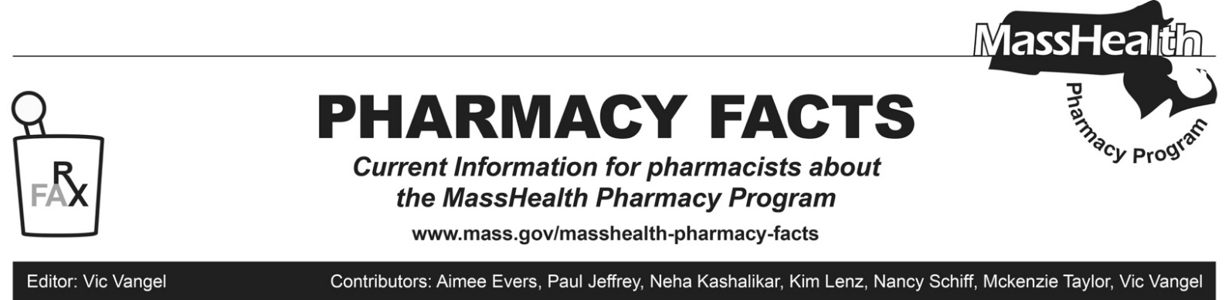
Coronavirus Disease 2019 (COVID-19) and New Quantity Limits for Ivermectin—Effective Immediately

Amid the COVID-19 pandemic, the prescribing of ivermectin for the prevention or treatment of COVID-19 has increased. The FDA has not authorized or approved the use of ivermectin in the prevention or treatment of COVID-19 and has warned about the potential risks for such use. More information can be found in the official CDC Health Advisory.

Accordingly, MassHealth is adopting new policies for the prescribing and dispensing of ivermectin. MassHealth is imposing new quantity limits of 20 ivermectin tablets per 90 days. Pharmacy claims within these new quantity limits do not require prior authorization. If a rejection is encountered within these new quantity limits, please contact the Drug Utilization Review (DUR) program at (800) 745-7318 for further information.

Prescribers may request prior authorization for ivermectin outside of quantity limits using the General Drug Prior Authorization Request form.

These policies apply to all pharmacy claims processed through the Pharmacy Online Processing System (POPS), including claims for the Health Safety Net program.

MHDL Update

Below are certain updates to the MassHealth Drug List (MHDL). See the MHDL for a complete listing of updates.

Additions

Effective September 20, 2021, the following newly marketed drugs have been added to the MassHealth Drug List.
- Accrufer (ferric maltol) – PA
- Comirnaty (COVID-19 Pfizer vaccine for members ≥ 16 years of age)
- Comirnaty (COVID-19 Pfizer vaccine COVID EUA – May 10, 2021 for members 12 to 15 years of age)
- Comirnaty (Pfizer COVID-19 vaccine for members ≥ 16 years of age)
- Comirnaty (Pfizer COVID-19 vaccine COVID EUA – May 10, 2021 for members 12 to 15 years of age)
- Cosela (trilaciclib) – PA
- Empaveli (pegcetacoplan) – PA
- Impeklo (clobetasol propionate lotion) – PA
- Jemperli (dostarlimab-gxly) – PA
- Myfembree (relugolix/estradiol/norethindrone) – PA
- Oriahnn (elagolix/estradiol/norethindrone) – PA
- Prevnar 20 (pneumococcal 20-valent conjugate vaccine)
- Zynrelef (bupivacaine/meloxicam) ^

Change in PA Status

- Effective September 20, 2021, the following gout agent will no longer require prior authorization.
- Colcrys (colchicine tablet) ^{BP}
- Effective September 20, 2021, the following ophthalmic anti-allergy and anti-inflammatory agents will no longer require prior authorization.
- Alrex (loteprednol 0.2%)
- Lotemax (loteprednol 0.5% gel, ointment) ^{BP}
- olopatadine 0.1% eye drops
- olopatadine 0.2% eye drops
- Effective September 20, 2021, the following topical dermatologic agent will no longer require prior authorization.
- Solaraze # (diclofenac 3% gel)
- Effective September 20, 2021, the following serotonin and norepinephrine reuptake inhibitor will no longer require prior authorization.
- Savella (milnacipran)
- Effective September 20, 2021, the following antiretroviral agent will no longer require prior authorization.
- Vocabria (cabotegravir)
- Effective September 20, 2021, the following antiparasitic agent will require PA when exceeding newly established quantity limits.
- Stromectol # (ivermectin tablet) – PA > 20 units/90 days

Updated MassHealth Brand Name Preferred Over Generic Drug List

The MassHealth Brand Name Preferred Over Generic Drug List has been updated to reflect recent changes to the MassHealth Drug List.

- Effective September 20, 2021, the following agents will be added to the MassHealth Brand Name Preferred Over Generic Drug List.
- Belbuca (buprenorphine buccal film) ^{BP} – PA
- Duetact (glimepiride/pioglitazone) ^{BP} – PA
- Dulera (mometasone/formoterol) ^{BP}
- Flovent (fluticasone propionate inhalation aerosol) ^{BP}
- Glumetza (metformin extended-release) ^{BP} – PA
- Invega (paliperidone tablet) ^{BP} – PA
- Kazano (alogliptin/metformin) ^{BP} – PA
- Mitigare (colchicine capsule) ^{BP} – PA
- Nesina (alogliptin) ^{BP} – PA
- Oseni (alogliptin/pioglitazone) ^{BP} – PA
- Viibryd (vilazodone) ^{BP} – PA
- Zioptan (tafluprost) ^{BP} – PA
- Effective September 20, 2021, the following agents will be removed from the MassHealth Brand Name Preferred Over Generic Drug List.
- Fycompa (perampanel tablet) – PA
- Osmoprep (sodium phosphate)
- Velphoro (sucroferric oxyhydroxide)

Legend

PA Prior authorization is required. The prescriber must obtain prior authorization for the drug in order for the pharmacy to receive payment. Note: PA applies to both the brand-name and the FDA “A”-rated generic equivalent of listed product.

# Designates a brand-name drug with FDA “A”-rated generic equivalents. Prior authorization is required for the brand, unless a particular form of that drug (for example, tablet, capsule, or liquid) does not have an FDA “A”-rated generic equivalent.

^{BP} Brand preferred over generic equivalents. In general, MassHealth requires a trial of the preferred drug or clinical rationale for prescribing the nonpreferred drug generic equivalent.

^{PD} In general, MassHealth requires a trial of the preferred drug (PD) or a clinical rationale for prescribing a nonpreferred drug within a therapeutic class.

^{CO} Carve-Out. This agent is listed on the Acute Hospital Carve-Out Drugs List and is subject to additional monitoring and billing requirements.
^ This drug is available through the health care professional who administers the drug. MassHealth does not pay for this drug to be dispensed through a retail pharmacy.

