Number 173, October 29, 2021
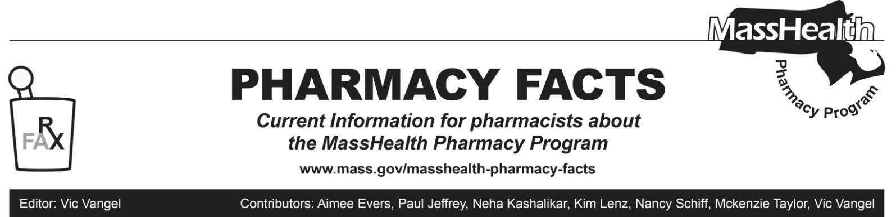
MHDL Update

Below are certain updates to the MassHealth Drug List (MHDL). See the MHDL for a complete listing of updates.
- Additions
Effective November 1, 2021, the following newly marketed drugs have been added to the MassHealth Drug List.

- Azstarys (serdexmethylphenidate/dexmethylphenidate) – PA
- Kloxxado (naloxone 8 mg nasal spray) – PA
- Lumakras (sotorasib) – PA
- Rylaze (asparaginase erwinia chrysanthemi-rywn) ^ – PA
- Rybrevant (amivantamab-vmjw) – PA
- Vaxneuvance (pneumococcal 15-valent conjugate vaccine)
- Change in Prior-Authorization (PA) Status
- Effective November 1, 2021, the following oncology agent will no longer require PA.
  - Soltamox (tamoxifen solution)
- Effective November 1, 2021, the following antimalarial agent will require PA when exceeding newly established quantity limits.
  - Krintafel (tafenoquine) – PA > 2 units/365 days
- Effective November 1, 2021, the following cerebral stimulant and ADHD agent will no longer require PA within newly established quantity limits. Pediatric Behavioral Health Medication Initiative criteria will still apply. For additional information, please see the Pediatric Behavioral Health Medication Initiative documents at mass.gov/druglist.
- Daytrana (methylphenidate transdermal) – PA <3 years and PA > 1 unit/day
- Effective November 1, 2021, the following cerebral stimulant and ADHD agent will no longer require prior authorization within updated quantity limits. Pediatric Behavioral Health Medication Initiative criteria will still apply. For additional information, please see the Pediatric Behavioral Health Medication Initiative documents at mass.gov/druglist.
- dextroamphetamine solution – PA < 3 years and PA > 40 mL/day
- Effective November 1, 2021, the following antidiabetic agent will require PA.
- miglitol – PA
- Effective November 1, 2021, the following inhaled respiratory agent will require PA.
- Proair Respiclick (albuterol inhalation powder) – PA
- Effective November 1, 2021, the following topical corticosteroid agents will require PA.
  - desonide lotion – PA
  - hydrocortisone valerate ointment – PA
- Effective November 1, 2021, the following topical corticosteroid agents will no longer require prior authorization.
  - desoximetasone 0.25% cream
  - Luxiq # (betamethasone valerate foam)
  - Pandel (hydrocortisone probutate cream)
- Effective November 1, 2021, the following ophthalmic anti-inflammatory agents will no longer require prior authorization.
  - Durezol (difluprednate) ^{BP}
  - Lacrisert (hydroxypropyl cellulose ophthalmic insert)
  - Prolensa (bromfenac 0.07%)

- Effective November 1, 2021, the following vaginal antibiotic agents will no longer require PA.
  - Cleocin Vaginal Ovule (clindamycin vaginal suppository)
  - Nuvessa (metronidazole 1.3% vaginal gel)
- Effective November 1, 2021, the following ophthalmic antibiotic agents will no longer require PA.
  - Besivance (besifloxacin ophthalmic suspension)
  - Blephamide (sulfacetamide/prednisolone sodium acetate ophthalmic suspension)
  - Ciloxan (ciprofloxacin ophthalmic ointment)
  - Pred-G (gentamicin/prednisolone ophthalmic suspension)
  - Tobradex (tobramycin 0.3%/dexamethasone 0.1%, ophthalmic ointment)
  - Tobrex (tobramycin ophthalmic ointment)
- Effective November 1, 2021, the following ophthalmic antibiotic agents will require prior authorization.
  - bacitracin ophthalmic ointment – PA
  - levofloxacin ophthalmic solution – PA
  - neomycin/polymyxin B/hydrocortisone ophthalmic suspension – PA
Updated MassHealth Brand Name Preferred Over Generic Drug List
- Effective November 1, 2021, the following agents will be added to the MassHealth Brand Name Preferred Over Generic Drug List.
- Absorica (isotretinoin) ^{BP} – PA
- Androgel (testosterone 1.62% gel packet) ^{BP} – PA
- Depo-Testosterone (testosterone cypionate) ^{BP} – PA
- Exelon (rivastigmine patch) ^{BP} – PA > 1 unit/day
- Fortesta (testosterone 2% gel pump) ^{BP} – PA
- Prometrium (progesterone capsule) ^{BP}
- Testim (testosterone 1% gel tube) ^{BP} – PA
- Zovirax (acyclovir suspension) ^{BP}
- Effective November 1, 2021, the following agents will be removed from the MassHealth Brand Name Preferred Over Generic Drug List.
- Belbuca (buprenorphine buccal film) – PA
- Chantix # (varenicline)

_____________________________________________

Legend

^{PA} Prior authorization is required. The prescriber must obtain prior authorization for the drug in order for the pharmacy to receive payment. Note: PA applies to both the brand-name and the FDA “A”-rated generic equivalent of listed product.

^{BP} Brand preferred over generic equivalents. In general, MassHealth requires a trial of the preferred drug or clinical rationale for prescribing the nonpreferred drug generic equivalent.

# Designates a brand-name drug with FDA “A”-rated generic equivalents. Prior authorization is required for the brand, unless a particular form of that drug (for example, tablet, capsule, or liquid) does not have an FDA “A”-rated generic equivalent.

^ Available through the health care professional who administers the drug. MassHealth does not pay for this drug to be dispensed through a retail pharmacy.

^{PD} In general, MassHealth requires a trial of the preferred drug (PD) or a clinical rationale for prescribing a nonpreferred drug within a therapeutic class.

^{CO} Carve-Out. This agent is listed on the Acute Hospital Carve-Out Drugs List and is subject to additional monitoring and billing requirements.

