Pharmacy Facts
Number 174, December 14, 2021
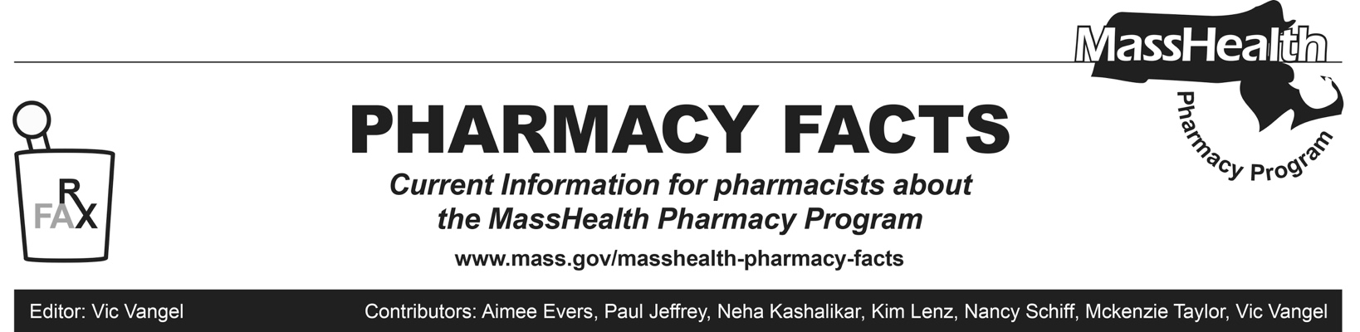

MHDL Update

Below are certain updates to the MassHealth Drug List (MHDL). See the MHDL for a complete listing of updates.

Additions
- Effective December 20, 2021, the following newly marketed drugs have been added to the MassHealth Drug List.
- Brexafemme (ibrexafungerp) – PA
- Bylvay (odevixibat) – PA
- Dengvaxia (dengue tetravalent vaccine, live)
- erythromycin stearate tablet
- Hemady (dexamethasone 20 mg tablet) – PA
- Rezurock (belumosudil) – PA
- Ticovac (tick-borne encephalitis vaccine)
- Truseltiq (infigratinib) – PA
- Zynlonta (loncastuximab tesirine-lpyl) – PA
- Effective for the date listed below, the following COVID-19 preventative therapy has been added to the MassHealth Drug List on November 8, 2021.
- Comirnaty (COVID-19 Pfizer vaccine COVID EUA – October 29, 2021 for members 5 to 11 years of age)
- Comirnaty (Pfizer COVID-19 vaccine COVID EUA – October 29, 2021 for members 5 to 11 years of age)

Change in Prior-Authorization Status
- Effective December 20, 2021, the following oral antibiotic agents will no longer require prior authorization (PA).
- moxifloxacin tablet
- Zyvox # (linezolid tablet)

- Effective December 20, 2021, the following antibiotic agents will require PA.
• cefpodoxime suspension – PA
• ciprofloxacin 100 mg tablet – PA
• Furadantin (nitrofurantoin) – PA
• Zithromax (azithromycin powder packet) – PA
- Effective December 20, 2021, the following antiviral agent will no longer require PA.
- Denavir (penciclovir)

- Effective December 20, 2021, the following antidepressant agents will require PA.
- amitriptyline/chlordiazepoxide – PA
- amitriptyline/perphenazine – PA
- maprotiline – PA
- protriptyline – PA
- trimipramine – PA

- Effective December 20, 2021, the following corticosteroid agent will require PA.
- prednisolone tablet – PA

- Effective December 20, 2021, the following immunosupressant agent will require PA.
- Sandimmune (cyclosporine solution) – PA

- Effective December 20, 2021, the following anti-acne and rosacea agent will no longer require PA within the newly established age limit.
- Altreno (tretinoin 0.05% lotion) – PA ≥ 22 years

- Effective December 20, 2021, the following insulin agent will require PA.
- Humulin N (insulin NPH) – PA

Updated MassHealth Brand Name Preferred Over Generic Drug List
The MassHealth Brand Name Preferred Over Generic Drug List has been updated to reflect recent changes to the MassHealth Drug List.
- Effective December 20, 2021, the following agents will be added to the MassHealth Brand Name Preferred Over Generic Drug List.
- Ancobon (flucytosine) ^{BP}
- Hepsera (adefovir) ^{BP} – PA >1 unit/day
- Letairis (ambrisentan) ^{BP} – PA
- Pristiq (desvenlafaxine succinate extended-release) ^{BP} – PA < 6 years and PA > 1 unit/day
- Revatio (sildenafil 20 mg tablet) ^{BP} – PA
- Revatio (sildenafil oral suspension) ^{BP} – PA

- Effective December 20, 2021, the following agents will be removed from the MassHealth Brand Name Preferred Over Generic Drug List.
- Depo-Testosterone (testosterone cypionate) – PA
- Humalog (insulin lispro 75/25)
- Humalog (insulin lispro)
- Prometrium # (progesterone capsule)
- Novolog (insulin aspart 70/30)
- Novolog (insulin aspart)

Legend
PA Prior authorization is required. The prescriber must obtain prior authorization for the drug in order for the pharmacy to receive payment. Note: PA applies to both the brand-name and the FDA “A”-rated generic equivalent of listed product.

# Designates a brand-name drug with FDA “A”-rated generic equivalents. Prior authorization is required for the brand, unless a particular form of that drug (for example, tablet, capsule, or liquid) does not have an FDA “A”-rated generic equivalent.

BP Brand preferred over generic equivalents. In general, MassHealth requires a trial of the preferred drug or clinical rationale for prescribing the nonpreferred drug generic equivalent.

CO Carve-Out. This agent is listed on the Acute Hospital Carve-Out Drugs List and is subject to additional monitoring and billing requirements.

PD Preferred Drug. In general, MassHealth requires a trial of the preferred drug or clinical rationale for prescribing a non-preferred drug within a therapeutic class.

Influenza Treatment Agents

Pharmacies are reminded that oseltamivir is available for the treatment of influenza without prior authorization when used within quantity limits and that Xofluza does require prior authorization (PA). We remind pharmacies because the timing of initiation of therapy is so important with these agents. When a pharmacy submits a claim for Xofluza, the claim will deny and the pharmacy will see this message. “This product requires PA. Oseltamivir is available without PA within quantity limits. Please see the MassHealth drug list for more information regarding influenza treatment or prophylaxis.”

Pharmacies are also reminded that if a prior authorization submission cannot be submitted timely, the pharmacy can use existing procedures to submit a claim with an emergency override.
Consistent with 130 CMR 406.411(B) and to ensure that MassHealth members and HSN patients do not experience gaps in therapy, pharmacists may utilize an emergency override if a claim for a medication is rejected due to lack of PA. MassHealth will pay the pharmacy for at least a 72-hour, nonrefillable supply of the drug dispensed under these circumstances. To obtain an emergency override, pharmacists should contact the Drug Utilization Review Program at (800) 745-7318 during normal business hours. If outside business hours, pharmacies may submit an emergency override claim with a value of “03” for Level of Service (field 418)

