Number 175, December 16, 2021
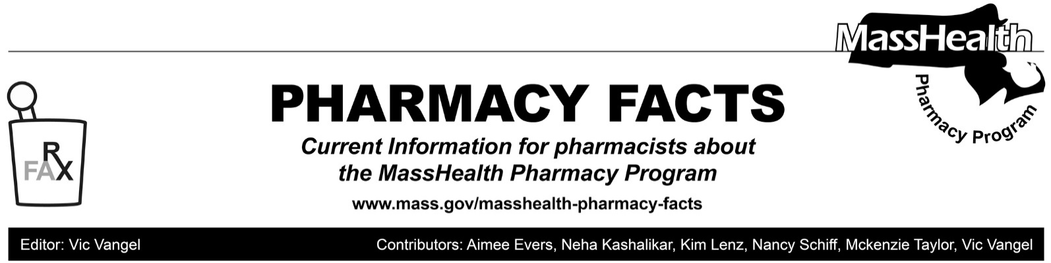
MassHealth Pharmacy Coverage of Pediatric Enteral Special Formula and Thickening Agents

Due to concerns about the supply chain for formula and thickening agents, the following items have been added to the MassHealth Pharmacy Non-Drug Product List.

● Pediatric Enteral Special Formula—PA
● Thickening Agents—PA

This change is effective December 16, 2021, and will remain in effect unless MassHealth provides alternative guidance. Pharmacies may process and dispense pediatric enteral special formula and thickening agents with a valid prescription from the member’s prescriber through MassHealth’s Pharmacy Online Processing System (POPS). Pharmacies will be paid the lower of the Wholesale Acquisition Cost or the submitted Usual and Customary Charge. MassHealth expects to codify this rate methodology in forthcoming amendments to Executive Office of Health and Human Services rate regulations. This change applies to MassHealth Standard, CommonHealth, CarePlus, Family Assistance, and Children’s Medical Security Plan (CMSP) members whose pharmacy claims are paid through POPS. This coverage does not apply to Health Safety Net patients or MassHealth Limited members.

Updated MassHealth Brand Name Preferred Over Generic Drug List

Effective December 20, 2021, the following agents will be removed from the MassHealth Brand Name Preferred Over Generic Drug List.

● Humalog (insulin lispro 75/25)
● Humalog (insulin lispro)
● Novolog (insulin aspart 70/30)
● Novolog (insulin aspart)

Although insulin lispro and insulin aspart are authorized generics, they are currently not interchangeable with the respective brand product. MassHealth will continue to pay for both the branded product and the authorized generic. Beginning February 7, 2021, MassHealth will require prior authorization for brand Humalog and Novolog for new prescriptions. Current refills for Humalog and Novolog will pay at the pharmacy for the life of that prescription. A new prescription will be needed from the prescriber for insulin lispro or insulin aspart once current refills are exhausted.

BIN/PCN/Group Numbers for ACOs, MCOs and PCC Plan

The following tables show the correct combinations, effective for calendar year 2022, for pharmacies for Accountable Care Partnership Plans (ACPPs), Primary Care Affordable Care Organizations (ACOs), Managed Care Organizations (MCO)s, Primary Care Clinician (PCC) Plan, and MassHealth-Only Senior Care Organizations (SCOs).

Accountable Care Partnership Plans | PBM | BIN | PCN | Group | Pharmacy Help Desk
Be Healthy Partnership (HNE) | OptumRx | 610593 | MHP | HNEMH | (800) 918-7545  (Optum Rx)
Berkshire Fallon Health Collaborative | OptumRx | 610011 | IRX | FCHPMCD | (844) 368-8734  (Optum Rx)
BMC HealthNet Plan Community Alliance | Express Scripts | 003858 | MA | MAHLTH | (877) 401-2069  (ESI)
BMC HealthNet Plan Mercy Alliance | Express Scripts | 003858 | MA | MAHLTH | (877) 401-2069  (ESI)
BMC HealthNet Plan Signature Alliance | Express Scripts | 003858 | MA | MAHLTH | (877) 401-2069  (ESI)
BMC HealthNet Plan Southcoast Alliance | Express Scripts | 003858 | MA | MAHLTH | (877) 401-2069  (ESI)
Fallon 365 Care | OptumRx | 610011 | IRX | FCHPMCD | (844) 368-8734  (Optum Rx)
My Care Family | CVS Caremark | 004336 | ADV | RX1653 | (800) 364-6331  (CVS Caremark)
Tufts Health Together with Atrius Health | CVS Caremark | 004336 | ADV | RX1143 | (877) 683-6174  (CVS Caremark)
Tufts Health Together with BIDCO | CVS Caremark | 004336 | ADV | RX1143 | (877) 683-6174  (CVS Caremark)
Tufts Health Together with Boston Children’s ACO | CVS Caremark | 004336 | ADV | RX1143 | (877) 683-6174  (CVS Caremark)
Tufts Health Together with CHA | CVS Caremark | 004336 | ADV | RX1143 | (877) 683-6174  (CVS Caremark)
Wellforce Care Plan (Fallon) | OptumRx | 610011 | IRX | FCHPMCD | (844) 368-8734  (Optum Rx)

BIN/PCN/Group Numbers for ACOs, MCOs, PCC Plan, and SCO MassHealth-Only

Primary Care ACOs | PBM | BIN | PCN | Group | Pharmacy Help Desk
Community Care Cooperative (C3) | Conduent | 009555 | MASSPROD | MassHealth | (866) 246-8503 (Conduent/POPS)  (800) 745-7318 (DUR)
Mass General Brigham ACO | Conduent | 009555 | MASSPROD | MassHealth | (866) 246-8503 (Conduent/POPS)  (800) 745-7318 (DUR)
Steward Health Choice | Conduent | 009555 | MASSPROD | MassHealth | (866) 246-8503 (Conduent/POPS) (800) 745-7318 (DUR)
MCOs* | PBM | BIN | PCN | Group | Pharmacy Help Desk
BMC HealthNet Plan | Express Scripts | 003858 | MA | MAHLTH | (877) 401-2069  (ESI)
Tufts Health Together | CVS Caremark | 004336 | ADV | RX1143 | (877) 683-6174 (CVS Caremark)
PCC Plan | PBM | BIN | PCN | Group | Pharmacy Help Desk
Primary Care Clinician (PCC) Plan | Conduent | 009555 | MASSPROD | MassHealth | (866) 246-8503 (Conduent/POPS)  (800) 745-7318 (DUR)
SCO Plan- Medicaid Only | PBM | BIN | PCN | Group | Pharmacy Help Desk
Commonwealth Care Alliance | Navitus | 610602 | MCD | MHO | (877) 908-6023
Senior Whole Health | CVS  Caremark | 004336 | ADV | RX 51BB | (866) 693-4620
Tufts Health Plan SCO | CVS  Caremark | 004336 | ADV | RXTHP | (866) 693-4620  (CVS Caremark)
United Health Care SCO | Optum Rx | 610494 | 9999 | ACUMA | (877)-889-6510
NaviCare | Optum Rx | 610011 | IRX | FCHPSCOND | (844) 368-8734  (Optum Rx)
Boston Medical Center SCO | Express Scripts | 003858 | MA | MAHLTH | (877) 858-5958

*Members of the Lahey Clinical Performance Network ACO should submit claims to the appropriate MCO using the information above.

Please direct any questions or comments (or to be removed from this fax distribution) to
PharmFactsMA@Conduent.com.

