Pharmacy Facts
Number 176, January 13, 2022
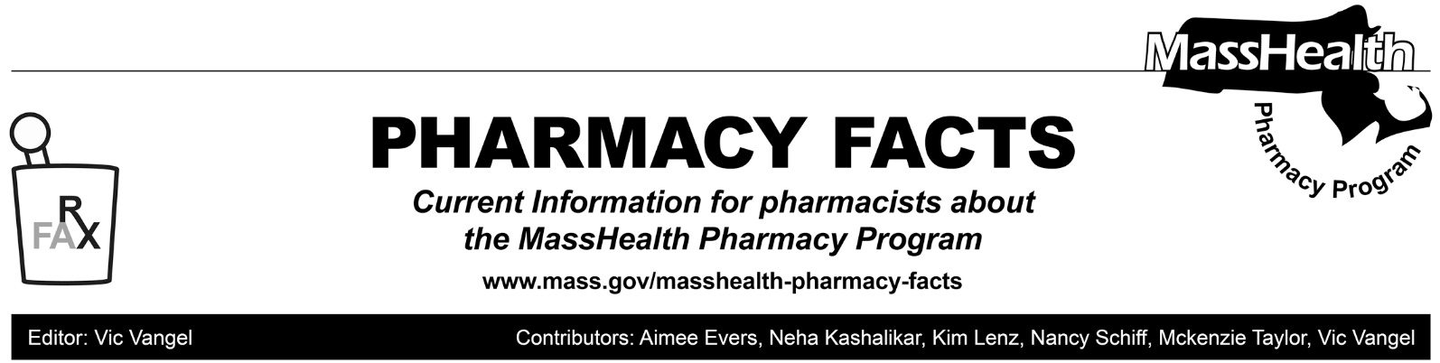

Pharmacy Coverage and Billing Information for COVID-19 Oral Antivirals
On December 22, 2021, the U.S. Food and Drug Administration (FDA) granted emergency use authorization (EUA) for nirmatrelvir co-packaged with ritonavir (Paxlovid) for the treatment of mild-to-moderate COVID-19 in adults and pediatric patients (≥12 years of age and weighing at least 40 kg) at high risk for progression to severe COVID-19. On December 23, 2021, the FDA granted EUA for molnupravir for the treatment of mild-to-moderate COVID-19 in adults at high risk for progression to severe COVID-19.
For additional information please see the FDA’s EUA and its accompanying Fact Sheet for Healthcare Providers for nirmatrelvir co-packaged with ritonavir and the EUA and its accompanying Fact Sheet for Healthcare Providers for molnupravir.
For claims billed through the MassHealth Pharmacy Online Processing System (POPS), MassHealth will pay MassHealth-enrolled pharmacies a $10.02 dispensing fee for nirmatrelvir co-packaged with ritonavir effective for dates of service on or after December 22, 2021, and for molunpravir for dates of service on or after December 23, 2021. Prior authorization is not required. There is no cost sharing for claims for these drugs.
MassHealth will follow the National Council for Prescription Drug Programs (NCPDP) Emergency Preparedness Guidance for claims submission through POPS.

In general, claims submitted for zero-cost oral antivirals should be submitted on a single B1/B3 billing transaction including the following data elements and values:
- The submitted Transaction Code (103-A3) is a “B1” (Claim Billing).
- The submitted Prescription/Service Reference Number Qualifier (455-EM) is a “1” (Rx Billing).
- The claim pricing segment follows the prescription claim request formula.
- The Product/Service ID Qualifier (436-E1) should be submitted with a value of the correct product (in this example “03” (NDC) and the Product/Service ID (407-D7) contain the NDC of the product).
- The Days Supply (405-D5) should be submitted with appropriate value.
- The Quantity Dispensed (442-E7) should be submitted with the value that represents the quantity of product dispensed.
- The Dispensing Fee Submitted (42-DC) field is submitted to identify that the pharmacy is seeking reimbursement for the agreed-upon dispensing fee of the free product.
- Basis of Cost Determination (423-DN) should be submitted with the value “15” (Free product at no associated cost).

