Number 177, January 14, 2022
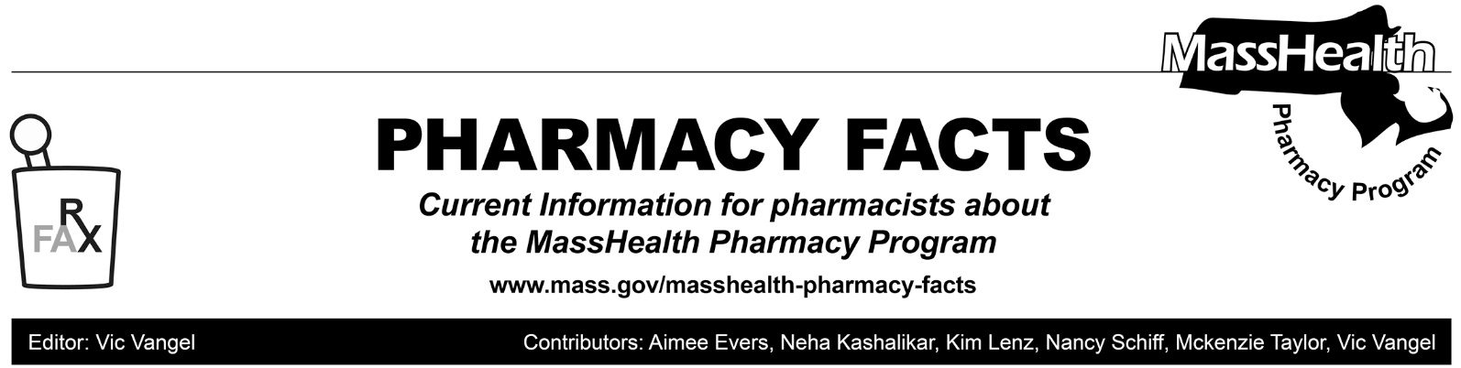

MassHealth Pharmacy Coverage of Over-the-Counter Diagnostic Antigen Tests for SARS-CoV-2

Effective January 14, 2022, the following over-the-counter (OTC) diagnostic SARS-CoV-2 antigen tests (“at-home antigen self-test kits”) have been added to the MassHealth Non-Drug Product List.
- BinaxNOW
- IHealth
- Inteliswab
- FlowFlex
- QuickVue At-home
Pharmacies can submit claims through the MassHealth Pharmacy Online Processing System (POPS) for the NDCs listed in the table at the bottom of the page. Test kits will be covered without prior authorization within the quantity limit of eight test kits per member per month. Note that test kits may be packaged individually or with multiple test kits in one package; the limit without prior authorization is eight test kits per member per month, regardless of how they are packaged (e.g., four packages containing two test kits or eight packages containing one test kit will be covered without prior authorization). Pharmacies are reminded that regardless of packaging, the billing unit is per test kit.
Coverage of additional test kits exceeding the quantity limit described above will require prior authorization. Such requests will be reviewed by MassHealth on a case-by-case basis. The Massachusetts Department of Public Health has issued a statewide standing order that allows licensed pharmacists to dispense at-home antigen self-test kits to any individual, and to treat that standing order as a prescription for any such test kit. Accordingly, an individual prescription is not required for any such test kit.

This coverage policy applies to members enrolled in MassHealth fee-for-service, the Primary Care Clinician Plan and Primary Care Accountable Care Organizations, as well as Health Safety Net patients and Children’s Medical Security Plan members.
Pharmacies will be paid the lower of the rates listed below or the Usual and Customary Charge submitted for covered OTC COVID-19 at-home antigen self-test kits. MassHealth expects to codify this rate methodology in forthcoming amendments to Executive Office of Health and Human Services rate regulations.

.
Product | Rate | NDC
BinaxNOW | $24.00 (box of 2) | 11877001140
IHealth | $20.00 (box of 2) | 56362000589
Inteliswab | $24.00 (box of 2) | 08337000158
QuickVue | $24.00 (box of 2) | 14613033972
FlowFlex | $10.00 (box of 1) | 82607066026
FlowFlex | $20.00 (box of 2) | 82607066027

MassHealth anticipates adding additional at-home antigen self-test kits to the MassHealth Non-Drug Product List in the near-future. Please continue to monitor for additions.

