Number 178 January 24, 2022
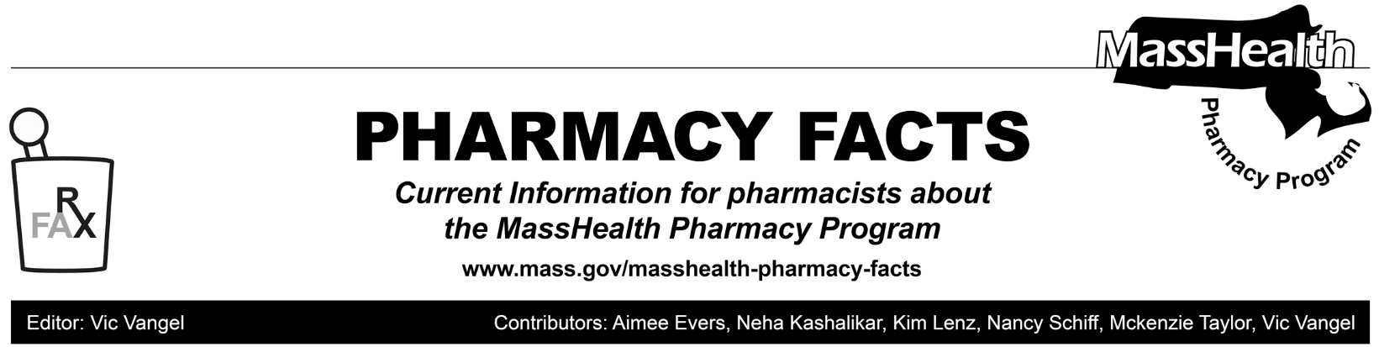
MassHealth Pharmacy Regulation Changes

This Pharmacy Facts describes revisions to the pharmacy regulations at 130 CMR 406.000. These revisions implement new polices to exclude certain drugs from being purchased through the 340B Drug Pricing Program for MassHealth members; requiring or allowing 90-day supplies of particular drugs; and adding some exceptions to day-supply limits. Amendments were made to clarify or update some already-existing policies, including the 365-day supply for drugs used for family planning; payment for vaccines and non-drug products provided to pharmacies; cash payments; and required notifications when a drug was not dispensed because the prescriber had not sought prior authorization (PA).

Amendments, including the following, were made to implement new policies:
- 130 CMR 406.404(D) which discusses the rules for 340B entities was amended to give MassHealth the authority to exclude certain drugs from purchase through the 340B Drug-Pricing Program for MassHealth members. This authority applies to drugs that cost more than $100,000 per year gross cost per utilizer (as defined in 130 CMR 406.402) and is limited to no more than 25 drugs. It does not apply to claims paid utilizing the adjudicated payment amount per discharge (APAD) or adjudicated payment per episode of care (APEC) methodology, other than for drugs listed on the Acute Hospital Carve-Out Drugs List section of the MassHealth Drug List. MassHealth will provide notice of its intention to exclude drugs from purchase through the 340B drug pricing program consistent with requirements of M.G.L. c. 118E, §13L, and allow for provider input.
- 130 CMR 406.411(D)(1), which discusses day-supply limits, was amended to allow MassHealth to designate particular generic, low-cost drug, and preferred drugs as required to be dispensed in a 90-day supply after a trial supply is dispensed in up to a 30-day supply, and allows MassHealth to designate exclusions from days’ supply requirements. In addition, regulatory changes will allow (but not require) certain drugs to be dispensed in a 90-day supply. MassHealth will designate drugs required or allowed to be dispensed in a 90-day supply on the MassHealth Drug List. These changes are designed to give MassHealth additional flexibility as circumstances change.

Please note that for the duration of the COVID-19 federal public health emergency, MassHealth’s previously announced COVID-19 90-day supply policy is still in effect. Please see Pharmacy Facts #141 and #142 (https://www.mass.gov/lists/masshealth-pharmacy-facts) for more detail. MassHealth will provide guidance in the MassHealth Drug List or via other written issuance if this policy changes before the end of the federal public health emergency.
- 130 CMR 406.411(D)(2), which addresses exceptions to the day’s supply limits, was updated as follows.
- 130 CMR 406.411(D)(2)(a)(9) and 406.411(D)(2)(a)(10) were amended to update language related to prescriptions to conform with new policies from the Department of Public Health (DPH).
- 130 CMR 406.411(D)(2)(a)(11) was added to allow MassHealth to designate other exceptions to the days’ supply limits via Pharmacy Facts or other written issuance.
Amendments to clarify some already existing policies include:

- 130 CMR 406.411 (D)(2)(b) was amended to reflect that drugs used for family planning may be dispensed in up to a 365-day supply. Please note that Pharmacy Facts 157 already permitted pharmacies to dispense up to a 365-day supply of drugs used for family planning if requested by a MassHealth member or that member’s prescriber as long as sufficient quantity remains on the prescription to support the quantity being filled.

- 130 CMR 130 406.412(B), which discusses the non-drug products paid through the Pharmacy Online Processing System (POPS), was amended to update language about the payment method for products listed on the Non-drug Product List of the MassHealth Drug List to be consistent with current practices.

- 130 CMR 130 406.412(D), which describes covered professional services paid through POPS, was amended to increase the ability for pharmacies to administer and be paid for certain vaccines for MassHealth members younger than 18-years of age as allowed by DPH.
130 CMR 406.424: Cash Payments was added to give clear guidance to providers about when it is impermissible to accept a cash payment from MassHealth members for prescribed drugs in order to enhance program integrity and ensure members are not improperly charged for drugs available through MassHealth. Guidance was provided concerning the steps pharmacies must take and document prior to accepting cash payment.
- 130 CMR 406.422, which discusses prior authorization, was amended to add language requiring pharmacies to notify member and prescriber if the pharmacy does not dispense a drug because prior authorization was required and not sought.

MassHealth pharmacy regulations can be found on the Mass.gov website at 130 CMR 406.000: Pharmacy Services | Mass.gov.

These regulations are effective January 24, 2022.

