Number 180, March 15, 2022
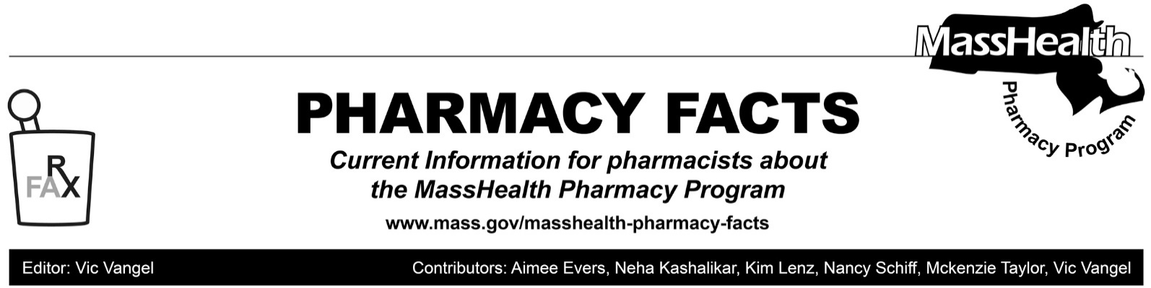
MHDL Update

Below are certain updates to the MassHealth Drug List (MHDL). See the MHDL for a complete listing of updates.

Additions
- Effective March 21, 2022, the following newly marketed drugs have been added to the MassHealth Drug List.
- Prehevbrio (hepatitis B recombinant vaccine)¹
- Qulipta (atogepant) – PA
- Skytrofa (lonapegsomatropin-tcgd) – PA
- Tavneos (avacopan) – PA
- Tivdak (tisotumab vedotin-tftv) – PA
- Trudhesa (dihydroergotamine nasal spray) – PA
- Ukoniq (umbralisib) – PA
- Vuity (pilocarpine 1.2% ophthalmic solution) – PA
- Welireg (belzutifan) – PA
- Effective for the date listed below, the following COVID-19 treatment has been added to the MassHealth Drug List on February 24, 2022.
- bebtelovimab (COVID EUA – February 11, 2022)
Change in Prior-Authorization Status
- Effective March 21, 2022, the following cerebral stimulant agent will require prior authorization.
- Vyvanse (lisdexamfetamine chewable tablet) – PA
- Effective March 21, 2022, the following benign prostatic hyperplasia agents will no longer require prior authorization.
- Avodart # (dutasteride)
- Proscar # (finasteride)
- Effective March 21, 2022, the following intranasal corticosteroid agent will no longer require prior authorization within quantity limits.
- Omnaris (ciclesonide 50 mcg nasal spray) – > 1 inhaler/month PA
- Effective March 21, 2022, the following intranasal corticosteroid agent will require prior authorization for all quantities.
- Zetonna (ciclesonide 37 mcg nasal aerosol) – PA
- Effective March 21, 2022, the following topical antifungal agents will no longer require prior authorization.
  - Ertaczo (sertaconazole)
- Vusion (miconazole/zinc oxide ointment) ^{BP}
- Effective March 21, 2022, the following topical antifungal agent will require prior authorization.
  - Loprox (ciclopirox 0.77% suspension) – PA
- Effective March 21, 2022 the following dermatological agent will no longer require prior authorization.
  - Carac (fluorouracil 0.5% cream) ^{BP}
- Effective March 21, 2022, the following cardiovascular agents will no longer require prior authorization.
- Bidil (isosorbide dinitrate/hydralazine)
- Ranexa # (ranolazine)
- Effective March 21, 2022, the following cardiovascular agents will require prior authorization.
- isradipine immediate-release – PA
- nicardipine capsule – PA

Updated MassHealth Brand Name Preferred Over Generic Drug List
The MassHealth Brand Name Preferred Over Generic Drug List has been updated to reflect recent changes to the MassHealth Drug List.

Effective March 21, 2022, the following agents will be added to the MassHealth Brand Name Preferred Over Generic Drug List.
- Coreg CR (carvedilol extended-release) ^{BP} – PA
- Corgard (nadolol) ^{BP}
- Cosopt PF (dorzolamide/timolol, preservative free) ^{BP} – PA
- Exelderm (sulconazole) ^{BP} – PA
- Inspra (eplerenone) ^{BP}
- Lotronex (alosetron) ^{BP} – PA
- Luzu (luliconazole) ^{BP} – PA
- Naftin (naftifine 1% gel) ^{BP} – PA
- Nitrolingual (nitroglycerin lingual spray) ^{BP} – PA
- Oxistat (oxiconazole cream) ^{BP} – PA
- Vimpat (lacosamide solution, tablet) ^{BP} – PA
- Vusion (miconazole/zinc oxide ointm ent) ^{BP}
Updated MassHealth Non-Drug Product List

The MassHealth Non-Drug Product List has been updated to reflect recent changes to the MassHealth Drug List.

Effective March 21, 2022, the following products will be added to the MassHealth Non-Drug Product List.
- Carestart (COVID-19 antigen self-test) – PA > 8 tests/28 days
- On-Go (COVID-19 antigen self-test) – PA > 8 tests/28 days

MassHealth Pharmacy Coverage of Pediatric Enteral Special Formula and Thickening Agents – Health Safety Net Coverage (HSN)
Due to concerns about the supply chain for formula and thickening agents, the following items were added to the MassHealth Pharmacy Non-Drug Product List:
- Pediatric Enteral Special Formula – PA
- Thickening Agents – PA

In addition to coverage for MassHealth members described in Pharmacy Facts 175, this change will also apply to Health Safety Net patients whose pharmacy claims are paid through MassHealth’s Pharmacy Online Processing System (POPS), effective for dates of service on or after February 25, 2022. This coverage does not apply to MassHealth Limited members.

Legend

PA Prior authorization is required. The prescriber must obtain prior authorization for the drug in order for the pharmacy to receive payment. Note: PA applies to both the brand-name and the FDA “A”-rated generic equivalent of listed product.

# Designates a brand-name drug with FDA “A”-rated generic equivalents. Prior authorization is required for the brand, unless a particular form of that drug (for example, tablet, capsule, or liquid) does not have an FDA “A”-rated generic equivalent.

^{BP} Brand preferred over generic equivalents. In general, MassHealth requires a trial of the preferred drug or clinical rationale for prescribing the nonpreferred drug generic equivalent.

^{PD} In general, MassHealth requires a trial of the preferred drug (PD) or a clinical rationale for prescribing a nonpreferred drug within a therapeutic class.

^{CO} This agent is listed on the Acute Hospital Carve-Out Drugs List and is subject to additional monitoring and billing requirements.

