Number 181, May 9, 2022
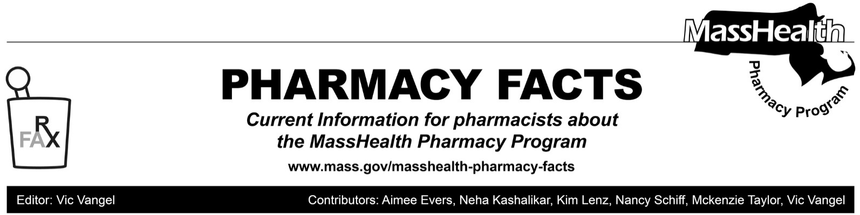
Upcoming Changes to 340B Pharmacy Claims Adjudication

Effective May 12, 2022, MassHealth will begin to deny 340B pharmacy claims submitted through the Pharmacy Online Processing System (POPS) when the 340-B Ingredient Cost Submitted (NCPDP field 409-D9) is greater than the Wholesale Acquisition Cost (WAC). If the submitted 340-B ingredient cost exceeds the WAC, the pharmacy will see a claim rejection that reads as follows.

23 - M/I INGREDIENT COST SUBMITTED, with text message, YOUR INGREDIENT COST SUBMITTED EXCEEDS THE MAXIMUM ALLOWABLE AMOUNT PAYABLE UNDER THE MASSHEALTH PAYMENT METHODOLOGY. PLEASE CORRECT AND RESUBMIT.

If the pharmacy feels that the 340-B Ingredient Cost Submitted is justified, they should reach out to the MassHealth Pharmacy Technical Help Desk at (866) 246-8503.
Pharmacies must submit a Basis of Cost Determination (NCPDP field 423-D9) value of “08” when submitting any 340B pharmacy claim billed with 340-B acquisition cost. Any 340B facility dispensing a drug not purchased through the 340B program must submit the claim with a Basis of Cost Determination value of “05,” indicating that a 340-B purchased drug was not dispensed. Please refer to the POPS Billing Guide for detailed billing instructions (Microsoft Word - BG-POPS-v14-081513vb.doc (mass.gov)).
This applies to all MassHealth, Children’s Medical Security Plan (CMSP), and Health Safety Net (HSN) claims billed through POPS.
MHDL Update
Additions
Effective May 9, 2022, the following newly

marketed drugs have been added to the MassHealth Drug List.
- citalopram capsule – PA
- Cortrophin (corticotropin) – PA
- diclofenac potassium 25 mg tablet – PA
- Elepsia XR (levetiracetam extended-release) – PA
- Elyxyb (celecoxib oral solution) – PA
- Eprontia (topiramate solution) – PA
- Kimyrsa (oritavancin) – PA
- Leqvio (inclisiran) – PA
- Livmarli (maralixibat) – PA
- Livtencity (maribavir) – PA
- Quadracel (tetanus toxoids/diphtheria/acellular pertussis/inactivated poliovirus vaccine)
- Synojoynt (hyaluronate) – PA
- Tezspire (tezepelumab-ekko) – PA
- Tyrvaya (varenicline nasal spray) – PA
- Xarelto (rivaroxaban suspension) – PA

Change in Prior-Authorization Status

- Effective May 9, 2022, the following glaucoma agent will no longer require prior authorization (PA).
- Simbrinza (brinzolamide/brimonidine)
- Effective May 9, 2022, the following injectable antibiotic agent will no longer require PA.
- Teflaro (ceftaroline) ^{BP}
- Effective May 9, 2022, the following antiparkinsonian agents will no longer require PA.
- Comtan # (entacapone)
- Stalevo # (carbidopa/levodopa/entacapone)
- ropinirole extended-release

- Effective May 9, 2022, the following probiotic agents will no longer require PA within the updated age limit.
- Align (bifidobacterium infantis) – PA
> 22 years
  - Culturelle (lactobacillus rhamnosus GG) – PA ≥ 22 years
  - Florastor (saccaromyces boulardii) – PA ≥ 22 years
- Effective May 9, 2022, the following supplement will no longer require PA within the newly updated age limit.
  - coenzyme Q10 – PA ≥ 22 years
- Effective May 9, 2022, the following topical osteoporosis and bone metabolism agent will no longer require PA .
- Reclast # (zoledronic acid 5 mg)
Updated MassHealth Brand Name Preferred Over Generic Drug List
- Effective May 9, 2022, the following gents will be added to the MassHealth Brand Name Preferred Over Generic Drug List.
- Atelvia (risedronate delayed-release) ^{BP} – PA
- Miacalcin (calcitonin salmon injection) ^{BP} – PA
- Xerese (acyclovir/hydrocortisone) ^{BP}
- Effective May 9, 2022, the following agents will be removed from the MassHealth Brand Name Preferred Over Generic Drug List.
- Androgel (testosterone 1.62% gel packet) – PA
- Naftin (naftifine 1% gel) – PA
- Protopic # (tacrolimus topical)
- Vimpat (lacosamide solution, tablet)

Updated MassHealth Non-Drug Product List
List. Effective May 9, 2022 the following product was added to the MassHealth Non-Drug Product List.
- Synojoynt (hyaluronate) – PA

Legend

PA Prior authorization is required. The prescriber must obtain prior authorization for the drug in order for the pharmacy to receive payment. Note: PA applies to both the brand-name and the FDA “A”-rated generic equivalent of listed product.

# Designates a brand-name drug with FDA “A”-rated generic equivalents. Prior authorization is required for the brand, unless a particular form of that drug (for example, tablet, capsule, or liquid) does not have an FDA “A”-rated generic equivalent.

^{BP} Brand preferred over generic equivalents. In general, MassHealth requires a trial of the preferred drug or clinical rationale for prescribing the nonpreferred drug generic equivalent.

^{PD} In general, MassHealth requires a trial of the preferred drug (PD) or a clinical rationale for prescribing a nonpreferred drug within a therapeutic class.

The MassHealth Non-Drug Product List has been
updated to reflect changes to the MassHealth Drug

