Number 182, June 22, 2022
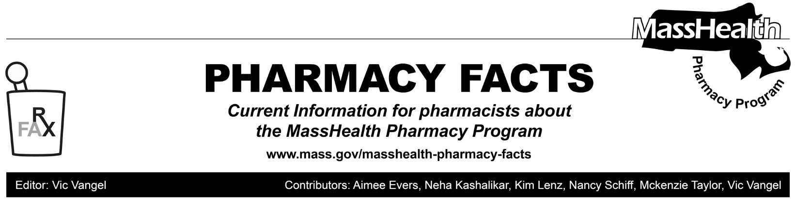
MHDL Update

What follows are certain updates to the MassHealth Drug List (MHDL). See the MHDL for a complete listing of updates.

Additions

- Effective June 27, 2022, the following newly marketed drugs have been added to the MassHealth Drug List.
- Adbry (tralokinumab-ldrm) – PA
- Carvykti (ciltacabtagene autoleucel) CO ^ – PA
- Cibinqo (abrocitinib) – PA
- Dartisla ODT (glycopyrrolate orally disintegrating tablet) – PA
- Enjaymo (sutimlimab-jome) – PA
- Ibsrela (tenapanor) – PA
- Kimmtrak (tebentafusp-tebn) – PA
- Scemblix (asciminib) – PA
- Seglentis (celecoxib/tramadol) – PA
- Susvimo (ranibizumab) ^
- Vyvgart (efgartigimod alfa-fcab) – PA
- Effective June 27, 2022, the following COVID-19 therapy has been added to the MassHealth Drug List.
- Olumiant (baricitinib for members ≥ 18 years of age) H

Change in Prior-Authorization Status

- Effective June 27, 2022, the following hematologic agent will require prior authorization (PA).
  - Siklos (hydroxyurea tablet) – PA
- Effective June 27, 2022, the following constipation agent will no longer require PA.
  - Linzess (linaclotide 145 mcg, 290 mcg)
- Effective June 27, 2022, the following opioid reversal agent will no longer require PA.
- Kloxxado (naloxone 8 mg nasal spray)
- Effective June 27, 2022, the following agent will no longer be restricted to the health care professional who administers the drug.
- Mifeprex # (mifepristone 200 mg)
- Effective June 27, 2022, the following butalbital-containing agent will require PA.
- butalbital 50 mg/acetaminophen 325 mg/caffeine 40 mg capsule – PA

Updated MassHealth Brand Name Preferred Over Generic Drug List

The MassHealth Brand Name Preferred Over Generic Drug List has been updated to reflect recent changes to the MassHealth Drug List.

- Effective June 27, 2022, the following agents will be added to the MassHealth Brand Name Preferred Over Generic Drug List.
- Breo (fluticasone/vilanterol) ^{BP} – PA
- Cystadane (betaine) ^{BP}
- Daytrana (methylphenidate transdermal) ^{BP} – PA < 3 years and PA > 1 unit/day
- Lantus (insulin glargine) ^{BP}
- Pennsaid (diclofenac topical solution) ^{BP}
- Pentasa (mesalamine controlled-release) ^{BP}
- Tegretol XR (carbamazepine extended-release) ^{BP} – PA < 6 years
- Trileptal (oxcarbazepine suspension) ^{BP} – PA < 6 years

- Effective June 27, 2022, the following agents will be removed from the MassHealth Brand Name Preferred Over Generic Drug List.
- Catapres-TTS (clonidine patch) – PA
- Cayston (aztreonam)
- Corgard # (nadolol)
- Narcan # (naloxone 4 mg nasal spray)
- Renagel # (sevelamer hydrochloride)
- Revatio (sildenafil 20 mg tablet) – PA
- Xopenex HFA # (levalbuterol inhaler)

Updated MassHealth Non-Drug Product List

The MassHealth Non-Drug Product List has been updated to reflect recent changes to the MassHealth Drug List.

Effective May 17, 2022, the following product was added to the MassHealth Non-Drug Product List.
- Medically necessary formula
Effective May 20, 2022, the following products do not require PA.
- Pediatric enteral special formula
- Thickening agents

____________________________________
Legend

PA Prior authorization is required. The prescriber must obtain prior authorization for the drug in order for the pharmacy to receive payment. Note: PA applies to both the brand-name and the FDA “A”-rated generic equivalent of listed product.

# Designates a brand-name drug with FDA “A”-rated generic equivalents. Prior authorization is required for the brand, unless a particular form of that drug (for example, tablet, capsule, or liquid) does not have an FDA “A”-rated generic equivalent.

^{BP} Brand preferred over generic equivalents. In general, MassHealth requires a trial of the preferred drug or clinical rationale for prescribing the nonpreferred drug generic equivalent.

^{H} Available only in an inpatient hospital setting. MassHealth does not pay for this drug to be dispensed through the retail pharmacy or physician's office.

^{PD} In general, MassHealth requires a trial of the preferred drug (PD) or a clinical rationale for prescribing a nonpreferred drug within a therapeutic class.

^{CO} Carve-Out. This agent is listed on the Acute Hospital Carve-Out Drugs List and is subject to additional monitoring and billing requirements.

^ Available through the health care professional who administers the drug. MassHealth does not pay for this drug to be dispensed through a retail pharmacy.

