Number 183, August 12, 2022
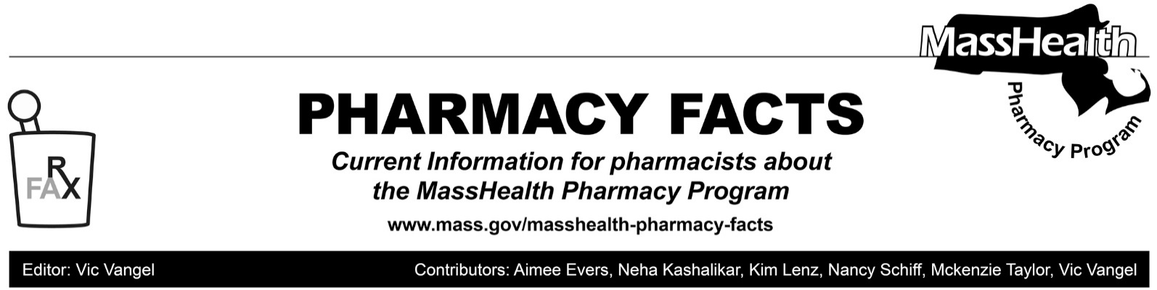
Changes to Prescription Drug Days’ Supply Limitations, Effective September 19, 2022

In Pharmacy Facts 141, Pharmacy Facts 142, All Provider Bulletin 289, All Provider Bulletin 291, and All Provider Bulletin 319, MassHealth implemented the following temporary policy change in response to Coronavirus Disease 2019 (COVID-19):

“Despite the requirements of 130 CMR 406.411(D)(1): Days’ Supply Limitation, pharmacies may dispense up to a 90-day supply of a prescription drug if requested by a MassHealth member or that
member’s prescriber as long as sufficient quantity remains on the prescription to support the quantity being filled.”

In All Provider Bulletin 319 and Pharmacy Facts 178, MassHealth indicated that this policy would be in place through the end of the federal public health emergency (PHE). However, in light of the numerous extensions of the PHE since the issuance of these communications, MassHealth has decided to end this policy before the end of the PHE. Specifically, effective September 19, 2022, the days’ supply limitations described in MassHealth pharmacy regulation 130 CMR 406.411(D) will apply. As a result, MassHealth will no longer allow 90-day supplies for most brand name drugs. Members will still be able to get these brand name drugs in 30-day supplies.

Also effective September 19, 2022, the MassHealth Drug List will designate which drugs will be allowed to be dispensed in a 90-day supply using the footnote of A90 in the A-Z list. MassHealth will allow for a 90-day supply for these drugs when a prescriber authorizes or a member requests a 90-day supply to be dispensed, as long as sufficient quantity remains on the prescription to support the quantity being filled. If a prescriber authorizes a 90-day supply, the pharmacy provider will be expected to dispense that prescription in a 90-day supply unless if the pharmacist, in their professional judgment, thinks that it is inappropriate or dangerous to do so. If the pharmacist, in their professional judgment, thinks that it is inappropriate or dangerous to have a 90-day supply of a particular prescription, they should contact the MassHealth Drug Utilization Review (DUR) to get an override at (800) 745-7318.

Effective December 19, 2022, MassHealth anticipates requiring a subset of these drugs to be dispensed in a 90-day supply, consistent with 130 CMR 406.411(D)(b)(1). These drugs will be designated on the MassHealth Drug List A-Z list with a footnote of M90. MassHealth will send out additional detail about mandatory 90-day supplies in future communications.

This policy will apply to members enrolled in MassHealth fee-for-service, the Primary Care Clinician (PCC) plan, and Primary Care Accountable Care Organizations (Primary Care ACOs).

The entire regulation can be found at MassHealth Pharmacy Regulations. The portion on Days’ Supply Limitations is reproduced as follows, for reference.

(D) Quantities.
(1) Days' Supply Limitations.
(a) The MassHealth agency requires that all drugs be dispensed in a 30-day supply, unless the drug is available only in a larger minimum package size, except as specified in 130 CMR 406.411(D)(1)(b) and 130 CMR 406.411(D)(2).
(b) 90-day supplies. The MassHealth agency requires or allows that drugs be dispensed in a 90-day supply in the following circumstances, except as specified in 130 CMR 406.411(D)(2):
1. Required 90-day supplies. The MassHealth agency requires certain designated generic drugs, other designated low-net-cost drugs, and drugs listed as preferred in the Brand Name Preferred section of the MassHealth Drug List to be dispensed in a 90-day supply after a trial supply is dispensed in up to a 30-day supply. Drugs subject to this requirement will be designated in the MassHealth Drug List. This requirement does not apply to drugs dispensed to members in certain long-term care facilities, hospices, and group homes, or as specified by law or regulation.
2. Allowed 90 day supplies. MassHealth allows that drugs be dispensed in up to a 90-day supply in the following circumstances:
a. Drugs designated in the MassHealth Drug List as allowed to be dispensed in 90-day supplies.
b. Drugs for which the MassHealth agency is not the primary payer but for which payment is available from the MassHealth agency for any portion of the claim (including any copayment or deductible), provided that the primary payer will pay for the drug when dispensed in up to a 90-day supply. Exceptions prohibiting the dispensing of a drug in a 90-day supply set forth in 130 CMR 406.411(D)(2) do not apply if the primary payer will pay for the drug when dispensed up to a 90-day supply.
(c) The MassHealth Drug List 90-day Supply Page. This page on the MassHealth Drug List describes the types of drugs that are allowed or required to be dispensed in a 90-day supply. This page also notes exclusions to the 90-day supply program which are at the discretion of the MassHealth agency.
(2) Exceptions to Days' Supply Limitations.
(a) The MassHealth agency allows exceptions to the limitations described in 130 CMR 406.411(D)(1) for the following products:
1. drugs in therapeutic classes that are commonly prescribed for less than a 30-day or 90-day supply (as applicable) including, but not limited to, antibiotics and analgesics;
2. drugs that, in the prescriber's professional judgment, are not clinically appropriate for the member in a 30-day or 90-day supply (as applicable);
3. drugs that are new to the member, and are being prescribed for a limited trial amount, sufficient to determine if there is an allergic or adverse reaction or lack of effectiveness. The initial trial amount and the member's reaction or lack of effectiveness must be documented in the member's medical record;
4. drugs packaged in such a way that the smallest quantity that may be dispensed is larger than a 30-day or 90-day supply, as applicable (for example, inhalers, ampules, vials, eye drops, and other sealed containers not intended by the manufacturer to be opened by any person other than the end user of the product);
5. drugs in topical dosage forms that do not allow the pharmacist to accurately predict the rate of the product's usage (for example, lotions or ointments);
6. products generally dispensed in the original manufacturer's packaging (for example, fluoride preparations, prenatal vitamins, and over-the-counter drugs);
7. methylphenidate and amphetamine prescribed in 60-day supplies;
8. drugs designated by MassHealth as required to be dispensed in less than 30-day or 90-day supplies (as applicable) in order to limit potential fraud, waste, or abuse.
9. opioid substances in schedule II if the patient requests less than the prescribed quantity as provided in M.G.L. c. 94, § 18(d3/4).
10. drugs designated for reporting to the Department of Public Health's Prescription Monitoring Program, 105 CMR 700.012(A): Pharmacy Reporting Requirements, are not eligible to be dispensed in a 90-day supply; and
11. as designated in a Pharmacy Facts, provider bulletin or other written issuance from the MassHealth agency.
(b) Drugs used for family planning may be dispensed in up to a 365-day supply.

