Number 184, September 16, 2022
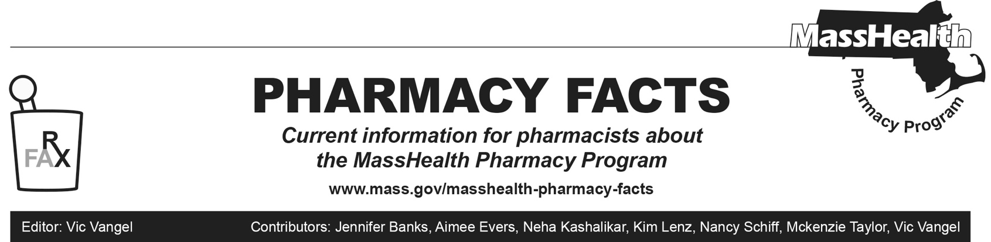
MHDL Updates
Below are certain updates to the MassHealth Drug List (MHDL). See the MHDL for a complete listing of updates.
- Additions
Effective September 19, 2022, the following newly marketed drugs have been added to the MassHealth Drug List.
- Apretude (cabotegravir injection) – PA
- Besremi (ropeginterferon alfa-2b-njft) – PA
- Camzyos (mavacamten) – PA
- Korsuva (difelikefalin) – ^
- Mounjaro (tirzepatide) – PA
- Norliqva (amlodipine solution) – PA
- Opdualag (nivolumab/relatlimab-rmbw) – PA
- Priorix (measles/mumps/rubella vaccine)
- Pyrukynd (mitapivat) – PA
- Quviviq (daridorexant) – PA
- Recorlev (levoketoconazole) – PA
- Tarpeyo (budesonide 4 mg delayed-release capsule) – PA
- Vabysmo (faricimab-svoa) – ^
- Vijoice (alpelisib) – PA
- Voxzogo (vosoritide) – PA
- Zimhi (naloxone 5 mg/0.5 mL syringe)
2. Effective for the date listed below, the following COVID-19 preventive therapy has been added to the MassHealth Drug List on September 19, 2022.
- Novavax COVID-19 vaccine, adjuvanted (COVID EUA – July 13, 2022)
3. Effective August 15, 2022, the following agents have been added to the MassHealth Drug List on September 19, 2022.

- ACAM2000 (smallpox vaccine, live)
- Jynneos (smallpox and monkeypox vaccine,
live, non-replicating)
- Tpoxx (tecovirimat)

Change in Prior-Authorization Status

1. Effective September 19, 2022, the following antimalarial agent will no longer require prior authorization (PA).
- Qualaquin (quinine); #, A90
2. Effective September 19, 2022, the following immunosuppressant agent will no longer require PA .
- Myfortic (mycophenolic acid); #, A90
3. Effective September 19, 2022, the following modafinil agents will require PA for concurrent therapy (overlapping pharmacy claims for different agents within the last 30 days)
- Nuvigil (armodafinil) – PA < 6 years and PA > 1 unit/day; #
- Provigil (modafinil 100 mg) – PA < 6 years and PA > 1.5 units/day; #
- Provigil (modafinil 200 mg) – PA < 6 years and PA > 2 units/day; #

Updated MassHealth Brand Name Preferred Over Generic Drug List
The MassHealth Brand Name Preferred Over Generic Drug List has been updated to reflect recent changes to the MassHealth Drug List.

1. Effective September 19, 2022, the following agents will be added to the MassHealth Brand Name Preferred Over Generic Drug List.
- Mestinon (pyridostigmine bromide solution); BP, A90
- Nexavar (sorafenib) – PA; BP, A90
- Vecitical (calcitriol ointment) – PA; BP, A90
2. Effective September 19, 2022, the following agents will be removed from the MassHealth Brand Name Preferred Over Generic Drug List.
- Androgel (testosterone 1% gel packet) – PA
- Antara (fenofibrate 30 mg, 90 mg capsule); #, M90
- Diastat (diazepam rectal gel) – PA > 5 kits (10 syringes)/month; #
____________________________________

Legend

PA Prior authorization is required. The prescriber must obtain prior authorization for the drug in order for the pharmacy to receive payment. Note: PA applies to both the brand-name and the FDA “A”-rated generic equivalent of listed product.

# Designates a brand-name drug with FDA “A”-rated generic equivalents. Prior authorization is required for the brand, unless a particular form of that drug (for example, tablet, capsule, or liquid) does not have an FDA “A”-rated generic equivalent.

^{BP} Brand preferred over generic equivalents. In general, MassHealth requires a trial of the preferred drug or clinical rationale for prescribing the nonpreferred drug generic equivalent.

^{PD} In general, MassHealth requires a trial of the preferred drug (PD) or a clinical rationale for prescribing a nonpreferred drug within a therapeutic class.

^ Available through the health care professional who administers the drug. MassHealth does not pay for this drug to be dispensed through a retail pharmacy.

A90 Allowable 90-day supply. Dispensing in up to a 90-day supply is allowed. May not include all strengths or formulations. Quantity limits and other restrictions may apply.

M90 Effective 12/19/22, mandatory 90-day supply. After dispensing up to a 30-day supply initial fill, dispensing in a 90-day supply is required. May not include all strengths or formulations. Quantity limits and other restrictions may also apply. Prior to 12/19/22, allowable 90-day supply and dispensing in up to a 90-day supply is allowed.

