Number 185, September 22, 2022
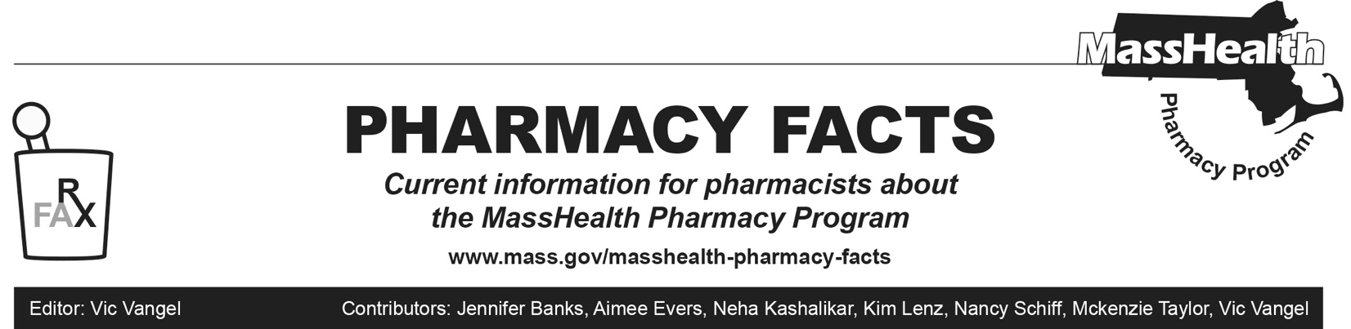
Off-Cycle MHDL Update
This issue announces changes that will be posted to the MassHealth Drug List on Oct 31, 2022.
Change in Prior-Authorization Status
1. Effective September 23, 2022, the following respiratory agents will not require prior authorization.
- Proventil ^{BP}
- Ventolin ^{BP}
2. Effective September 23, 2022, the following respiratory agent will require prior authorization.
- albuterol inhaler – PA
Updated MassHealth Brand Name Preferred Over Generic Drug List
Effective September 23, 2022, the following agents will be added to the MassHealth Brand Name Preferred Over Generic Drug List.
- Proventil ^{BP}
- Ventolin ^{BP}

Legend

^{BP} Brand preferred over generic equivalents. In general, MassHealth requires a trial of the preferred drug or clinical rationale for prescribing the nonpreferred drug generic equivalent.

