Number 186, October 18, 2022
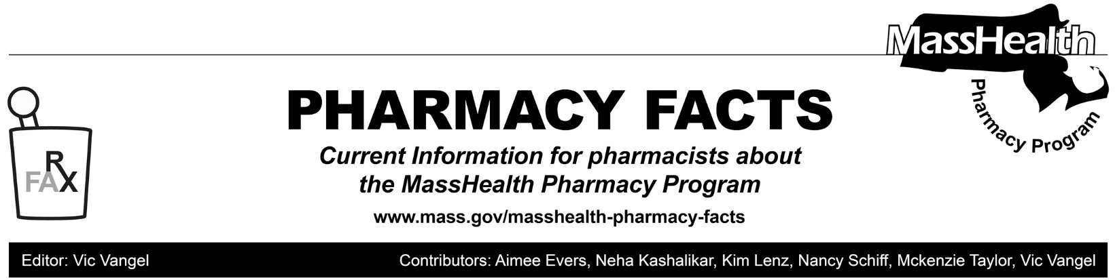
Changes to Prescription Drug Days’ Supply Limitations, Effective December 19, 2022

In Pharmacy Facts 183 and All Provider Bulletin 347 MassHealth announced that effective September 19, 2022, MassHealth would begin implementing the days’ supply limitations described in MassHealth pharmacy regulation 130 CMR 406.411(D) that became effective on January 24, 2022. These changes allow certain drugs to be dispensed in a 90-day supply. (See also Pharmacy Facts 178.) These drugs are designated on the MassHealth Drug List with a footnote of A90.

Effective December 19, 2022, MassHealth will make it mandatory for certain designated generic drugs, other designated low-net-cost drugs, and drugs listed as preferred in the Brand Name Preferred section of the MassHealth Drug List to be dispensed in a 90-day supply. These drugs will be designated on the MassHealth Drug List A-Z list with a footnote of M90.
This policy will apply to members enrolled in MassHealth fee-for-service, the Primary Care Clinician (PCC) plan, Primary Care Accountable Care Organizations (Primary Care ACOs), and Health Safety Net (HSN) patients.

This requirement does not apply to members:
- living in nursing facilities, assisted living facilities, rest homes, group homes and hospice;
- enrolled in Children’s Medical Security Plan (CMSP); and
- with a primary insurance that does not require a 90-day supply to be dispensed and MassHealth is the secondary payer.

Members receiving a prescription drug on the
mandatory 90-day list for the first time will not be required to receive a 90-day supply on the first fill. A pharmacy should submit claim with a value of “2” (starter dose) in the Submission Clarification Code field (NCPDP Field 420-DK). If the pharmacy submits a claim with the value of “2” the subsequent fill can be submitted with a Submission Clarification Code of “6” to submit claim for the balance of quantity found on the original prescription. For example, a member might receive a prescription for a drug found on the M90 list in a quantity of 90 tablets with the directions take one tablet daily. If the member has not used that drug in the past, the pharmacy may submit the claim for 30 tablets using the SCC “2” and then the subsequent fill can be submitted once in a quantity of 60 tablets using the SCC “6.”

Members receiving a drug on the mandatory 90-day list in special packaging such as compliance packaging will not be required to receive a 90-day supply. To convey these situations the pharmacy may submit an appropriate value in the Special Package Indicator field (NCPDP field 429-DT). Accepted values are, 3=Pharmacy unit dose, 4=Custom packaging, and 5=Multi-drug compliance packaging. Use of these codes will be closely monitored.

In situations where the pharmacist (or their prescriber) in their professional judgement thinks it is dangerous or otherwise inappropriate to have a 90-day supply, the provider should contact the MassHealth Drug Utilization Review (DUR) to get an override at (800) 745-7318 during normal business hours. If outside business hours, pharmacies may submit an emergency override claim with a value of “03” for Level of Service (field 418). After the prescription is adjudicated, the pharmacy should remove the “03” from the level of service field before the next fill. The use of the Level of Service Code “03” will be limited to once per year per member and drug.

If an insufficient quantity of drug remains on an existing refill of a drug, the pharmacy is expected to obtain a new prescription from the prescriber to allow the dispensing of a 90-day supply. If the pharmacy is unable to timely receive a new prescription, the pharmacy may utilize the emergency override procedures.

Pharmacy claims will be closely monitored to ensure that 90-day supply claims are being processed when appropriate.

