Number 188, October 26, 2022
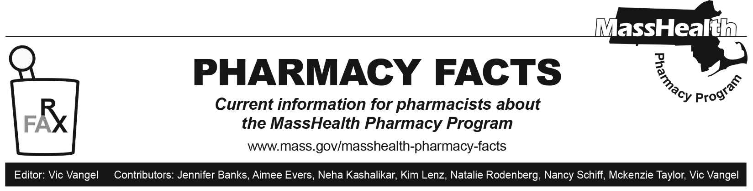

MHDL Update

What follows are certain updates to the MassHealth Drug List (MHDL). See the MHDL for a complete listing of updates.

Additions

- Effective October 31, 2022, the following newly marketed drugs have been added to the MassHealth Drug List.
- Adlarity (donepezil patch) – PA
- Amvuttra (vutrisiran) – PA
- Entadfi (finasteride/tadalafil) – PA
- Epsolay (benzoyl peroxide) – PA
- Fleqsuvy (baclofen suspension) – PA
- Fyarro (sirolimus injection) – PA
- Igalmi (dexmedetomidine) ^
- Lyvispah (baclofen granules) – PA
- Pemfexy (pemetrexed) – PA
- Releuko (filgrastim-ayow) – PA
- Tlando (testosterone undecanoate capsule) – PA
- Twyneo (tretinoin/benzoyl peroxide) – PA
- Tyvaso DPI (treprostinil inhalation powder) – PA
- venlafaxine besylate extended-release tablet – PA
- Vivjoa (oteseconazole) – PA
- Vonjo (pacritinib) – PA
- Vtama (tapinarof) – PA
- Effective on August 31, 2022, the following COVID-19 preventive therapies will be added to the MassHealth Drug List on October 31, 2022.
- Comirnaty (COVID-19 Pfizer vaccine, bivalent COVID EUA – August 31, 2022, for members ≥ 5 years of age)
- Comirnaty (Pfizer COVID-19 vaccine, bivalent COVID EUA – August 31, 2022, for members ≥ 5 years of age)
- Spikevax (COVID-19 Moderna vaccine, bivalent COVID EUA – August 31, 2022, for members ≥ 6 years of age)
- Spikevax (Moderna COVID-19 vaccine, bivalent COVID EUA – August 31, 2022, for members ≥ 6 years of age)

Change in Prior-Authorization Status

- Effective October 31, 2022, the following inflammatory bowel disorder agent will no longer require prior authorization (PA).
  - Uceris (budesonide extended-release tablet); BP
- Effective October 31, 2022, the following glucagon product will no longer require PA.
  - Gvoke (glucagon auto-injection, prefilled syringe, vial)
- Effective October 31, 2022, the following anti-acne and rosacea agent will no longer require PA.
  - clindamycin pledgets; A90
- Effective October 31, 2022, the following anti-acne and rosacea agents will no longer require PA outside of age limits.
  - Cleocin T (clindamycin gel, lotion, solution); #, A90
  - Erygel (erythromycin gel); #, A90
  - erythromycin solution; A90
  - benzoyl peroxide; *, A90

Updated MassHealth Brand Name Preferred Over Generic Drug List

The MassHealth Brand Name Preferred Over Generic Drug List has been updated to reflect recent changes to the MassHealth Drug List.

- Effective October 31, 2022, the following agents will be added to the MassHealth Brand Name Preferred Over Generic Drug List.
- Dermotic (fluocinolone oil, otic drops); BP, A90
- Divigel (estradiol); BP, A90
- Edurant (rilpivirine); BP
- Gattex (teduglutide injection) – PA; BP
- Gilenya (fingolimod) – PA; BP, A90
- Solodyn (minocycline extended-release 80 mg, 105 mg tablet); BP, A90
- Tresiba (insulin degludec); BP
- Victoza (liraglutide); BP
- Zyvox (linezolid suspension) – PA; BP, A90
- Effective September 23, 2022, the following agents were added to the MassHealth Brand Name Preferred Over Generic Drug List.
- Proventil (albuterol inhaler); BP, A90
- Ventolin (albuterol inhaler); BP, A90
- Effective October 31, 2022, the following agents will be removed from the MassHealth Brand Name Preferred Over Generic Drug List.
- Brovana (arformoterol) – PA; A90
- Noxafil # (posaconazole tablet); A90
- Perforomist (formoterol) – PA
- Vytorin # (ezetimibe/simvastatin) – PA > 1 unit/day; M90
- Zegerid # (omeprazole/sodium bicarbonate capsule); M90
- Zovirax # (acyclovir suspension); A90
- Zytiga (abiraterone 250 mg) – PA, A90

Legend

PA Prior authorization is required. The prescriber must obtain prior authorization for the drug in order for the pharmacy to receive payment. Note: PA applies to both the brand-name and the FDA “A”-rated generic equivalent of listed product.

# Designates a brand-name drug with FDA “A”-rated generic equivalents. Prior authorization is required for the brand, unless a particular form of that drug (for example, tablet, capsule, or liquid) does not have an FDA “A”-rated generic equivalent.

^{BP} Brand preferred over generic equivalents. In general, MassHealth requires a trial of the preferred drug or clinical rationale for prescribing the nonpreferred drug generic equivalent.

* The generic OTC and, if any, generic prescription versions of the drug are payable under MassHealth without prior authorization.

^ This drug is available through the health care professional who administers the drug. MassHealth does not pay for this drug to be dispensed through a retail pharmacy.

