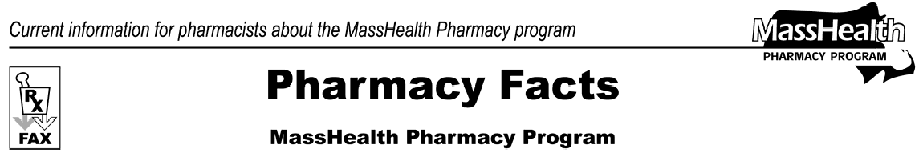
Number 19
April 13, 2006
- Editor: Vic Vangel • Contributors: Chris Burke, Gary Gilmore, Paul Jeffrey, James Monahan •

MassHealth Drug List Changes in Prior Authorization Status
MassHealth has changed the prior-authorization requirements for the following medications effective April 17, 2006.
Adoxa (doxycycline) – PA
Relenza (zanamivir) – PA all quantities (June 1st to September 30th); PA > 20 inhalations/month and 40 inhalations/season (October 1st to May 31st)

Tamiflu (oseltamivir) – PA all quantities (June 1st to September 30th); PA > 10 capsules or 75 ml per month and PA > 20 capsules or 150 ml per season (October 1st to May 31st)
Zofran ODT (ondansetron, orally disintegrating tablet)
– PA

MassHealth has changed the PA requirements of certain cerebral stimulants effective April 17, 2006. The following long-acting medications require prior authorization for quantities greater than 60 units/month separately or in combination with the cerebral stimulants listed here.
Adderall XR (amphetamine salts extended-release) –

PA > 60 units per month
Concerta (methylphenidate extended-release) – PA > 60 units per month
Focalin XR (dexmethylphenidate extended-release ) –

PA > 60 units per month
Metadate CD (methylphenidate extended-release) –

PA > 60 units per month
Ritalin LA (methylphenidate extended-release) – PA > 60 units per month

The following short-acting and intermediate-acting medications require prior authorization for quantities greater than 90 units/month, whether used individually or in combination with the cerebral stimulants listed here.
Adderall # (amphetamine salts) – PA > 90 units per month
Dexedrine # (dextroamphetamine) – PA > 90 units per month
Focalin (dexmethylphenidate) – PA > 90 units per month
Metadate ER # (methylphenidate extended-release) –

PA > 90 units per month
Methylin (methylphenidate) – PA > 90 units per month
Ritalin # (methylphenidate) – PA > 90 units per month
Ritalin SR # (methylphenidate extended-release) –

PA > 90 units per month

Written Prescription Requirements
Prescriptions for over-the-counter drugs require a valid prescription, which is not necessarily a written prescription. A valid prescription may be written, oral, facsimile, or electronic as permitted by state and federal laws. When filling a prescription for a brand-name product when a generic equivalent is available, a written prescription is required. On the face of the prescription, in the prescriber’s own handwriting, the words "brand name medically necessary" under the words "no substitution" must be written out in full and may not be abbreviated.

Medicare Part D Prescription Drug Coverage Update
A reminder that MassHealth will provide limited assistance for Part D drugs for dual eligible members when a Part D plan will not cover the medication at the time the prescription is presented. These procedures were summarized in Pharmacy Facts #17 and #18. If a Part D plan denies a claim because the drug is not available on the plan’s formulary or due to the plan's prior authorization, submit the claim to MassHealth using Other Coverage Code 3, along with the appropriate reject code. These reject codes include Reject Codes 70 and
75. The claim will still be subject to all of MassHealth’s other billing procedures and requirements, with the exception of prior authorization.

Please direct any questions or comments (or to be taken off of this fax distribution) to
Victor Moquin of ACS at 617-423-9830.

