Number 190, December 29, 2022
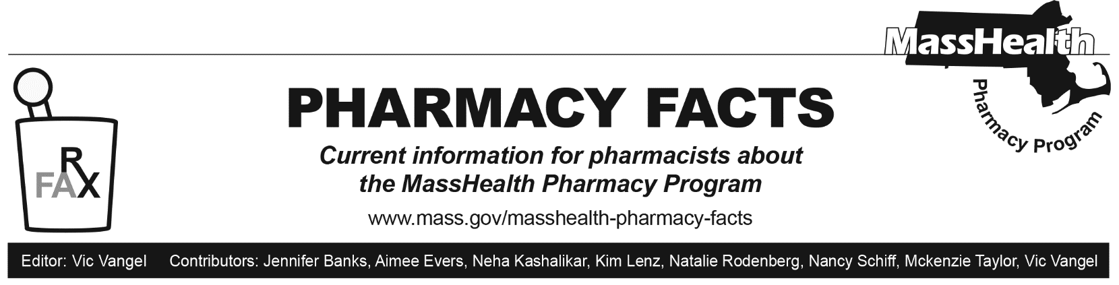

BIN/PCN/Group Numbers for ACOs, MCOs, and PCC Plan
The following tables show the correct combinations, effective for calendar year 2023, for pharmacies for Accountable Care Partnership Plans (ACPPs), Primary Care Accountable Care Organizations (ACOs), managed care organizations (MCOs), Primary Care Clinician (PCC) Plan, and MassHealth-only Senior Care Organizations (SCOs).

Effective January 1, 2023*

Accountable Care Partnership Plans | PBM | BIN | PCN | Group | Pharmacy Help Desk
Be Healthy Partnership (HNE) | OptumRx | 610593 | MHP | HNEMH | (800) 918-7545  (Optum Rx)
Berkshire Fallon Health Collaborative | OptumRx | 610011 | IRX | FCHPMCD | (844) 368-8734  (Optum Rx)
WellSense Health Plan Community Alliance | Express Scripts | 003858 | MA | MAHLTH | (877) 401-2069  (ESI)
WellSense Health Plan Mercy Alliance | Express Scripts | 003858 | MA | MAHLTH | (877) 401-2069  (ESI)
WellSense Health Plan Signature Alliance | Express Scripts | 003858 | MA | MAHLTH | (877) 401-2069  (ESI)
WellSense Health Plan Southcoast Alliance | Express Scripts | 003858 | MA | MAHLTH | (877) 401-2069  (ESI)
Fallon 365 Care | OptumRx | 610011 | IRX | FCHPMCD | (844) 368-8734  (Optum Rx)
My Care Family | CVS Caremark | 004336 | ADV | RX1653 | (800) 364-6331  (CVS Caremark)
Tufts Health Together with Atrius Health | OptumRx | 610011 | IRX | RXMCDMA | (866) 828-6668  (Optum Rx)
Tufts Health Together with BIDCO | OptumRx | 610011 | IRX | RXMCDMA | (866) 828-6668  (Optum Rx)
Tufts Health Together with Boston Children’s ACO | OptumRx | 610011 | IRX | RXMCDMA | (866) 828-6668  (Optum Rx)
Tufts Health Together with CHA | OptumRx | 610011 | IRX | RXMCDMA | (866) 828-6668  (Optum Rx)
Wellforce Care Plan (Fallon) | OptumRx | 610011 | IRX | FCHPMCD | (844) 368-8734  (Optum Rx)
*On April 1, 2023, there will be a new contract for ACPPs and MCOs.

BIN/PCN/Group Numbers for ACOs, MCOs, PCC Plan and SCO MassHealth Only
Primary Care ACOs | PBM | BIN | PCN | Group | Pharmacy Help Desk
Community Care Cooperative (C3) | Conduent | 009555 | MASSPROD | MassHealth | (866) 246-8503 (Conduent/POPS)  (800) 745-7318 (DUR)
Mass General Brigham ACO | Conduent | 009555 | MASSPROD | MassHealth | (866) 246-8503 (Conduent/POPS)  (800) 745-7318 (DUR)
Steward Health Choice | Conduent | 009555 | MASSPROD | MassHealth | (866) 246-8503 (Conduent/POPS) (800) 745-7318 (DUR)
MCOs** | PBM | BIN | PCN | Group | Pharmacy Help Desk
WellSense Health Plan | Express Scripts | 003858 | MA | MAHLTH | (877) 401-2069  (ESI)
Tufts Health Together | OptumRx | 610011 | IRX | RXMCDMA | (866) 828-6668  (Optum Rx)
PCC Plan | PBM | BIN | PCN | Group | Pharmacy Help Desk
Primary Care Clinician (PCC) Plan | Conduent | 009555 | MASSPROD | MassHealth | (866) 246-8503 (Conduent/POPS)  (800) 745-7318 (DUR)
SCO Plan— Medicaid Only | PBM | BIN | PCN | Group | Pharmacy Help Desk
Commonwealth Care Alliance | Navitus | 610602 | MCD | MHO | (855) 673-6504
Senior Whole Health | CVS  Caremark | 004336 | ADV | RX 51BB | (866) 693-4620
Tufts Health Plan SCO | OptumRx | 610011 | CTRXMEDD | RXMEDD | (855) 679-2639  (Optum Rx)
United Health Care SCO | Optum Rx | 610494 | 9999 | ACUMA | (877) 889-6510
NaviCare | Optum Rx | 610011 | IRX | FCHPSCOND | (844) 368-8734  (Optum Rx)
WellSense Health Plan SCO | Express Scripts | 003858 | MA | MAHLTH | (877) 858-5958
**Members of the Lahey Clinical Performance Network ACO should submit claims to the appropriate MCO using the information above.

MassHealth will include an updated version of this list in a future edition of Pharmacy Facts to reflect any changes.

