Number 191, January 23, 2023
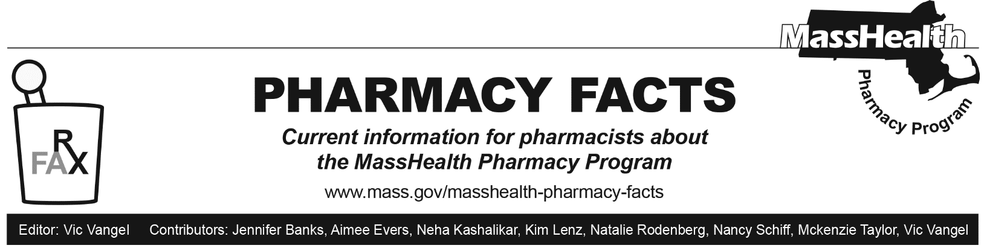

Pharmacy Claims Processing Updates, including 12-month Postpartum Coverage for MassHealth Members

Residence Codes
MassHealth is updating the Pharmacy Online Processing System (POPS) Billing Guide.
A new value (14=Homeless) will be accepted as a Residence Code (NCPDP Field 384-4X). Claims for homeless members will not be subject to mandatory 90-day supply requirements for certain prescription drugs. See Pharmacy Facts 183 for more details concerning mandatory 90-day supply requirements.
The accepted residence values will appear as:
1=Home
2=Skilled Nursing Facility
3=Nursing Facility
4=Assisted Living Facility
5=Custodial Care Facility
6=Group Home
11=Hospice
14= Homeless

Partial Fills for Schedule II Controlled Substances for Members in a Long-Term Care (LTC) Facility
Federal regulations allow for partial fills for Schedule II controlled substances for members residing in a LTC facility with a medical diagnosis documenting a terminal illness. See 21 CFR 1306.13. A pharmacy processing a partial fill for the Schedule II substance should enter the reduced number of day supply, quantity dispensed, and Submission Clarification Code 47 - Initial Fill for the initial dispense (NCPDP Field 420-DK). This allows for the prescribed quantity to be shortened.
If a subsequent fill is required, then the pharmacy should use Submission Clarification Code 48 - Incremental Fill. This submission clarification code can be used twice per prescription. The subsequent claim should have the same RX number, fill number, refill number and quantity prescribed as the initial claim.

Pregnancy
Members who are pregnant or in the postpartum period (extending through the end of the twelfth calendar month following the final month of their pregnancy) are exempt from MassHealth copayment requirements. In these cases, the pharmacist should enter a 2 in the Pregnancy Indicator Field (NCPDP- 335-2C) of the pharmacy claim.

