Number 194, February 15, 2023
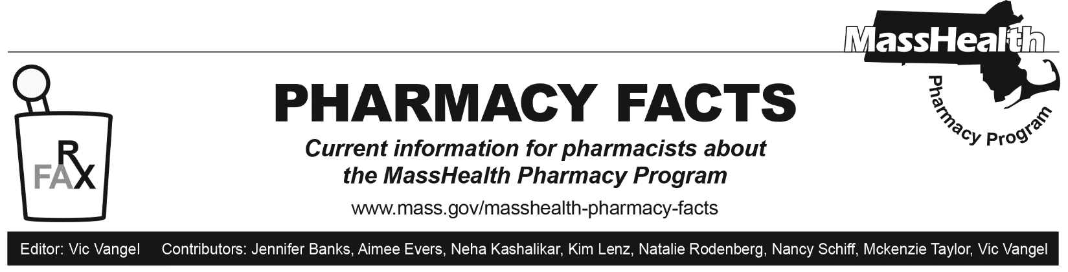
MassHealth Eligibility Redetermination

In March 2020, the federal government declared a public health emergency (PHE) due to the COVID-19 pandemic. In response to the PHE and consistent with federal continuous coverage requirements, MassHealth put protections in place that prevented members’ MassHealth coverage ending during the COVID-19 emergency.

The federal government has decided to end the continuous coverage requirements. In response to this decision, MassHealth will return to our standard annual eligibility renewal processes. Starting April 1, 2023, all current MassHealth members will need to renew their health coverage to ensure they still qualify for their current benefit. These renewals will take place over 12 months.
To reduce the number of qualified members that lose their coverage, MassHealth is working with the Massachusetts Health Connector, Health Care For All, and other partners such as our pharmacy network to make sure members know how to renew their coverage and are aware of other affordable health coverage options if needed.
We are asking pharmacy providers to display the attached posting within their pharmacy.
download (Mass.gov)

MassHealth members will soon need to
renew their health coverage.
Act now.
Stay covered.
What you need to do now
➊ Make sure MassHealth has your most up to date address, phone number, and email so you do not miss important information and notices from MassHealth.  If we are not able to contact you, your coverage  may change or you may lose your coverage during your renewal. | ➋ Report any household changes. These include a new job, address, changes to your income, disability status, or pregnancy.  Update your information and report changes using your MA Login Account at www.mahix.org/individual.

Don’t have an account?
If you are under 65, visit www.mass.gov/masshealthlogin or scan the QR code:
