Number 195, March 8, 2023 (CORRECTED)
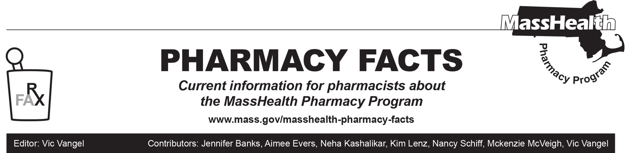
COVID-19 Vaccines

The MassHealth Pharmacy Program continues to maintain open access to COVID-19 vaccines for all members. This bulletin outlines recent guidance from the Centers for Disease Control and Prevention (CDC) outlining patients who qualify for vaccination and recommended products for the primary series as well as booster vaccinations. We encourage providers to bookmark and check for any updated guidance around the CDC’s Interim Clinical Considerations for the Use of COVID-19 Vaccines in the United States, available at https://www.cdc.gov/vaccines/covid-19/clinical-considerations/covid-19-vaccines-us.html.
Another helpful resource to reference is the FAQs for the Interim Clinical Considerations for COVID-19 Vaccination, available at https://www.cdc.gov/vaccines/covid-19/clinical-considerations/faq.html. The Massachusetts Department of Public Health COVID-19 vaccine provider bulletins can be found at: https://www.mass.gov/lists/weekly-covid-19-vaccine-provider-bulletins.
Who to Vaccinate
COVID-19 vaccination is recommended for all patients aged six months and older in the United States for the prevention of COVID-19. At this time there is no COVID-19 vaccine FDA-approved for children younger than six months of age.

Patients should stay up to date with COVID-19 vaccination by completing a primary series and receiving the most recent booster dose recommended for them by CDC (see the Interim Clinical Considerations link).

See the appendices from the CDC for recommendations on special populations such as those who were vaccinated outside of the United States and those who were initially part of a COVID-19 vaccine trial: Appendix B (People who received COVID-19 vaccine outside the United States) and Appendix C (People who received COVID-19 vaccine as part of a clinical trial).
Primary Series Vaccination
For primary series vaccination, three monovalent COVID-19 vaccines (listed in alphabetical order by manufacturer), are recommended: Moderna, Novavax, and Pfizer-BioNTech.

It is recommended that patients six months of age and older receive the primary series.

Monovalent vaccines should be used for the primary series, with the exception of children six months to four years of age who received two doses of a monovalent Pfizer vaccine. This patient subset should receive a bivalent Pfizer vaccine as their third primary series dose.

Vaccine products made by the same manufacturer should be used for all doses of the primary series. See attached link for additional information:
https://www.cdc.gov/vaccines/covid-19/clinical-considerations/interim-considerations-us.html#Interchangeability.
Booster Vaccination
Monovalent mRNA vaccines are not authorized as a booster dose.

It is recommended that patients six months of age and older receive one bivalent mRNA booster dose at least two months after completion of any FDA-approved or FDA-authorized primary series or previously received monovalent booster dose(s). One exception to this rule, is children aged six months to four years who receive a three-dose Pfizer primary series. These patients are not authorized to receive a booster dose at this time, regardless of whether the monovalent or bivalent Pfizer vaccine was administered for the third primary series dose.
A monovalent Novavax booster dose (instead of a bivalent mRNA booster dose) is recommended for use in limited situations. This includes, in patients 18 years of age or older who have completed any FDA-approved or FDA-authorized monovalent primary series, patients who have not received any previous booster dose(s), as well as patients who are unable or unwilling to receive an mRNA vaccine and would otherwise not receive a booster dose.
Bivalent Booster Product Varies by Age
- Ages six months–four years and have completed the Moderna primary series: one bivalent Moderna booster dose (given at least two months after completion of primary series vaccination).
- Ages six months–four years and have completed Pfizer primary series: no booster dose is recommended at this time.
- Age five years and have completed Moderna primary series: one bivalent mRNA booster dose (Moderna or Pfizer) (given at least two months after completion of primary series vaccination).
- Age five years and have completed Pfizer primary series: one bivalent Pfizer booster dose. (regardless of whether the third primary series dose was a monovalent or bivalent Pfizer vaccine). (given at least two months after completion of primary series vaccination).
- Ages six years and older and have completed any primary series: one bivalent mRNA booster dose (Moderna or Pfizer) (given at least two months after completion of primary series vaccination).
COVID-19 Vaccination Schedule
The COVID-19 vaccination schedule for people who are NOT immunocompromised can be found at: https://www.cdc.gov/vaccines/covid-19/clinical-considerations/interim-considerations-us.html#not-immunocompromised. A vaccination schedule infographic for people who are not moderately or severely immunocompromised can be found at: https://www.cdc.gov/vaccines/covid-19/images/COVID19-vaccination-schedule-most-people.png.
The recommended schedule for those who ARE immunocompromised can be found at: https://www.cdc.gov/vaccines/covid-19/clinical-considerations/interim-considerations-us.html#immunocompromised . A vaccination schedule infographic for people who are immunocompromised can be found at: https://www.cdc.gov/vaccines/covid-19/images/COVID19-vaccination-schedule-immunocompromised.png.
COVID-19 Vaccine Formulations Currently Approved or Authorized in the United States
The table on the next page can be found at: https://www.cdc.gov/vaccines/covid-19/downloads/summary-interim-clinical-considerations.pdf.

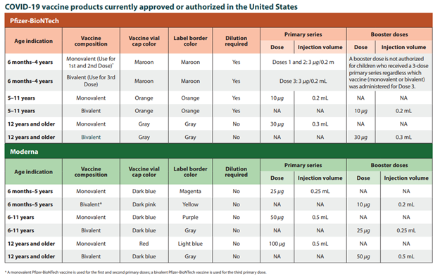

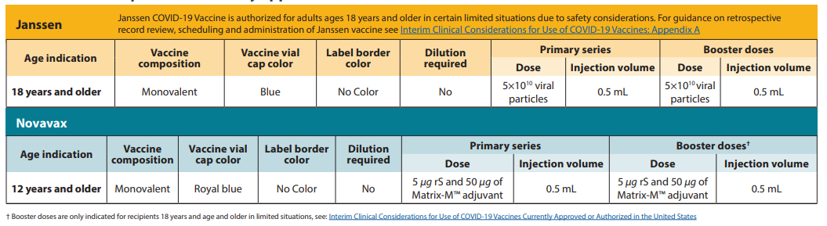
COVID-19 vaccine formulations currently approved or authorized in the United States
The table below can be found at: https://www.cdc.gov/vaccines/covid-19/downloads/summary-interim-clinical-considerations.pdf.

