Number 198, April 7, 2023
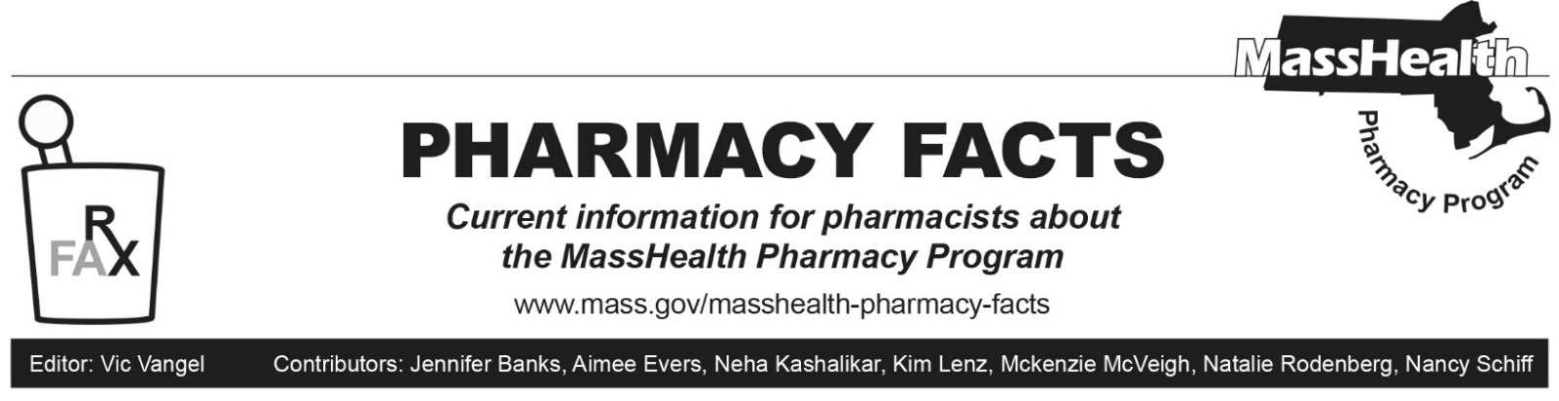
Pharmacy Claims Processing Updates

Submission Clarification Codes

MassHealth is updating the POPS Billing Guide. A new value, “57=Discharge Medication,” will be accepted as a Submission Clarification Code (NCPDP Field 420-DK). Claims for discharge medications will not be subject to mandatory 90-day supply requirements that apply to certain prescription drugs, so discharge medications can be dispensed in smaller quantities. See Pharmacy Facts 189 for more details about mandatory 90-day supply requirements.

