Number 199, April 27, 2023
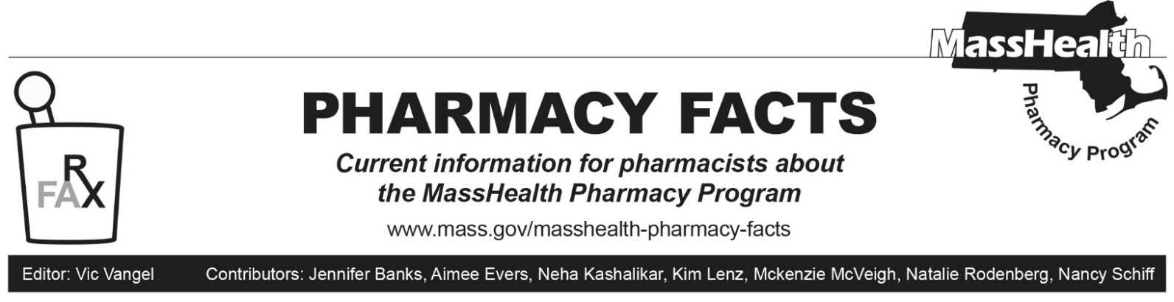

Pharmacy Copay Changes Effective May 1, 2023
Effective May 1, 2023, through March 31, 2024, MassHealth members, including those in managed care plans, do not have to pay copays for prescription drugs. This also applies to Health Safety Net (HSN) patients during this period.

This does not apply to Children’s Medical Security Plan (CMSP) members–CMSP members must still pay copays.

There are permanently no copays for members enrolled in One Care, Program for All-inclusive Care for the Elderly (PACE), and Senior Care Options (SCO) plans.

MassHealth will publish an updated copay poster on its website that will reflect these changes.

