Number 20
May 24, 2006

www.mass.gov/masshealth/pharmacy
- Editor: Vic Vangel • Contributors: Chris Burke, Gary Gilmore, Paul Jeffrey, James Monahan •

MassHealth Drug List

Additions
The following newly marketed drugs have been added to the MassHealth Drug List.
Amitiza (lubiprostone) – PA Arranon (nelarabine) – PA Boniva IV (ibandronate) – PA
Levemir (insulin detemir) prefilled syringe – PA
Levemir (insulin detemir) vial Sutent (sunitinib)
Taclonex (betamethasone/calcipotriene) – PA Vivaglobin (immune globulin, subcutaneous) – PA Vusion (miconazole/zinc oxide) – PA

Change in Prior Authorization Status
MassHealth has changed the coverage of tobacco cessation products. Effective July 1, 2006, MassHealth includes coverage of the tobacco cessation products with the following restrictions.
The following medications require PA for greater than 90 days per treatment regimen. PA is also required for greater than two treatment regimens per year.
nicotine gum (generics) – PA > 90 days/ treatment regimen and PA > two treatment regimens/year
nicotine lozenge (Commit) – PA > 90 days/ treatment regimen and PA > two treatment regimens/year
nicotine transdermal patch (generics) – PA > 90 days/treatment regimen and PA > two treatment regimens/year
The following medications require prior authorization for all quantities.
nicotine inhaler (Nicotrol) – PA
nicotine nasal spray (Nicotrol) – PA
The following medication requires prior-authorization for the brand, unless a particular form of that drug (for example, tablet, capsule, or liquid) does not have an FDA “A”-rated generic equivalent.
bupropion sustained release (Zyban #)
Effective July 1, 2006, the following medication requires prior authorization.
Rituxan (rituximab) – PA
MassHealth no longer requires prior authorization for members over the age of 21 for the following medication.
MetroCream # (metronidazole)
MassHealth no longer requires prior authorization for the following generic medication.
albuterol HFA

Submitting Claims for All Prescriptions
We would like to remind pharmacists that they should submit all claims for processing even if they think the claim might deny for various reasons such as a drug not being listed on the MassHealth Drug List. We receive many calls from members and their physicians telling us that a pharmacy informs them that a drug claim is being denied by MassHealth when in fact we see that a claim has never been submitted. Some drugs that are listed on the MassHealth Drug List as requiring prior authorization (PA) will adjudicate without PA if a member has a particular diagnosis or prior use of another medication.
An example of this would be a claim for an angiotensin II receptor antagonist (ARB) not requiring prior authorization when the member has had a prior history of use of an angiotensin converting enzyme (ACE) inhibitor.

Medicare Part D Prescription Drug Coverage Update
Please remember that MassHealth has procedures in place that reduce a dual-eligible member’s copay from the
$2.00 and $5.00 levels (as determined by the Part-D plan) to the standard MassHealth copay levels of $1.00 and
$3.00. These procedures were described in detail in Pharmacy Facts #17.
Immunosuppressive drugs - The pharmacist must bill Medicare Part B if the dual-eligible member had a Medicare-covered transplant. If Medicare did not cover the member’s transplant, bill the Medicare Part D plan.
Erythropoietins are other drugs that must be billed to a member’s Part D plan if the claim is not covered by Part B.

CoPays
A reminder that a pharmacy cannot refuse service, or fail to fill a prescription as written based on a MassHealth member’s inability to pay a copay. This is also true for MassHealth members enrolled in a MassHealth managed care organization (MCO).

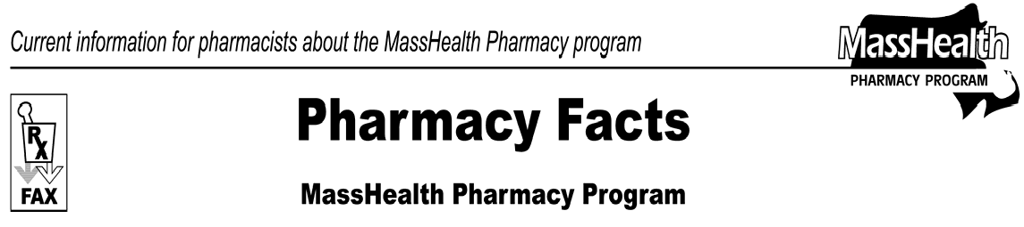

Please direct any questions or comments (or to be taken off of this fax distribution) to
Victor Moquin of ACS at 617-423-9830.

