Number 200, May 5, 2023
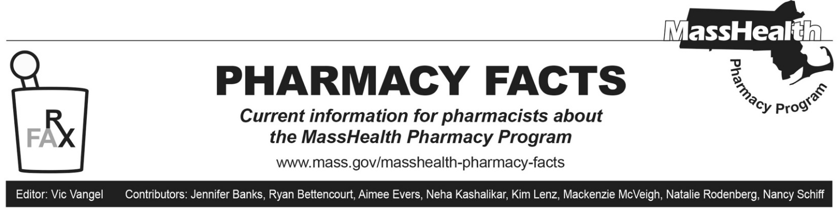

Pharmacy Copay Changes Effective May 1, 2023
Pharmacy Facts 199 announced that, effective May 1, 2023, through March 31, 2024, MassHealth members, including those in managed care plans, do not have to pay copays for prescription drugs. This also applies to Health Safety Net (HSN) patients during this period.

Children’s Medical Security Plan (CMSP) members must still pay copays.

There will continue to be no copays for members enrolled in One Care, Program for All-inclusive Care for the Elderly (PACE), and Senior Care Options (SCO) plans.

Pharmacy Copay Poster Changes
The pharmacy copay poster has been updated to reflect the new policy changes effective May 1, 2023, and can be found on the MassHealth Pharmacy Publications and Notices for Pharmacy Providers page, under the heading “Copay Poster.”

Pharmacies are required by MassHealth regulations at 130 CMR 450.130(F) to post a notice about MassHealth copays in areas where copays are collected. The notice must

- be visible to the public and easily readable;
- specify the exclusions from the copay requirement listed in 130 CMR 450.130(D) and (E); and
- instruct members to inform providers if they believe that they are excluded from the copay requirement.

